Cloudera Configuration on Centos 7

Cloudera Setup and Installation

10/18/2016

Shalaj Shukla

Contents

Setup http server 3

Create Virtual host on machine 3

Create local Cloudera repository 13

Install Cloudera Manager 19

Cloudera Manager 19

Setup Pre-requisites 20

Check configuration of all nodes 20

Host Machines Configuration 21

Disable Firewall (IPTables) 22

Enabling NTP 22

Set umask to 022 24

SSH Password less sudo Access 25

Set swappiness to 10 28

Disabling SELinux 29

Download and install 30

Add hosts to cluster 65

Add Role Instance 80

HDFS Service 80

Zookeeper Service 88

Yarn Service 93

Hive Service 98

Impala Service 103

Oozie Service 107

Hue Service 113

Setup High Availability 121

HDFS High Availability 121

Architecture 121

Configuration 122

Check High Availability Feature 132

Journal Node 136

Configuration difference between HA and Non HA Version 139

YARN (MR2) Resource Manager High Availability 142

Automatic Failover 143

Configuration 143

Install Custom-database (MySQL) 151

Uninstall Cloudera Manager and Managed Software 151

# Setup http server

If httpd service is not installed please install it using below command

|  |
| --- |
| yum install httpd |

Make sure httpd service starts automatically at boot time, use the following command:

|  |
| --- |
| systemctl enable httpd.service |

Now we will create document root we will placed Cloudera files under document root that will be act as our local repository for Cloudera, we are creating it in (172.27.155.122) machine

*Note: by default document root is* ***/var/www/html*** *so if you do not want to create separate document root you can use this folder also and skip Create Virtual host section*

First just start the httpd service and test the home page

|  |
| --- |
| systemctl start httpd.service |

Go to browser and visit **http:<host IP>:port** , in our case it is [**http://172.27.155.122:80**](http://172.27.155.122:80)and check if service is running properly

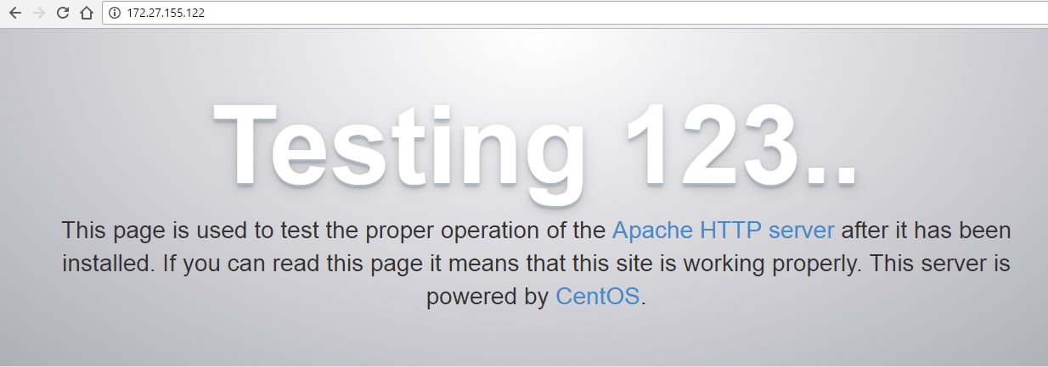

If you find this page it means service is running properly

## Create Virtual host on machine

Run following commands to create new document root folder structure

|  |
| --- |
| sudo mkdir -p /var/www/mac122.com/ |
| sudo chown -R apache:apache /var/www/mac122.com/ |
| sudo chmod -R 755 /var/www/ |

Now edit file httpd.conf

sudo vim /etc/httpd/conf/httpd.conf

Add directory element for /var/www/mac122.com ( if you add this element you can see those files using browser otherwise you will get 403 forbidden error, you can skip this step ,only you will not able to see the files and folders in browser)

|  |
| --- |
| <Directory "/var/www/mac122.com">  Options Indexes FollowSymLinks  AllowOverride None  Require all granted  </Directory> |

Also add below lines at the end of file

|  |
| --- |
| <VirtualHost *:80>  ServerAdmin webmaster@mac122.com  ServerName www.mac122.com  ServerAlias mac122.com  DocumentRoot /var/www/mac122.com/  ErrorLog /var/www/mac122.com/error.log  CustomLog /var/www/mac122.com/requests.log combined  </VirtualHost> |

Full httpd.conf file

|  |
| --- |
| #  # This is the main Apache HTTP server configuration file. It contains the  # configuration directives that give the server its instructions.  # See <URL:http://httpd.apache.org/docs/2.4/> for detailed information.  # In particular, see  # <URL:http://httpd.apache.org/docs/2.4/mod/directives.html>  # for a discussion of each configuration directive.  #  # Do NOT simply read the instructions in here without understanding  # what they do. They're here only as hints or reminders. If you are unsure  # consult the online docs. You have been warned.  #  # Configuration and logfile names: If the filenames you specify for many  # of the server's control files begin with "/" (or "drive:/" for Win32), the  # server will use that explicit path. If the filenames do *not* begin  # with "/", the value of ServerRoot is prepended -- so 'log/access_log'  # with ServerRoot set to '/www' will be interpreted by the  # server as '/www/log/access_log', where as '/log/access_log' will be  # interpreted as '/log/access_log'.  #  # ServerRoot: The top of the directory tree under which the server's  # configuration, error, and log files are kept.  #  # Do not add a slash at the end of the directory path. If you point  # ServerRoot at a non-local disk, be sure to specify a local disk on the  # Mutex directive, if file-based mutexes are used. If you wish to share the  # same ServerRoot for multiple httpd daemons, you will need to change at  # least PidFile.  #  ServerRoot "/etc/httpd"  #  # Listen: Allows you to bind Apache to specific IP addresses and/or  # ports, instead of the default. See also the <VirtualHost>  # directive.  #  # Change this to Listen on specific IP addresses as shown below to  # prevent Apache from glomming onto all bound IP addresses.  #  #Listen 12.34.56.78:80  Listen 80  #  # Dynamic Shared Object (DSO) Support  #  # To be able to use the functionality of a module which was built as a DSO you  # have to place corresponding `LoadModule' lines at this location so the  # directives contained in it are actually available _before_ they are used.  # Statically compiled modules (those listed by `httpd -l') do not need  # to be loaded here.  #  # Example:  # LoadModule foo_module modules/mod_foo.so  #  Include conf.modules.d/*.conf  #  # If you wish httpd to run as a different user or group, you must run  # httpd as root initially and it will switch.  #  # User/Group: The name (or #number) of the user/group to run httpd as.  # It is usually good practice to create a dedicated user and group for  # running httpd, as with most system services.  #  User apache  Group apache  # 'Main' server configuration  #  # The directives in this section set up the values used by the 'main'  # server, which responds to any requests that aren't handled by a  # <VirtualHost> definition. These values also provide defaults for  # any <VirtualHost> containers you may define later in the file.  #  # All of these directives may appear inside <VirtualHost> containers,  # in which case these default settings will be overridden for the  # virtual host being defined.  #  #  # ServerAdmin: Your address, where problems with the server should be  # e-mailed. This address appears on some server-generated pages, such  # as error documents. e.g. admin@your-domain.com  #  ServerAdmin root@localhost  #  # ServerName gives the name and port that the server uses to identify itself.  # This can often be determined automatically, but we recommend you specify  # it explicitly to prevent problems during startup.  #  # If your host doesn't have a registered DNS name, enter its IP address here.  #  #ServerName www.example.com:80  #  # Deny access to the entirety of your server's filesystem. You must  # explicitly permit access to web content directories in other  # <Directory> blocks below.  #  <Directory />  AllowOverride none  Require all denied  </Directory>  #  # Note that from this point forward you must specifically allow  # particular features to be enabled - so if something's not working as  # you might expect, make sure that you have specifically enabled it  # below.  #  #  # DocumentRoot: The directory out of which you will serve your  # documents. By default, all requests are taken from this directory, but  # symbolic links and aliases may be used to point to other locations.  #  DocumentRoot "/var/www/html"  #  # Relax access to content within /var/www.  #  <Directory "/var/www">  AllowOverride None  # Allow open access:  Require all granted  </Directory>  # Further relax access to the default document root:  <Directory "/var/www/html">  #  # Possible values for the Options directive are "None", "All",  # or any combination of:  # Indexes Includes FollowSymLinks SymLinksifOwnerMatch ExecCGI MultiViews  #  # Note that "MultiViews" must be named *explicitly* --- "Options All"  # doesn't give it to you.  #  # The Options directive is both complicated and important. Please see  # http://httpd.apache.org/docs/2.4/mod/core.html#options  # for more information.  #  Options Indexes FollowSymLinks  #  # AllowOverride controls what directives may be placed in .htaccess files.  # It can be "All", "None", or any combination of the keywords:  # Options FileInfo AuthConfig Limit  #  AllowOverride None  #  # Controls who can get stuff from this server.  #  Require all granted  </Directory>  <Directory "/var/www/mac122.com">  Options Indexes FollowSymLinks  AllowOverride None  Require all granted  </Directory>  #  # DirectoryIndex: sets the file that Apache will serve if a directory  # is requested.  #  <IfModule dir_module>  DirectoryIndex index.html  </IfModule>  #  # The following lines prevent .htaccess and .htpasswd files from being  # viewed by Web clients.  #  <Files ".ht*">  Require all denied  </Files>  #  # ErrorLog: The location of the error log file.  # If you do not specify an ErrorLog directive within a <VirtualHost>  # container, error messages relating to that virtual host will be  # logged here. If you *do* define an error logfile for a <VirtualHost>  # container, that host's errors will be logged there and not here.  #  ErrorLog "logs/error_log"  #  # LogLevel: Control the number of messages logged to the error_log.  # Possible values include: debug, info, notice, warn, error, crit,  # alert, emerg.  #  LogLevel warn  <IfModule log_config_module>  #  # The following directives define some format nicknames for use with  # a CustomLog directive (see below).  #  LogFormat "%h %l %u %t \"%r\" %>s %b \"%{Referer}i\" \"%{User-Agent}i\"" combined  LogFormat "%h %l %u %t \"%r\" %>s %b" common  <IfModule logio_module>  # You need to enable mod_logio.c to use %I and %O  LogFormat "%h %l %u %t \"%r\" %>s %b \"%{Referer}i\" \"%{User-Agent}i\" %I %O" combinedio  </IfModule>  #  # The location and format of the access logfile (Common Logfile Format).  # If you do not define any access logfiles within a <VirtualHost>  # container, they will be logged here. Contrariwise, if you *do*  # define per-<VirtualHost> access logfiles, transactions will be  # logged therein and *not* in this file.  #  #CustomLog "logs/access_log" common  #  # If you prefer a logfile with access, agent, and referer information  # (Combined Logfile Format) you can use the following directive.  #  CustomLog "logs/access_log" combined  </IfModule>  <IfModule alias_module>  #  # Redirect: Allows you to tell clients about documents that used to  # exist in your server's namespace, but do not anymore. The client  # will make a new request for the document at its new location.  # Example:  # Redirect permanent /foo http://www.example.com/bar  #  # Alias: Maps web paths into filesystem paths and is used to  # access content that does not live under the DocumentRoot.  # Example:  # Alias /webpath /full/filesystem/path  #  # If you include a trailing / on /webpath then the server will  # require it to be present in the URL. You will also likely  # need to provide a <Directory> section to allow access to  # the filesystem path.  #  # ScriptAlias: This controls which directories contain server scripts.  # ScriptAliases are essentially the same as Aliases, except that  # documents in the target directory are treated as applications and  # run by the server when requested rather than as documents sent to the  # client. The same rules about trailing "/" apply to ScriptAlias  # directives as to Alias.  #  ScriptAlias /cgi-bin/ "/var/www/cgi-bin/"  </IfModule>  #  # "/var/www/cgi-bin" should be changed to whatever your ScriptAliased  # CGI directory exists, if you have that configured.  #  <Directory "/var/www/cgi-bin">  AllowOverride None  Options None  Require all granted  </Directory>  <IfModule mime_module>  #  # TypesConfig points to the file containing the list of mappings from  # filename extension to MIME-type.  #  TypesConfig /etc/mime.types  #  # AddType allows you to add to or override the MIME configuration  # file specified in TypesConfig for specific file types.  #  #AddType application/x-gzip .tgz  #  # AddEncoding allows you to have certain browsers uncompress  # information on the fly. Note: Not all browsers support this.  #  #AddEncoding x-compress .Z  #AddEncoding x-gzip .gz .tgz  #  # If the AddEncoding directives above are commented-out, then you  # probably should define those extensions to indicate media types:  #  AddType application/x-compress .Z  AddType application/x-gzip .gz .tgz  #  # AddHandler allows you to map certain file extensions to "handlers":  # actions unrelated to filetype. These can be either built into the server  # or added with the Action directive (see below)  #  # To use CGI scripts outside of ScriptAliased directories:  # (You will also need to add "ExecCGI" to the "Options" directive.)  #  #AddHandler cgi-script .cgi  # For type maps (negotiated resources):  #AddHandler type-map var  #  # Filters allow you to process content before it is sent to the client.  #  # To parse .shtml files for server-side includes (SSI):  # (You will also need to add "Includes" to the "Options" directive.)  #  AddType text/html .shtml  AddOutputFilter INCLUDES .shtml  </IfModule>  # Specify a default charset for all content served; this enables  # interpretation of all content as UTF-8 by default. To use the  # default browser choice (ISO-8859-1), or to allow the META tags  # in HTML content to override this choice, comment out this  # directive:  #  AddDefaultCharset UTF-8  <IfModule mime_magic_module>  #  # The mod_mime_magic module allows the server to use various hints from the  # contents of the file itself to determine its type. The MIMEMagicFile  # directive tells the module where the hint definitions are located.  #  MIMEMagicFile conf/magic  </IfModule>  #  # Customizable error responses come in three flavors:  # 1) plain text 2) local redirects 3) external redirects  #  # Some examples:  #ErrorDocument 500 "The server made a boo boo."  #ErrorDocument 404 /missing.html  #ErrorDocument 404 "/cgi-bin/missing_handler.pl"  #ErrorDocument 402 http://www.example.com/subscription_info.html  #  #  # EnableMMAP and EnableSendfile: On systems that support it,  # memory-mapping or the sendfile syscall may be used to deliver  # files. This usually improves server performance, but must  # be turned off when serving from networked-mounted  # filesystems or if support for these functions is otherwise  # broken on your system.  # Defaults if commented: EnableMMAP On, EnableSendfile Off  #  #EnableMMAP off  EnableSendfile on  # Supplemental configuration  #  # Load config files in the "/etc/httpd/conf.d" directory, if any.  IncludeOptional conf.d/*.conf  #IncludeOptional sites-enabled/*.conf  <VirtualHost *:80>  ServerAdmin webmaster@mac122.com  ServerName www.mac122.com  ServerAlias mac122.com  DocumentRoot /var/www/mac122.com/  ErrorLog /var/www/mac122.com/error.log  CustomLog /var/www/mac122.com/requests.log combined  </VirtualHost> |

You can place index.html file under /var/ww/mac122.com to verify the virtual host configuration

|  |
| --- |
| sudo vim /var/www/mac122.com/index.html |
| Add below content  <html>  <head>  <title>Welcome to cybage.com!</title>  </head>  <body>  <h1>Success! The virtual host is working!</h1>  </body>  </html> |

Now start the httpd service if it is not started

|  |
| --- |
| systemctl start httpd.service |

Open browser and go to link <http://172.27.155.122>

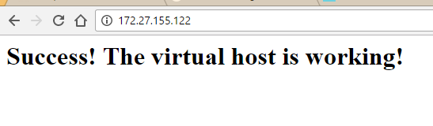

Hurray virtual host configured successfully

# Create local Cloudera repository

Go to /etc/yum.repos.d folder

|  |
| --- |
| cd /etc/yum.repos.d |
| Download repo file for coludera manager ( you can find different version for redhat in  [http://archive.cloudera.com/cm5/redhat/](http://archive.cloudera.com/cdh5/redhat/) here I am using redhat 7)  wget <http://archive.cloudera.com/cm5/redhat/7/x86_64/cm/cloudera-manager.repo> |
| Download repo file for coludera cdh ( you can find different version for redhat in <http://archive.cloudera.com/cdh5/redhat/> here I am using redhat 7)  wget <http://archive.cloudera.com/cdh5/redhat/7/x86_64/cdh/cloudera-cdh5.repo> |

You can find below two files under yum.repo.d folder

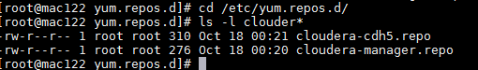

Check the content of both files

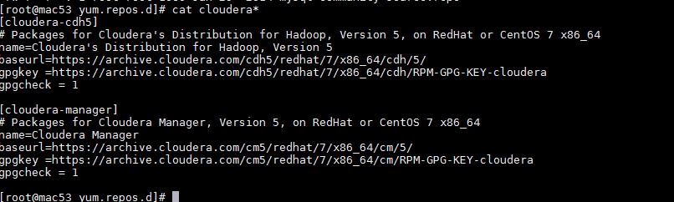

Currently the URL is pointing to archive.cloudera.com

Now install utilities (yum-utils and createrepo) by executing below command

|  |
| --- |
| yum install yum-utils createrepo |

Now go to /var/www/mac122.com

*Note: if you haven’t created virtual host you need to follow below steps for folder* ***/var/www/html*** *instead of* ***/var/www/mac122.com*** *folder which is default document root*

|  |
| --- |
| cd /var/www/mac122.com |
| Execute below command  ***nohup reposync cloudera-manager &***  this command will take some time it will download all the binaries related to Cloudera manager locally,after successful installation you will find cloudera-manager directory |
| Execute below command  **nohup reposync cloudera-cdh5 &**  this command will download all the binaries related to Cloudera Hadoop distributaion  after completion of this command you will find cloudera-cdh5 directory , these commands downloads all cloudera related rpm files , so both of these command take some time |

After successful installation you will find folder structure like below

|  |
| --- |
| [root@mac122 mac122.com]# ls -l  total 4116  drwxr-xr-x 3 root root 21 Oct 17 07:26 base  drwxr-xr-x 2 root root 6 Oct 17 09:18 cloudera-cdh5  drwxr-xr-x 2 root root 6 Oct 17 09:14 cloudera-manager  drwxr-xr-x 3 root root 21 Oct 17 08:59 extras  drwxr-xr-x 2 root root 8192 Oct 17 09:19 mysql56-community  drwxr-xr-x 2 root root 4096 Oct 17 09:04 mysql-connectors-community  drwxr-xr-x 2 root root 4096 Oct 17 09:09 mysql-tools-community  -rw------- 1 root root 2249943 Oct 17 09:19 nohup.out |

Now we need to create folder structure that is mentioned in cloudera repo file for cm and cdh under /var/www/mac122.com

|  |
| --- |
| [root@mac122 mac122.com]# mkdir -p cm5/redhat/7/x86_64/cm/5/  [root@mac122 mac122.com]# mkdir -p cdh5/redhat/7/x86_64/cdh/5/ |

Now we need to move RMPS folder from cloudera-manager to cm5/redhat/7/x86_64/cm/5/

|  |
| --- |
| [root@mac122 5]# pwd  /var/www/mac122.com/cm5/redhat/7/x86_64/cm/5  [root@mac122 5]# mv -f /var/www/mac53.com/cloudera-manager/* .  [root@mac122 5]# ls -l  total 0  drwxr-xr-x 3 root root 19 Oct 17 08:55 RPMS |

We need to move RPMS folder from cloudera-cdh5 to cdh5/redhat/7/x86_64/cdh/5/

|  |
| --- |
| [root@mac122 5]# pwd  /var/www/mac122.com/cdh5/redhat/7/x86_64/cdh/5  [root@mac122 5]# mv -f /var/www/mac53.com/cloudera-cdh5/* .  [root@mac122 5]# ls -l  total 0  drwxr-xr-x 4 root root 32 Oct 17 08:45 RPMS |

|  |
| --- |
| [root@mac122 mac122.com]# ls -l  total 4116  drwxr-xr-x 3 root root 21 Oct 17 07:26 base  drwxr-xr-x 3 root root 19 Oct 17 07:42 cdh5  drwxr-xr-x 2 root root 6 Oct 17 09:18 cloudera-cdh5  drwxr-xr-x 2 root root 6 Oct 17 09:14 cloudera-manager  drwxr-xr-x 3 root root 19 Oct 17 07:34 cm5  drwxr-xr-x 3 root root 21 Oct 17 08:59 extras  drwxr-xr-x 2 root root 8192 Oct 17 09:19 mysql56-community  drwxr-xr-x 2 root root 4096 Oct 17 09:04 mysql-connectors-community  drwxr-xr-x 2 root root 4096 Oct 17 09:09 mysql-tools-community  -rw------- 1 root root 2249943 Oct 17 09:19 nohup.out |

Now all files are under cdh5 and cm5 folder so we can delete all unnecessary files

|  |
| --- |
| rm -rf base cloudera-cdh5 cloudera-manager extras mysql56-community mysql-connectors-community mysql-tools-community |

|  |
| --- |
| [root@mac122mac122.com]# ls -l  total 4096  drwxr-xr-x 3 root root 19 Oct 17 07:42 cdh5  drwxr-xr-x 3 root root 19 Oct 17 07:34 cm5  -rw------- 1 root root 2309212 Oct 17 09:21 nohup.out |

We need to download Cloudera RPM key for both cm and cdh in respective folder

|  |
| --- |
| [root@mac122 cdh]# pwd  /var/www/mac122.com/cdh5/redhat/7/x86_64/cdh  [root@mac122 cdh]# wget <https://archive.cloudera.com/cdh5/redhat/7/x86_64/cdh/RPM-GPG-KEY-cloudera> |
| [root@mac122 cm]# pwd  /var/www/mac122.com/cm5/redhat/7/x86_64/cm  [root@mac122 cm]# wget <https://archive.cloudera.com/cm5/redhat/7/x86_64/cm/RPM-GPG-KEY-cloudera> |

Now we need to run createrepo command on both cm5 and cdh5 folder (this will create repodata folder)

|  |
| --- |
| [root@mac122 mac122.com]# cd cm5/redhat/7/x86_64/cm/5/  [root@mac122 5]# ***createrepo .*** |
| [root@mac122mac122.com]# cd cdh5/redhat/7/x86_64/cdh/5/  [root@mac122 5]# ***createrepo .*** |

Now we need to edit both Cloudera repo files

Replace <https://archive.cloudera.com> to <http://172.27.155.122> in cloudera-manager.repo and cloudera-cdh5.repo files, placed under /etc/yum.repo.d/

After editing content should be look like this

|  |
| --- |
| **cloudera-manager.repo file**  [cloudera-manager]  # Packages for Cloudera Manager, Version 5, on RedHat or CentOS 7 x86_64  name=Cloudera Manager  baseurl=http://172.27.155.122/cm5/redhat/7/x86_64/cm/5/  gpgkey =http://172.27.155.122/cm5/redhat/7/x86_64/cm/RPM-GPG-KEY-cloudera  gpgcheck = 1  **cloudera-cdh5.repo file**  [cloudera-cdh5]  # Packages for Cloudera's Distribution for Hadoop, Version 5, on RedHat or CentOS 7 x86_64  name=Cloudera's Distribution for Hadoop, Version 5  baseurl=http://172.27.155.122/cdh5/redhat/7/x86_64/cdh/5/  gpgkey =http://172.27.155.122/cdh5/redhat/7/x86_64/cdh/RPM-GPG-KEY-cloudera  gpgcheck = 1 |

Now we need to run ***yum repolist*** command

|  |
| --- |
| [root@mac122 5]# cd /etc/yum.repos.d/ |
| [root@mac122 5]# yum repolist |

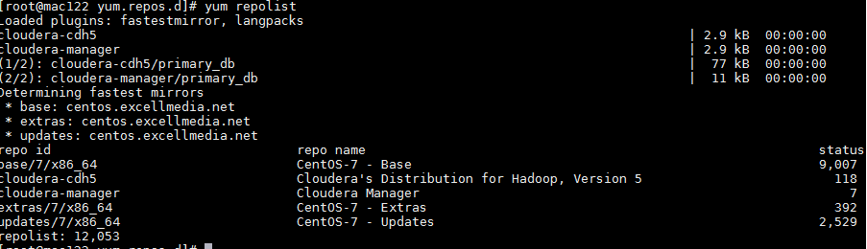

There should not be any error

Now copy cloudera-*.repo files from yum.repo.d folder to new virtual host folder so that anyone can download it using wget

|  |
| --- |
| [root@mac122 yum.repos.d]# pwd  /etc/yum.repos.d  [root@mac122 yum.repos.d]# cp cloudera-manager.repo /var/www/mac122.com/cm5/redhat/7/x86_64/cm  [root@mac122 yum.repos.d]# cp cloudera-cdh5.repo /var/www/mac122.com/cdh5/redhat/7/x86_64/cdh |

Check <http://172.27.155.122/cm5/redhat/7/x86_64/cm/>

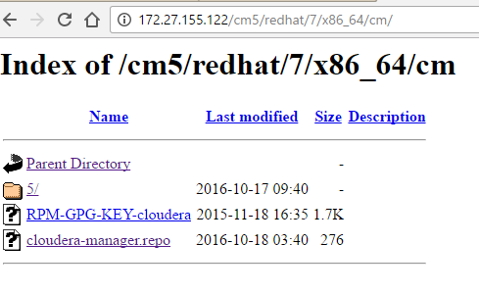

Check <http://172.27.155.122/cdh5/redhat/7/x86_64/cdh/>

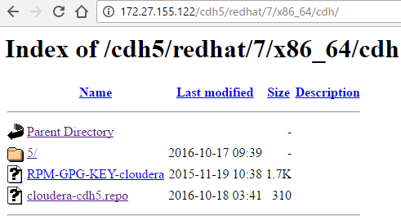

# Install Cloudera Manager

## Cloudera Manager

**What is it?**

* Cloudera Manager is a management tool for Hadoop eco system
* Easy for set up Hadoop cluster and also facilitates monitoring of Hadoop Cluster

**Components**

* Cloudera Manager on one machine
* Relational database on same machine as Cloudera manager or different machine
* Cloudera Agent on all machine

**How it works**

* Cloudera manager will be running on one machine in the cluster
* Cloudera agent will be running on all machines in the cluster
* Cloudera agent sends data collected from all machines such as resources utilization (memory, storage, CPU etc.)
* Data will be stored in a relational database which will act as a repository
* Cloudera manager consolidates this information and provide capabilities such as alerts, dashboards etc.

**Steps to set it up**

* Install Cloudera manager on one of the masters
* Set up database if you want it to be in different host than where Cloudera manager is running
* Set up Cloudera manager
* Start Cloudera manager
* Validate by going to url (http://hostname:7180)

## Setup Pre-requisites

### Check configuration of all nodes

Check Configuration of all four machines by issuing ***lscpu*** command

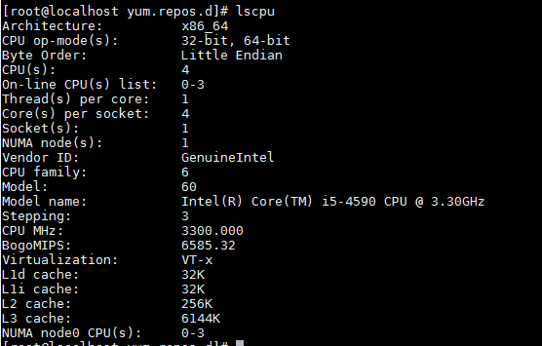

Check OS version of all four machines by checking content of /etc/*-release file

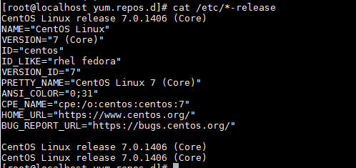

Check the java version on all four machines

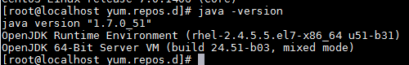

The entire configuration more or less should be same across cluster

### Host Machines Configuration

Here we are planning to setup four node clusters on following centos 7 machines

|  |  |
| --- | --- |
| **Machine** | **Roles** |
| 172.27.155.122 | All Cloudera Management services  Data Node  Cloudera-agent  Failover controller  Secondary Name Node |
| 172.27.155.53 | Data Node  Cloudera-agent |
| 172.27.155.55 | Data Node  Cloudera-agent  Name Node |
| 172.27.155.78 | Data Node  Cloudera-agent |

You can find all other roles as we install different role instances on machines

We need to have Yum install on machine by default yum comes with centos

Update hostname of all four machine using hostname <name_of_host> command

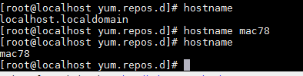

Update /etc/hosts file of all four nodes, file should be same across cluster

|  |
| --- |
| 127.0.0.1 localhost localhost.localdomain localhost4 localhost4.localdomain4  ::1 localhost localhost.localdomain localhost6 localhost6.localdomain6  172.27.155.78 mac78  172.27.155.55 mac55  172.27.155.53 mac53  172.27.155.122 mac122 |

***Note: please do not put any special character in hostname only alphabets, digits and hyphen allowed***

Also please set hostname permanently by issuing following command in all nodes

|  |
| --- |
| ***#*** hostnamectl set-hostname <Your-New-Host-Name-Here> |

### Disable Firewall (IPTables)

Disable firewall by issuing command below

|  |
| --- |
| [root@mac122 cloudera-scm-server]# systemctl disable firewalld  Removed symlink /etc/systemd/system/dbus-org.fedoraproject.FirewallD1.service.  Removed symlink /etc/systemd/system/basic.target.wants/firewalld.service.  [root@mac122 cloudera-scm-server]# systemctl stop firewalld  [root@mac122 cloudera-scm-server]# |

For Redhat 6 version please use below commands

|  |
| --- |
| # service iptables stop # chkconfig iptables off  # service ip6tables stop # chkconfig ip6tables off |

### Enabling NTP

CDH requires that you configure the Network Time Protocol (NTP) service on each machine in your cluster. To start NTP and configure it to run automatically on reboot, perform the following steps on each node in your cluster.

1. Install NTP if it is not installed already

|  |
| --- |
| # yum -y install ntp |

2. Open the /etc/ntp.conf file and copy one of the server name that we use later

|  |
| --- |
| # For more information about this file, see the man pages  # ntp.conf(5), ntp_acc(5), ntp_auth(5), ntp_clock(5), ntp_misc(5), ntp_mon(5).  driftfile /var/lib/ntp/drift  # Permit time synchronization with our time source, but do not  # permit the source to query or modify the service on this system.  restrict default nomodify notrap nopeer noquery  # Permit all access over the loopback interface. This could  # be tightened as well, but to do so would effect some of  # the administrative functions.  restrict 127.0.0.1  restrict ::1  # Hosts on local network are less restricted.  #restrict 192.168.1.0 mask 255.255.255.0 nomodify notrap  # Use public servers from the pool.ntp.org project.  # Please consider joining the pool (http://www.pool.ntp.org/join.html).  server 0.centos.pool.ntp.org iburst  server 1.centos.pool.ntp.org iburst  server 2.centos.pool.ntp.org iburst  server 3.centos.pool.ntp.org iburst  #broadcast 192.168.1.255 autokey # broadcast server  #broadcastclient # broadcast client  #broadcast 224.0.1.1 autokey # multicast server  #multicastclient 224.0.1.1 # multicast client  #manycastserver 239.255.254.254 # manycast server  #manycastclient 239.255.254.254 autokey # manycast client  # Enable public key cryptography.  #crypto  includefile /etc/ntp/crypto/pw  # Key file containing the keys and key identifiers used when operating  # with symmetric key cryptography.  keys /etc/ntp/keys  # Specify the key identifiers which are trusted.  #trustedkey 4 8 42  # Specify the key identifier to use with the ntpdc utility.  #requestkey 8  # Specify the key identifier to use with the ntpq utility.  #controlkey 8  # Enable writing of statistics records.  #statistics clockstats cryptostats loopstats peerstats  # Disable the monitoring facility to prevent amplification attacks using ntpdc  # monlist command when default restrict does not include the noquery flag. See  # CVE-2013-5211 for more details.  # Note: Monitoring will not be disabled with the limited restriction flag. |

3. Configure the NTP service to run at reboot.

|  |
| --- |
| chkconfig ntpd on |

4. Start and enable the NTP service

|  |
| --- |
| #systemctl start ntpd  #systemctl enable ntpd |

5. Synchronize the node

|  |
| --- |
| #ntpdate -u <your_ntp_server> |

In our case

ntpdate -u 0.centos.pool.ntp.org

6. Synchronize the system clock (to prevent synchronization problems).

|  |
| --- |
| #hwclock --systohc |

7. Check ntpstat

|  |
| --- |
| [root@mac122 ~]# ntpstat  synchronised to NTP server (123.108.200.124) at stratum 4  time correct to within 8130 ms  polling server every 64 s |

8. Check list of server

|  |
| --- |
| [root@mac122 ~]# ntpq -pn  remote refid st t when poll reach delay offset jitter  ==============================================================================  139.59.45.40 .INIT. 16 u - 64 0 0.000 0.000 0.000  *123.108.200.124 195.219.205.9 3 u 38 64 17 33.051 24.723 41.028  139.59.19.184 .INIT. 16 u - 64 0 0.000 0.000 0.000  139.59.61.225 .INIT. 16 u - 64 0 0.000 0.000 0.000 |

Here server with * is configured server

### Set umask to 022

By default umask value is 022 so that every file will be created with 755 permission

If it is not configured to 022 please update it accordingly

|  |
| --- |
| [root@mac92 ~]# umask  0022  [root@mac92 ~]# umask 022  [root@mac92 ~]# umask  0022 |

### SSH Password less sudo Access

In case if you do not want to setup with root user, we need to create ssh password less sudo access.

Please skip this step if you are planning to install with root user

Please follow below steps to configure ssh password less sudo access

1. First we need to create a new user on each node (username should be same)

|  |
| --- |
| [root@mac248 ~]# useradd cloudera-user  [root@mac248 ~]# passwd cloudera-user  Changing password for user cloudera-user.  New password:  BAD PASSWORD: The password fails the dictionary check - it is based on a dictionary word  Retype new password:  passwd: all authentication tokens updated successfully. |

Repeat this step to all nodes

2. Run visudo command to add new user to sudoers list

|  |
| --- |
| Defaults requiretty  Defaults:cloudera-user !requiretty  #  # Refuse to run if unable to disable echo on the tty. This setting should also be  # changed in order to be able to use sudo without a tty. See requiretty above.  #  ..  ..  ..  ..  ## Next comes the main part: which users can run what software on  ## which machines (the sudoers file can be shared between multiple  ## systems).  ## Syntax:  ##  ## user MACHINE=COMMANDS  ##  ## The COMMANDS section may have other options added to it.  ##  ## Allow root to run any commands anywhere  root ALL=(ALL) ALL  cloudera-user ALL=(ALL) NOPASSWD: ALL |

Add highlighted text at proper place in file and save it

Repeat this step to all nodes

3. Now create public and private key on one of the node , first we need to switch to Cloudera-user

|  |
| --- |
| [root@mac248 ~]# su - cloudera-user  [cloudera-user@mac248 ~]$ ssh-keygen -t rsa  Generating public/private rsa key pair.  Enter file in which to save the key (/home/cloudera-user/.ssh/id_rsa):  Created directory '/home/cloudera-user/.ssh'.  Enter passphrase (empty for no passphrase):  Enter same passphrase again:  Your identification has been saved in /home/cloudera-user/.ssh/id_rsa.  Your public key has been saved in /home/cloudera-user/.ssh/id_rsa.pub.  The key fingerprint is:  66:9a:b5:ab:a9:b6:06:50:cc:9d:6f:48:fe:0b:66:f1 cloudera-user@mac248  The key's randomart image is:  +--[ RSA 2048]----+  | o . . |  | + + |  | . o o |  |. + o |  | . = S |  | . + E* . |  | + .o.. |  | o .. . |  | oooo.. |  +-----------------+ |

4. Check if files are created successfully under .ssh folder

|  |
| --- |
| [cloudera-user@mac248 ~]$ ls -la  total 24  drwx------ 3 cloudera-user cloudera-user 4096 Apr 21 20:52 .  drwxr-xr-x. 6 root root 4096 Apr 21 20:44 ..  -rw-r--r-- 1 cloudera-user cloudera-user 18 Dec 7 04:49 .bash_logout  -rw-r--r-- 1 cloudera-user cloudera-user 193 Dec 7 04:49 .bash_profile  -rw-r--r-- 1 cloudera-user cloudera-user 231 Dec 7 04:49 .bashrc  drwx------ 2 cloudera-user cloudera-user 4096 Apr 21 20:52 .ssh  [cloudera-user@mac248 ~]$ cd .ssh  [cloudera-user@mac248 .ssh]$ ls -l  total 8  -rw------- 1 cloudera-user cloudera-user 1675 Apr 21 20:52 id_rsa  -rw-r--r-- 1 cloudera-user cloudera-user 402 Apr 21 20:52 id_rsa.pub |

5. Now create authorized_keys file on each of the node by issuing command below

|  |
| --- |
| [cloudera-user@mac248 .ssh]$ ssh-copy-id -i /home/cloudera-user/.ssh/id_rsa.pub cloudera-user@172.27.155.71  The authenticity of host '172.27.155.71 (172.27.155.71)' can't be established.  ECDSA key fingerprint is e8:61:2c:01:63:4e:0e:08:06:de:fb:be:be:57:82:7f.  Are you sure you want to continue connecting (yes/no)? yes  /bin/ssh-copy-id: INFO: attempting to log in with the new key(s), to filter out any that are already installed  /bin/ssh-copy-id: INFO: 1 key(s) remain to be installed -- if you are prompted now it is to install the new keys  cloudera-user@172.27.155.71's password:  Number of key(s) added: 1  Now try logging into the machine, with: "ssh 'cloudera-user@172.27.155.71'"  and check to make sure that only the key(s) you wanted were added. |

Same step we need to perform on each node including the node on which you created public and private key

|  |
| --- |
| [cloudera-user@mac248 .ssh]$ ssh-copy-id -i /home/cloudera-user/.ssh/id_rsa.pub cloudera-user@172.27.155.248  The authenticity of host '172.27.155.248 (172.27.155.248)' can't be established.  ECDSA key fingerprint is fd:c8:7e:95:da:8f:37:57:de:47:d8:d0:75:4b:80:e3.  Are you sure you want to continue connecting (yes/no)? yes  /bin/ssh-copy-id: INFO: attempting to log in with the new key(s), to filter out any that are already installed  /bin/ssh-copy-id: INFO: 1 key(s) remain to be installed -- if you are prompted now it is to install the new keys  cloudera-user@172.27.155.248's password:  Number of key(s) added: 1  Now try logging into the machine, with: "ssh 'cloudera-user@172.27.155.248'"  and check to make sure that only the key(s) you wanted were added. |

Here we are creating authorized_keys file on same node

6. Now run below command to ensure if SSH password less sudo access has been established

|  |
| --- |
| [cloudera-user@mac248 .ssh]$ ssh cloudera-user@172.27.155.71 sudo ls -l  total 0  [cloudera-user@mac248 .ssh]$ |

If command runs without asking password it means it is working fine ( run this command for all nodes)

7. Just to verify, check on each node if authorized_keys file is created under .ssh folder

|  |
| --- |
| [root@mohammadkhan-w8 .ssh]# su -cloudera-user  bash: loudera-user: command not found  [root@mohammadkhan-w8 .ssh]# su - cloudera-user  [cloudera-user@mac71 ~]$ cd .ssh  [cloudera-user@mac71 .ssh]$ ls -l  total 4  -rw------- 1 cloudera-user cloudera-user 402 Apr 21 15:29 authorized_keys |

### Set swappiness to 10

Check swappiness value

|  |
| --- |
| [root@mac122 log]# sysctl vm.swappiness  vm.swappiness = 60 |

OR

|  |
| --- |
| [root@mac53 etc]# cat /proc/sys/vm/swappiness  60 |

It means it’s going to start swapping out when 40% of physical memory is used

You can change swappiness value by editing /etc/sysctl.conf file

Add line add the end of file vm.swappiness = <value> like vm.swappiness = 10

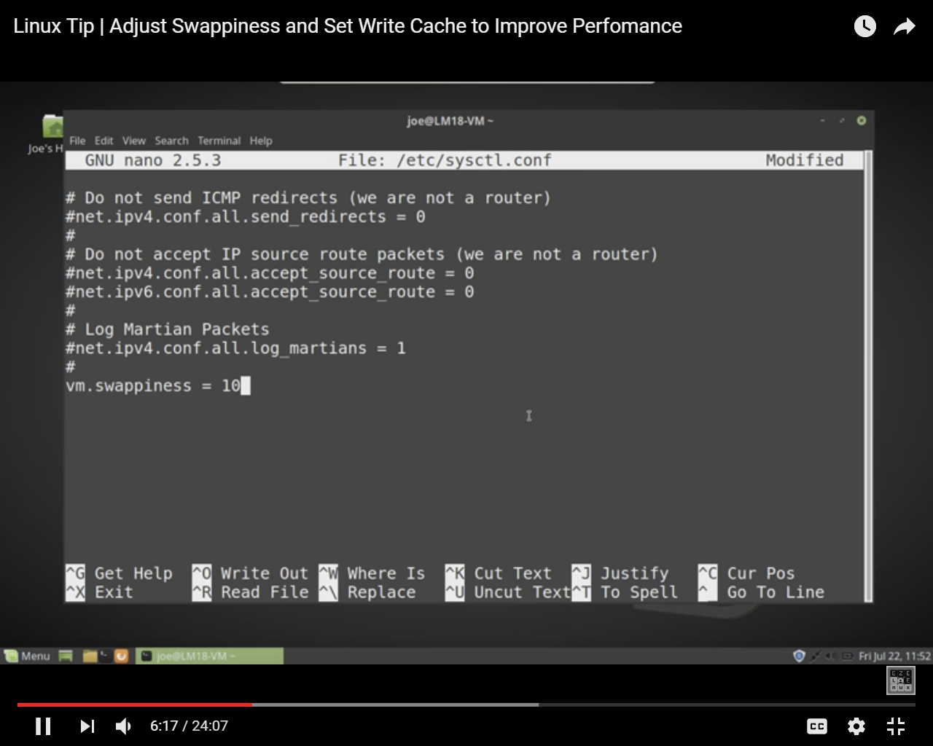

Cloudera recommended assigning 10 to swappiness

Reboot system

### Disabling SELinux

First you need to disable SELinux before installing Cloudera manager

Security-Enhanced Linux (SELinux) allows you to set access control through policies. You must disable SELinux on each host before you deploy CDH on your cluster.

To disable SELinux, perform the following steps on each host.

1. Check the SELinux state.

getenforce

If the output is disabled, you can skip this task, if the output is enforcing, continue to the next step.

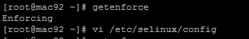

Or you can check sestatus command

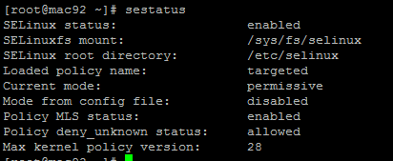

1. Open the /etc/selinux/config file (in some systems, the /etc/sysconfig/selinux file).

Change the line SELINUX=enforcing to SELINUX=disabled.

1. Save and close the file.
2. Reboot machine by reboot command

After reboot, you can verify the status of SELinux. Issue “sestatus” command to verify that SELinux permanently disabled:

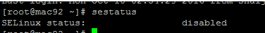

Or you can check by getenforce command

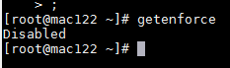

## Download and install

Now download Cloudera manager installer

|  |
| --- |
| wget http://archive.cloudera.com/cm5/installer/latest/cloudera-manager-installer.bin |

Give execute permission

|  |
| --- |
| chmod +x cloudera-manager-installer.bin |

Check if Cloudera-manager and Cloudera-cdh5.repo files are available under /etc/yum.repos.d folder, if not please download it as described below

|  |
| --- |
| cd /etc/yum.repos.d |
| Download repo file for Cloudera manager ( you can find different version for redhat in  [http://archive.cloudera.com/cm5/redhat/](http://archive.cloudera.com/cdh5/redhat/) here I am using redhat 7)  wget <http://archive.cloudera.com/cm5/redhat/7/x86_64/cm/cloudera-manager.repo> |
| Download repo file for Cloudera cdh ( you can find different version for redhat in <http://archive.cloudera.com/cdh5/redhat/> here I am using redhat 7)  wget <http://archive.cloudera.com/cdh5/redhat/7/x86_64/cdh/cloudera-cdh5.repo> |

If you have created local yum repository for Cloudera in any of the machine in same network, you should have those file pointing to local server in this case download these files from local machine

|  |
| --- |
| cd /etc/yum.repos.d |
| Download repo file for Cloudera manager from local repository  wget <http://172.27.155.122/cm5/redhat/7/x86_64/cm/cloudera-manager.repo> |
| Download repo file for Cloudera cdh from local repository  wget http://172.27.155.122/cdh5/redhat/7/x86_64/cdh/cloudera-cdh5.repo |

You can find below two files under yum.repo.d folder



Before install update the yum repository by issuing below command

|  |
| --- |
| yum -clean all;yum -y update |

Install Cloudera Manager Packages from a local repository

|  |
| --- |
| sudo ./cloudera-manager-installer.bin --skip_repo_package=1 |

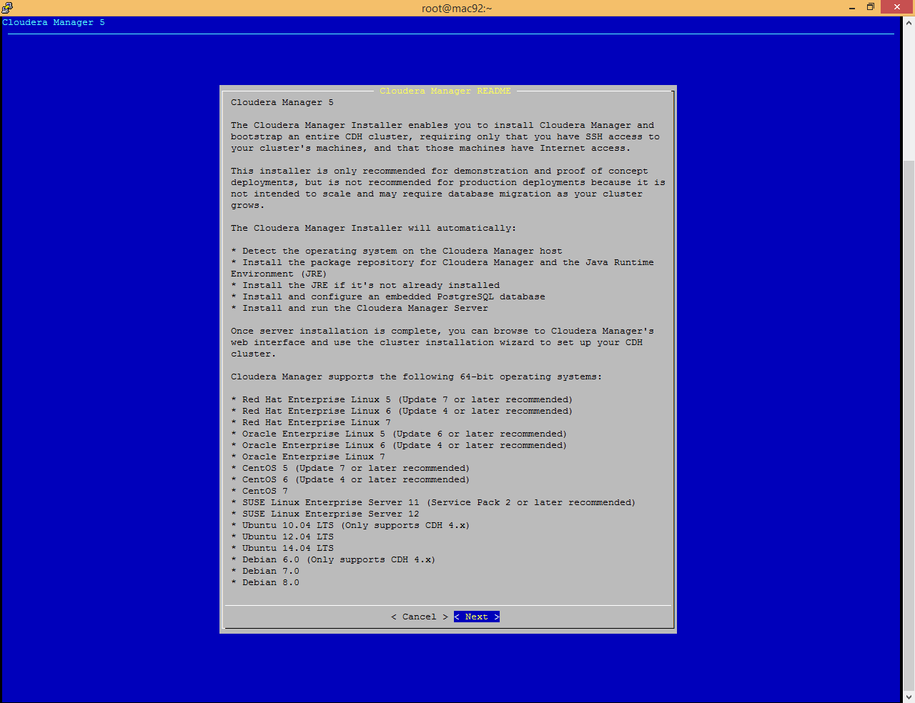

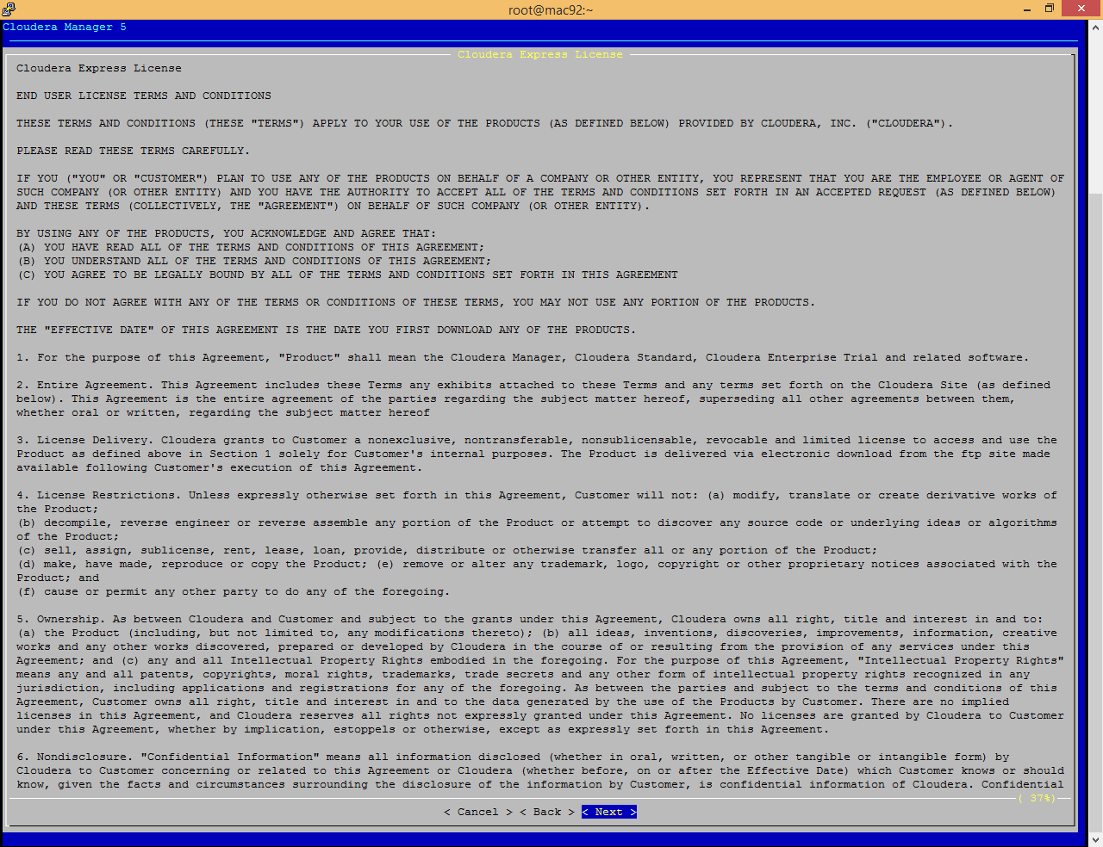

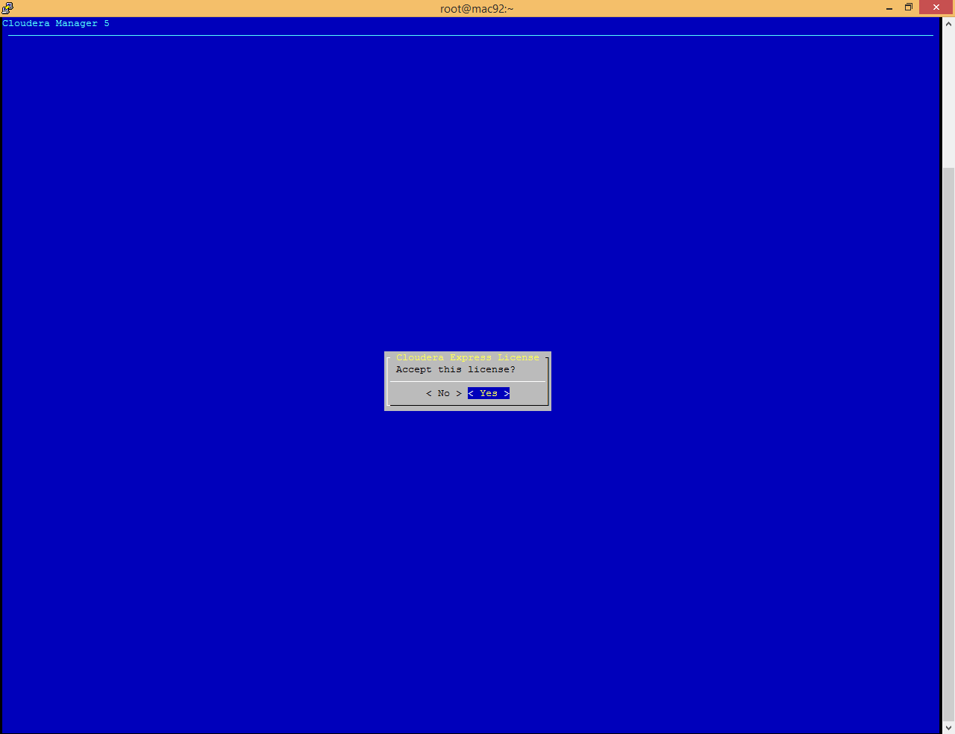

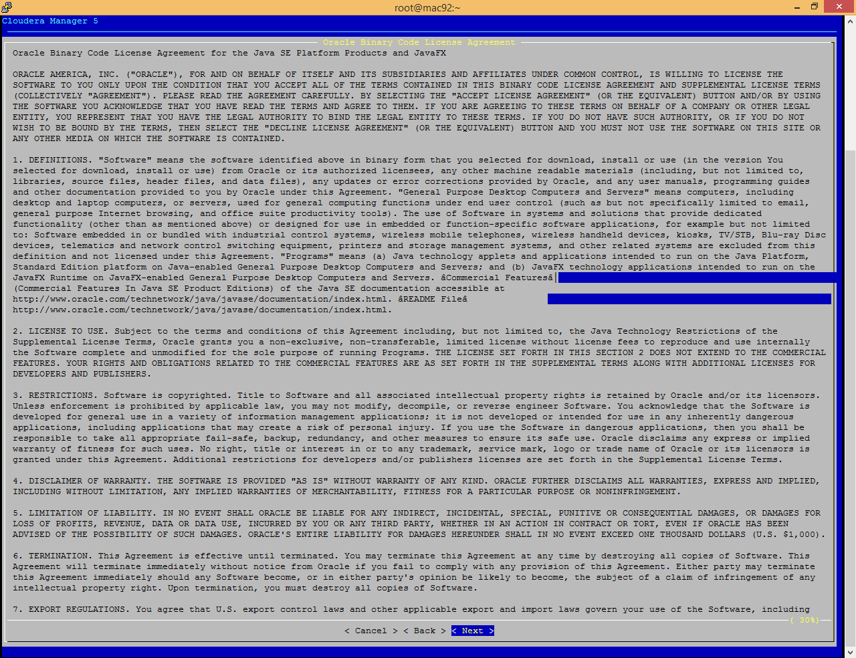

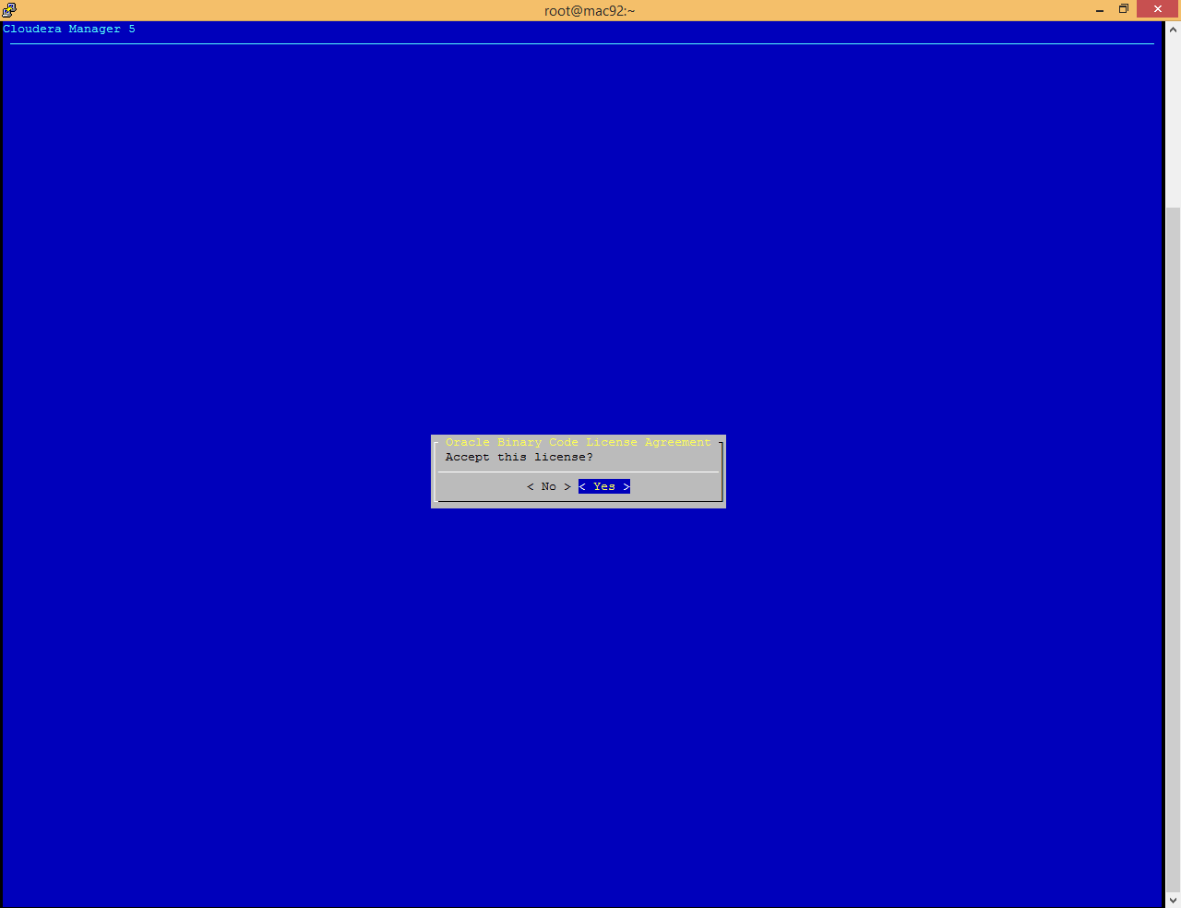

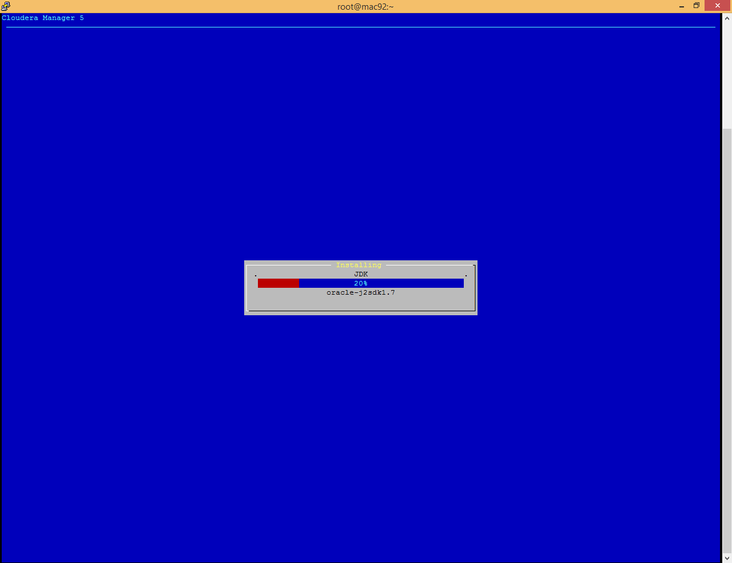

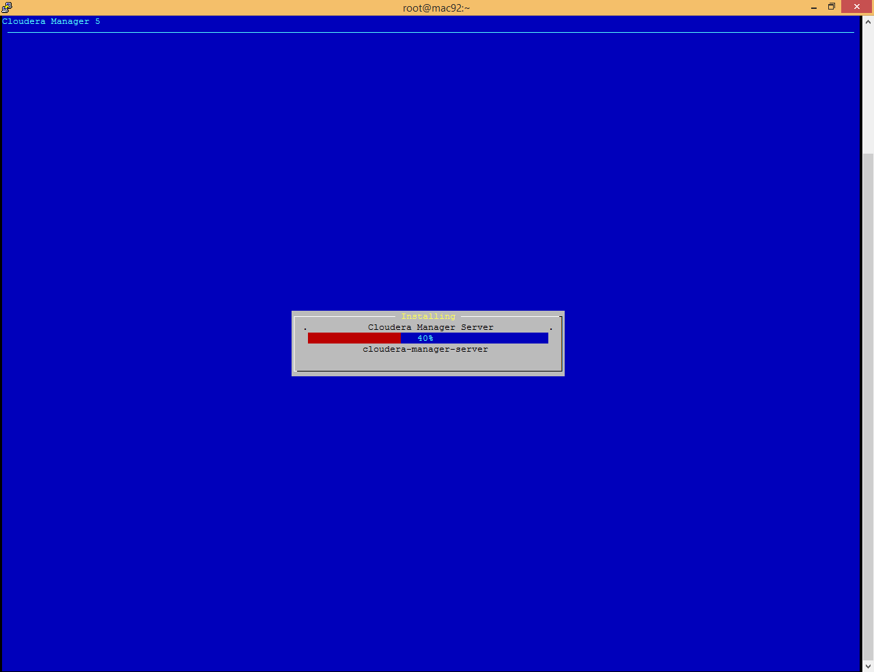

You can see the log information under **/var/log/cloudera-manager-installer**

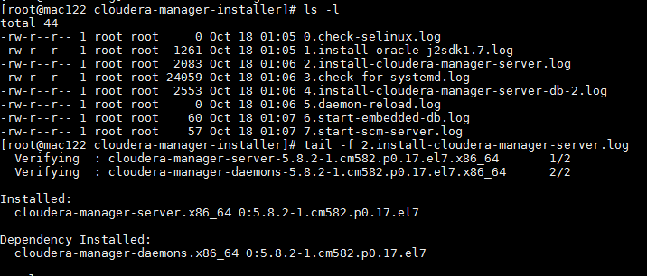

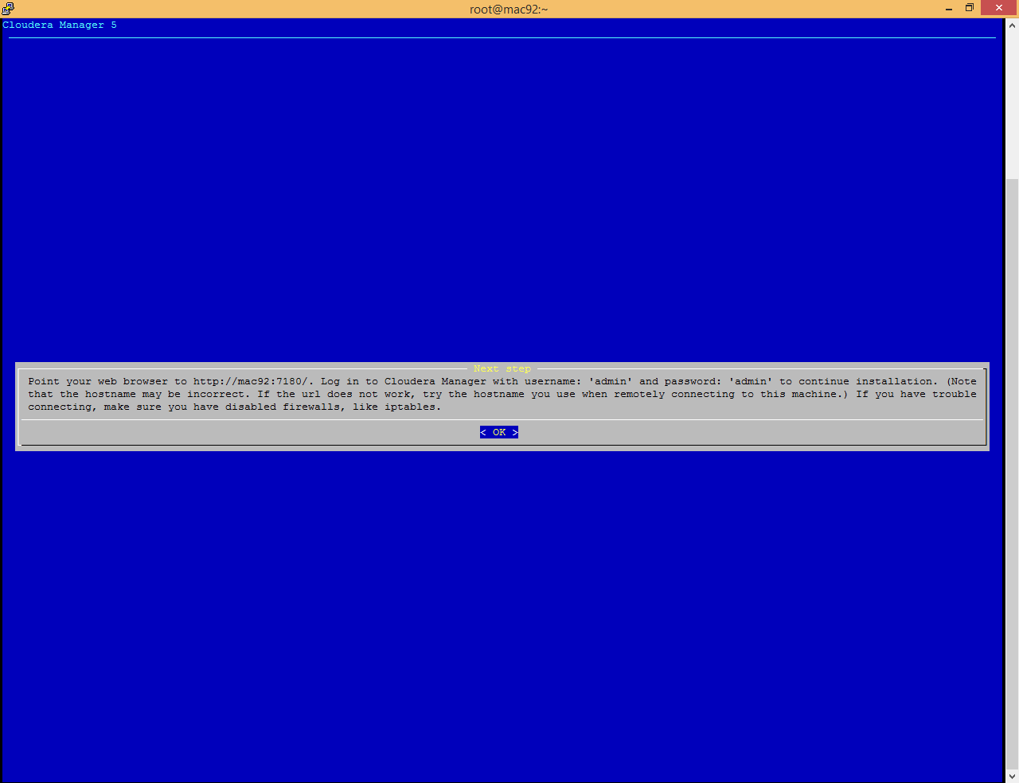

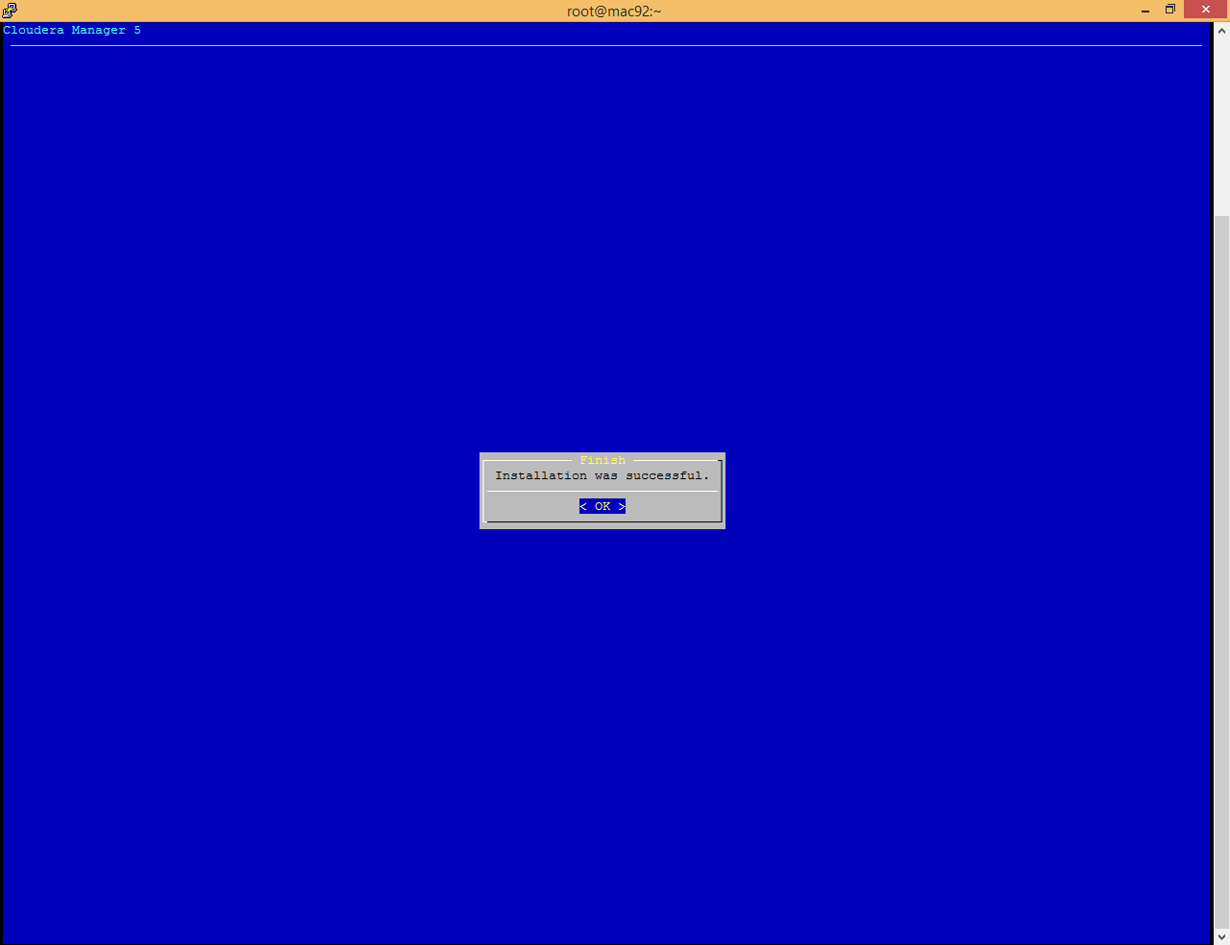

Now open <http://172.27.155.122:7180/>

If facing issue while opening this page please make sure that [firewall is disabled](#_Disable_Firewall_(IPTables))

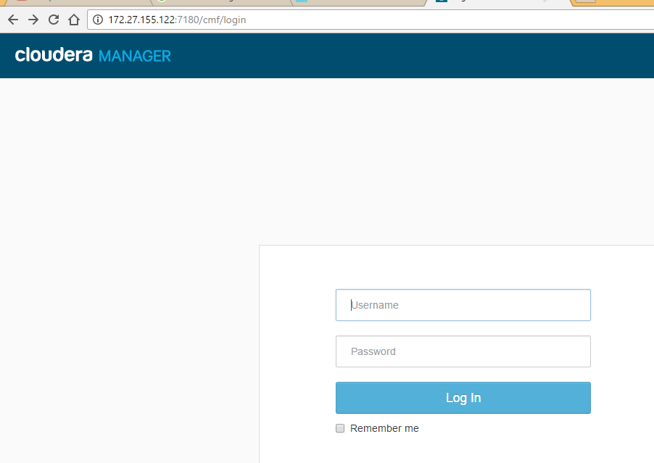

Login with admin/admin

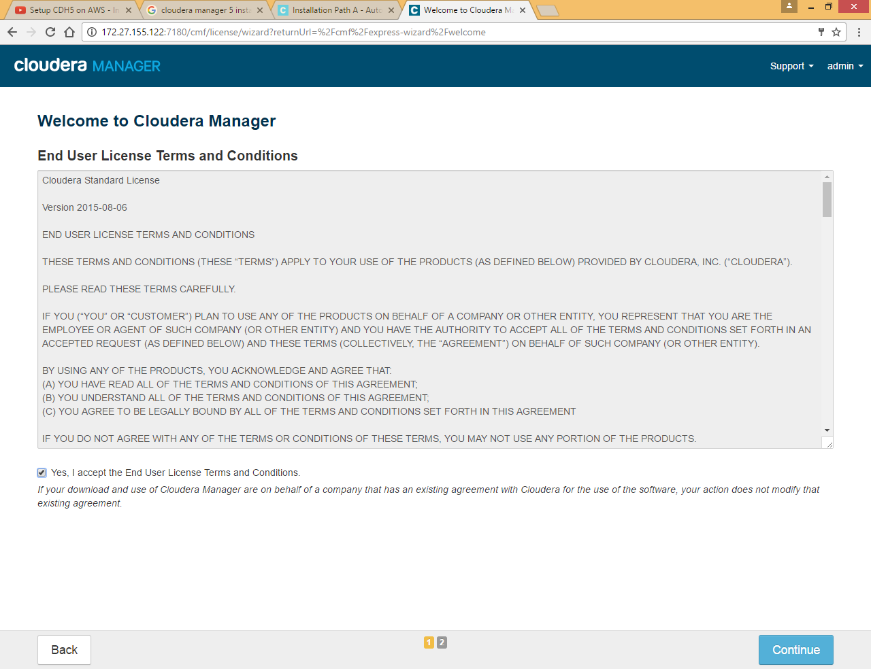

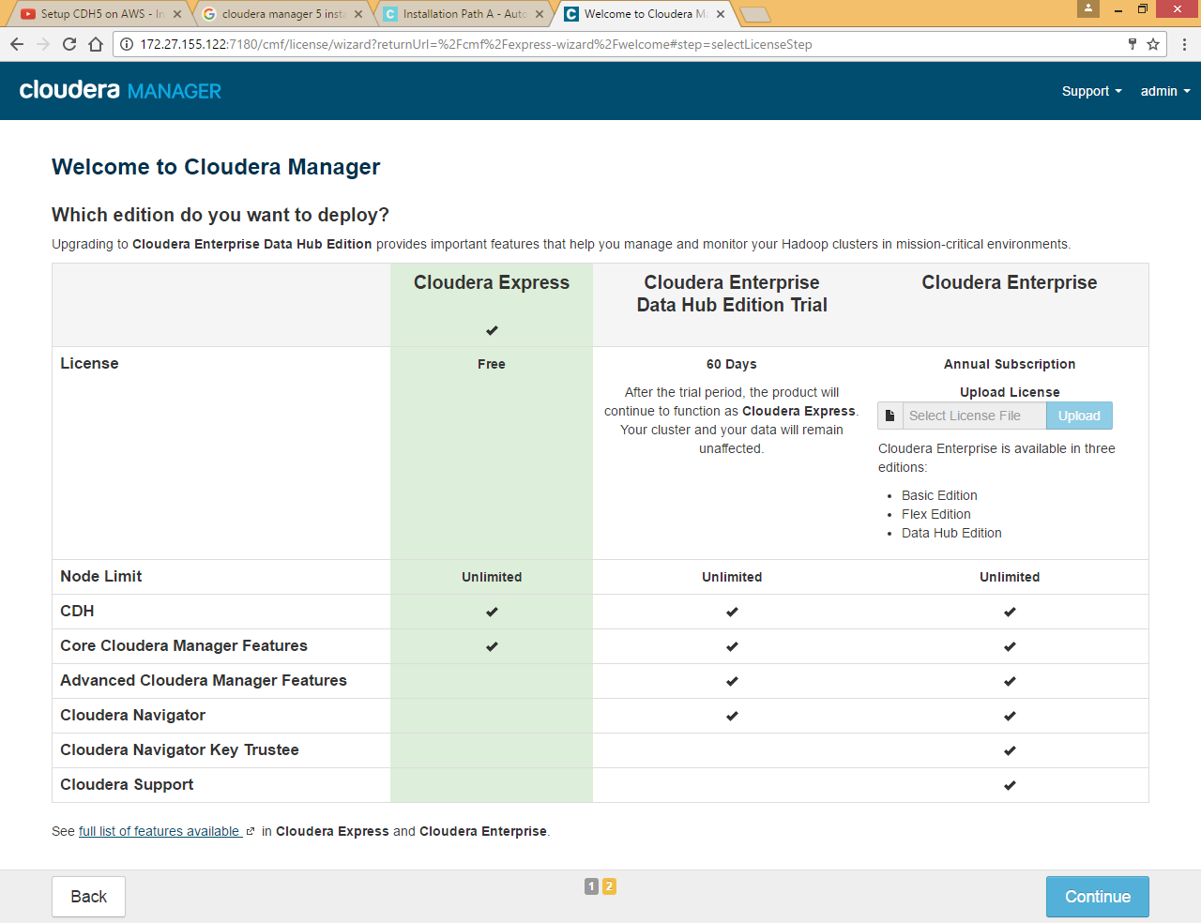

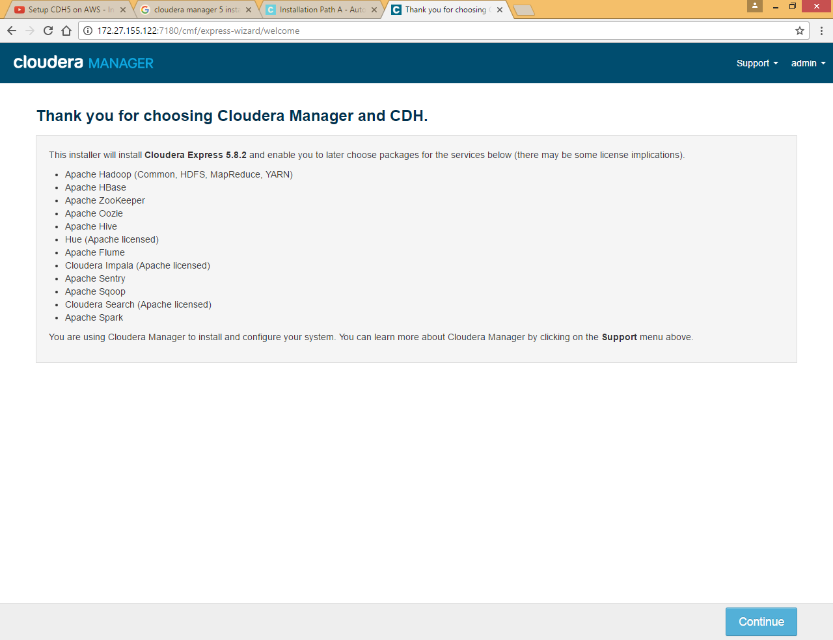

Here we are not providing all the nodes in one step we will go one node at a time, you can give all node IP separated by comma

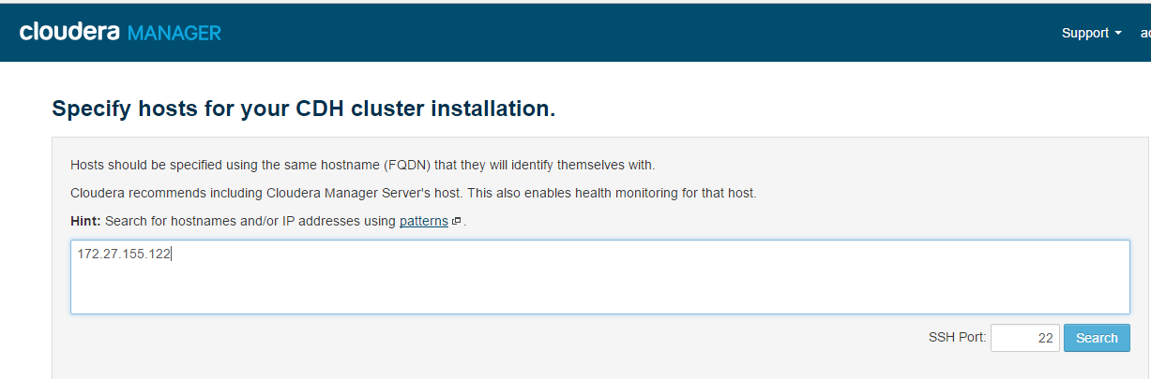

Click on Search

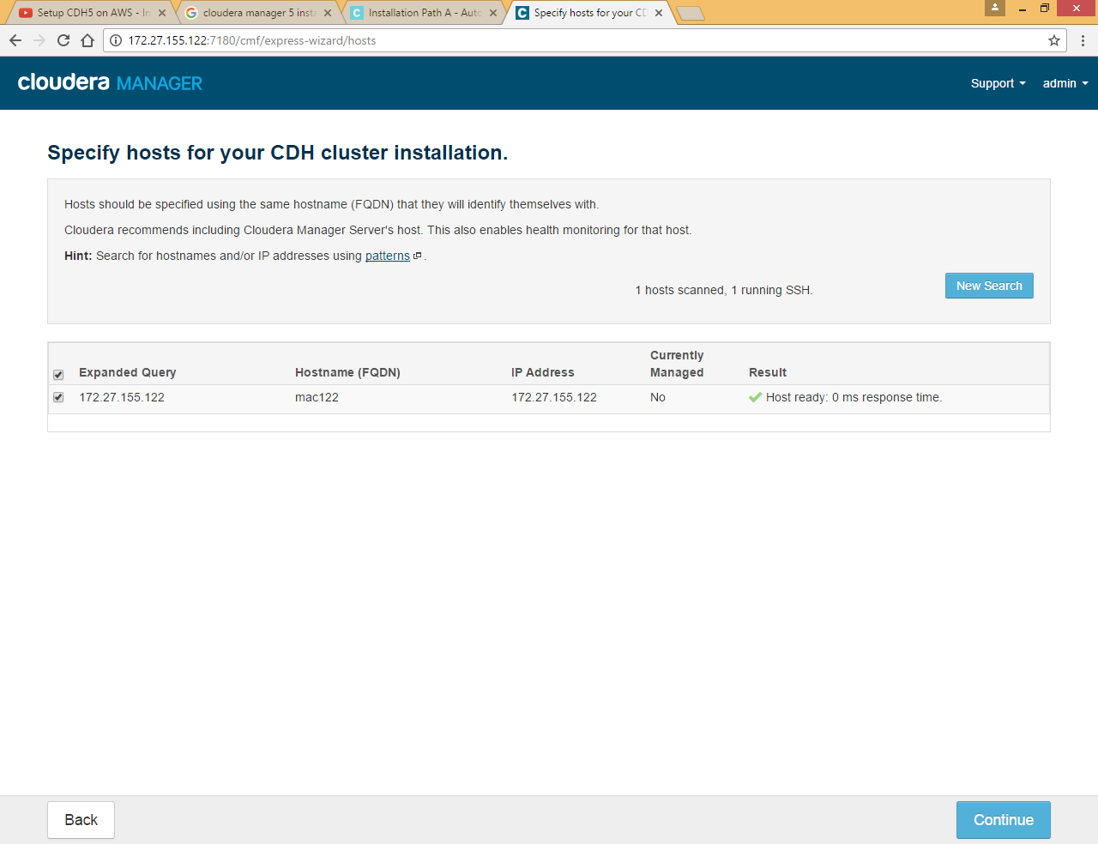

Choose Use Parcel option

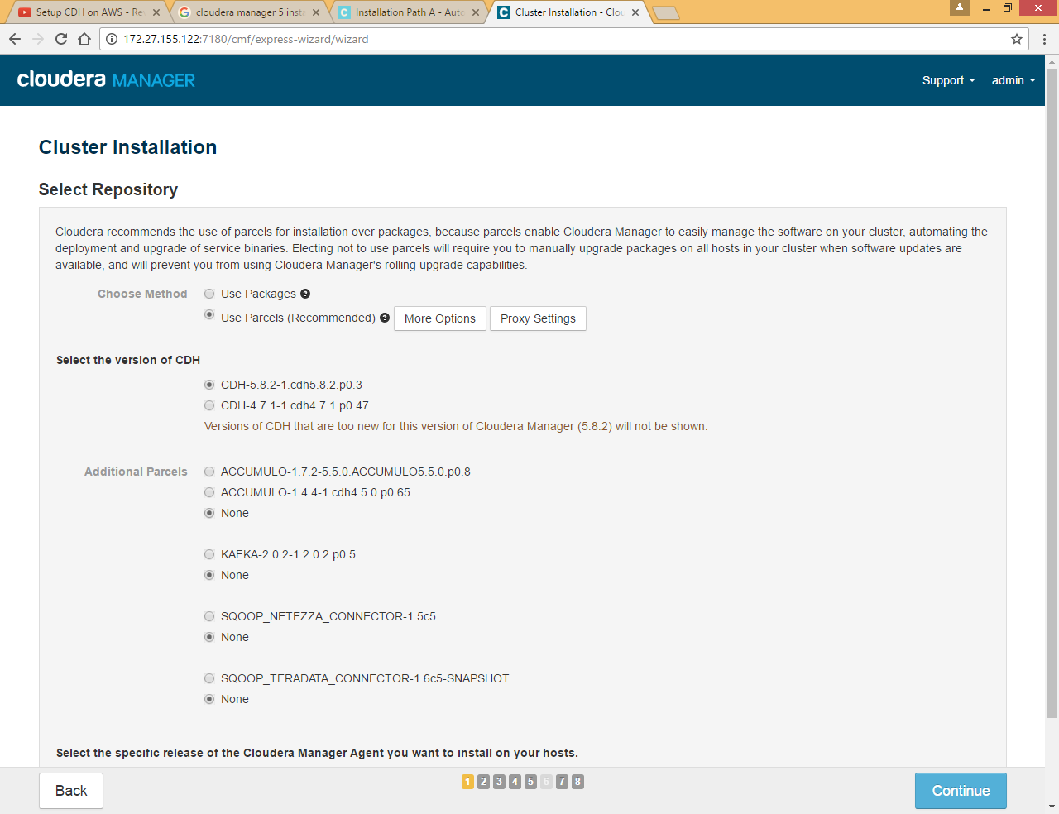

Here we need to choose custom repository to install it from local yum repository

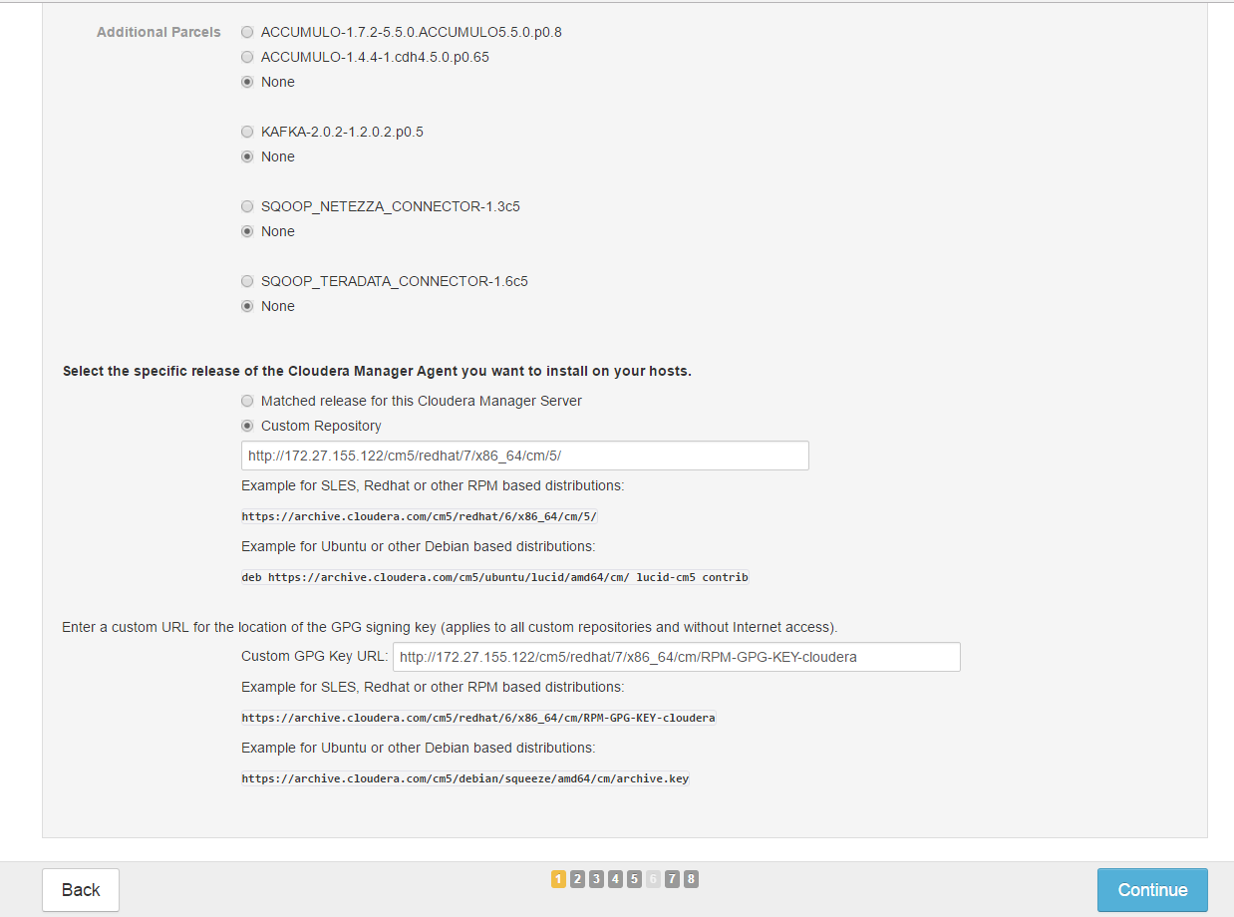

Enter <http://172.27.155.122/cm5/redhat/7/x86_64/cm/5/>for cm

And <http://172.27.155.122/cm5/redhat/7/x86_64/cm/RPM-GPG-KEY-cloudera> for GPS key

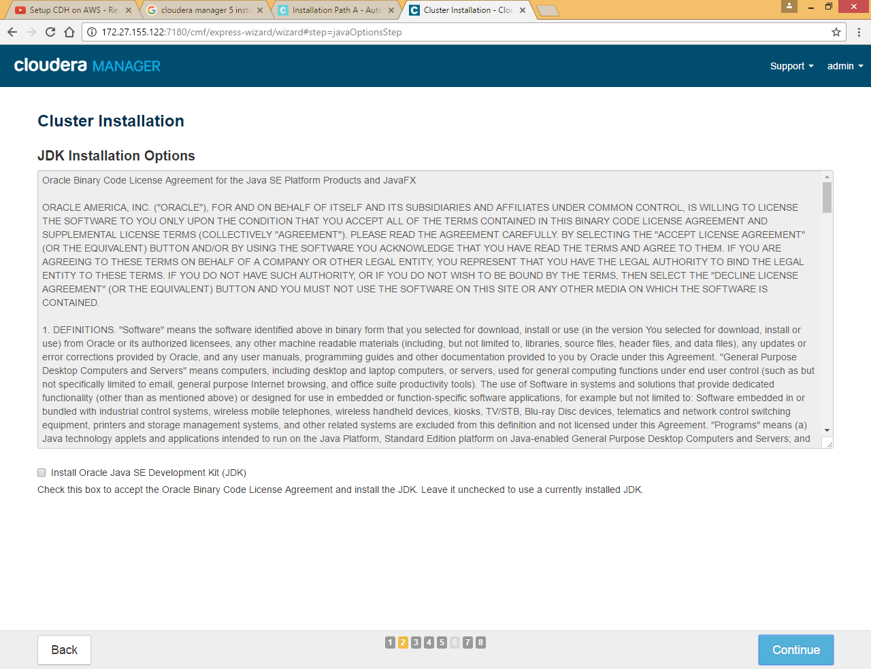

Leave JDK installation as we already have java installed

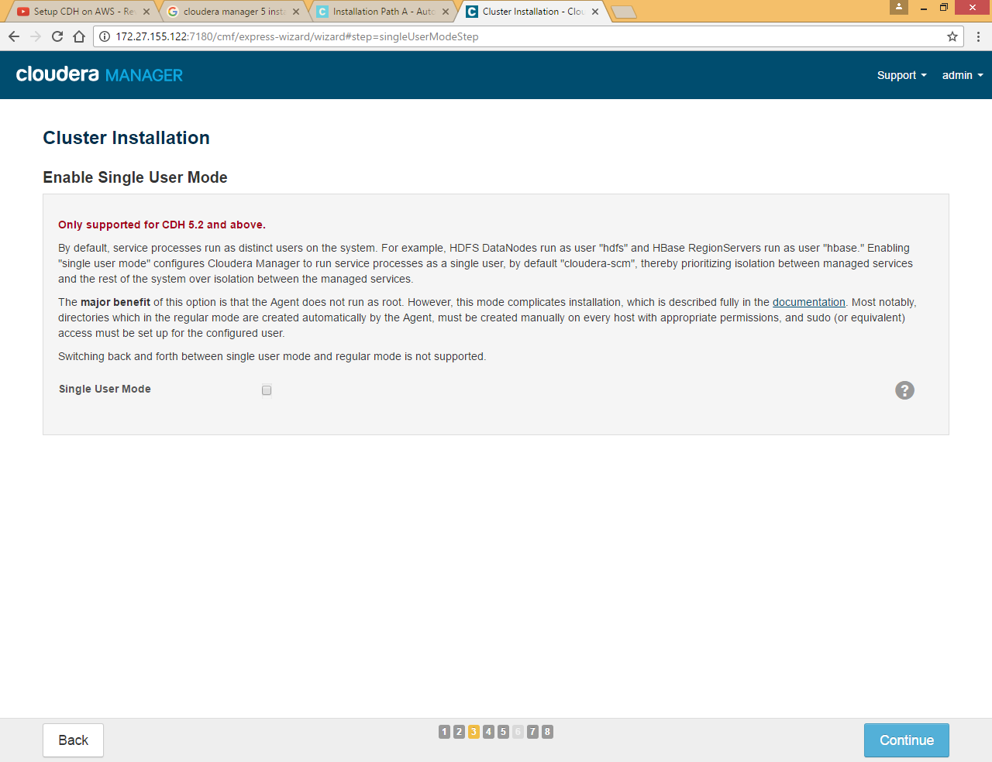

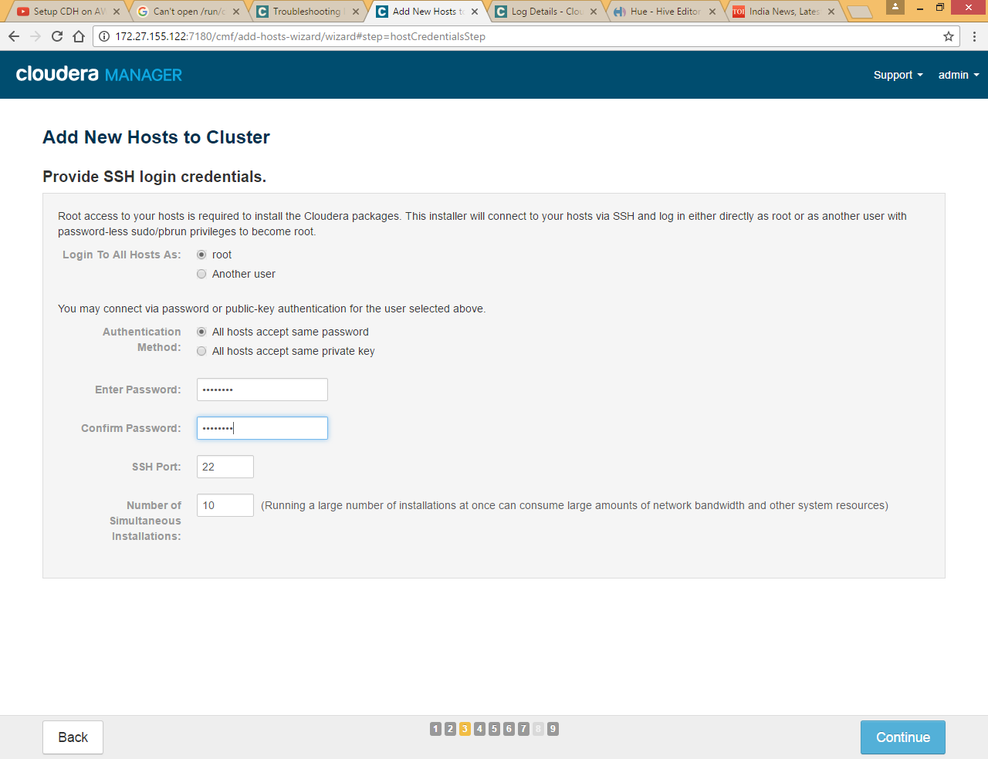

Provide machine password for root

If you established SSH password less sudo Access , choose id_rsa file as private key

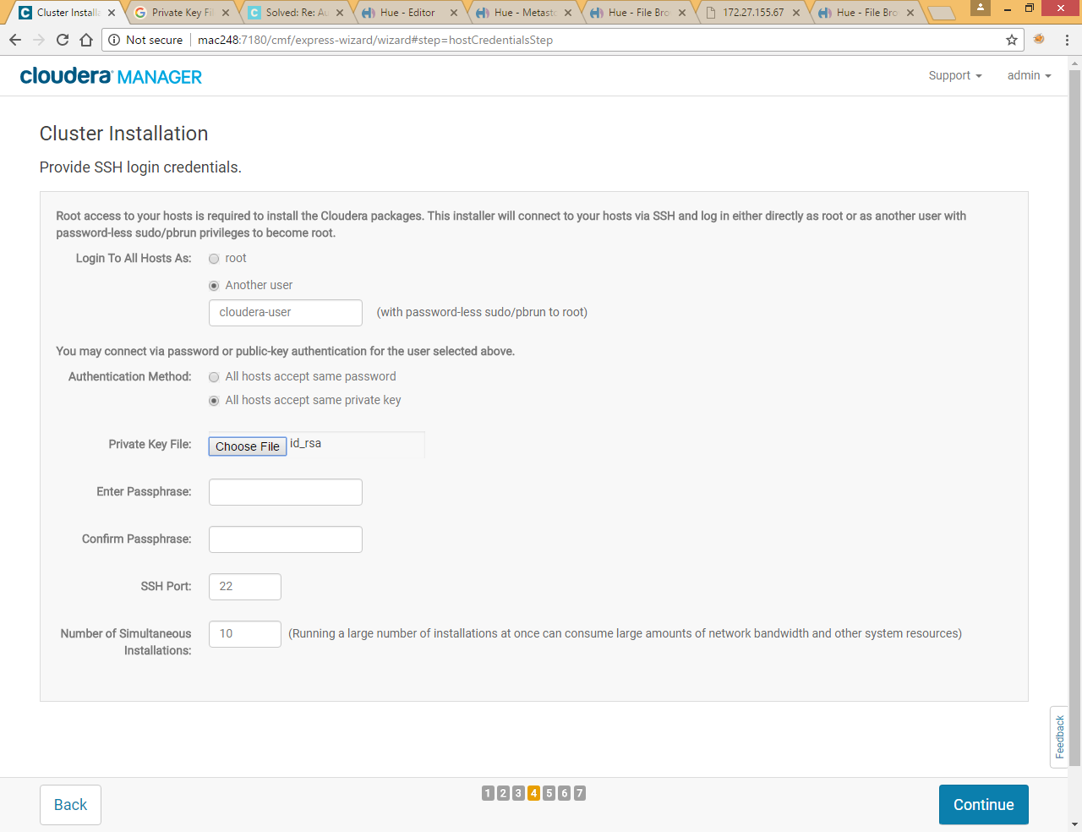

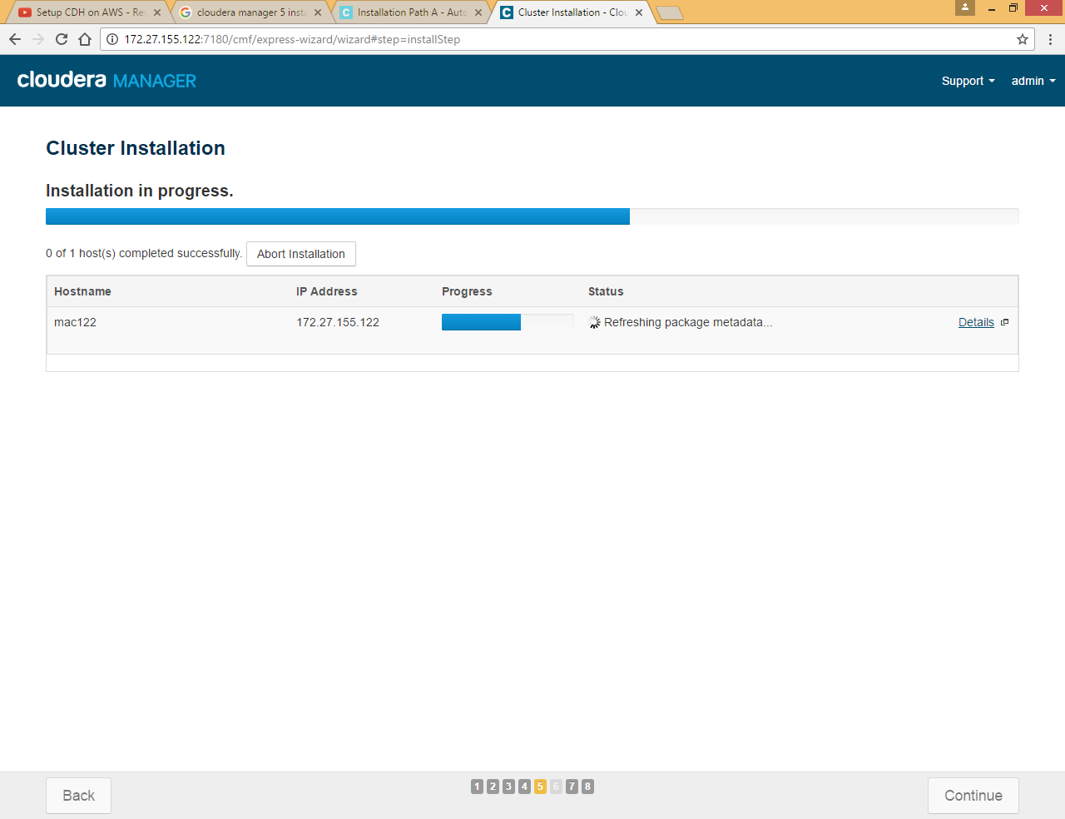

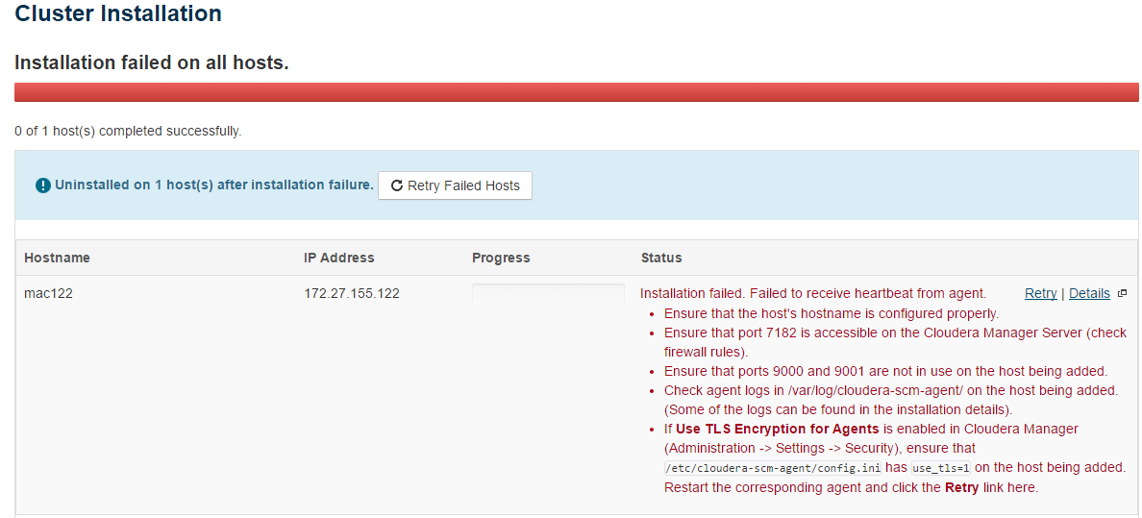

Check if 9000 and 9001 is in use or not

netstat -ln | grep ':9000 ' | grep 'LISTEN'



Command not returned anything it means ports are available

Check the log file under **/var/log/cloudera-scm-agent/**

|  |
| --- |
| ProtocolError: <ProtocolError for 127.0.0.1/RPC2: 401 Unauthorized>  [18/Oct/2016 05:53:10 +0000] 21072 MainThread agent INFO Trying to connect to newly launched supervisor (Attempt 5)  [18/Oct/2016 05:53:10 +0000] 21072 MainThread agent ERROR Failed! trying again in 1 second(s)  Traceback (most recent call last):  File "/usr/lib64/cmf/agent/build/env/lib/python2.7/site-packages/cmf-5.8.2-py2.7.egg/cmf/agent.py", line 2208, in connect_to_new_supervisor  self.get_supervisor_process_info()  File "/usr/lib64/cmf/agent/build/env/lib/python2.7/site-packages/cmf-5.8.2-py2.7.egg/cmf/agent.py", line 2230, in get_supervisor_process_info  self.identifier = self.supervisor_client.supervisor.getIdentification()  File "/usr/lib64/python2.7/xmlrpclib.py", line 1233, in __call__  return self.__send(self.__name, args)  File "/usr/lib64/python2.7/xmlrpclib.py", line 1587, in __request  verbose=self.__verbose  File "/usr/lib64/cmf/agent/build/env/lib/python2.7/site-packages/supervisor-3.0-py2.7.egg/supervisor/xmlrpc.py", line 470, in request |

Run command

ps -ef | grep supervisord

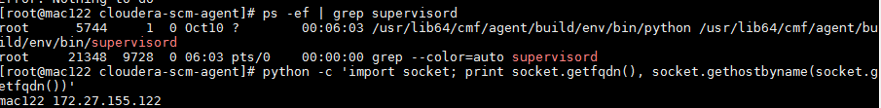

Now kill the first service

|  |
| --- |
| kill -9 5744 |



Again retry, this time it worked ☺

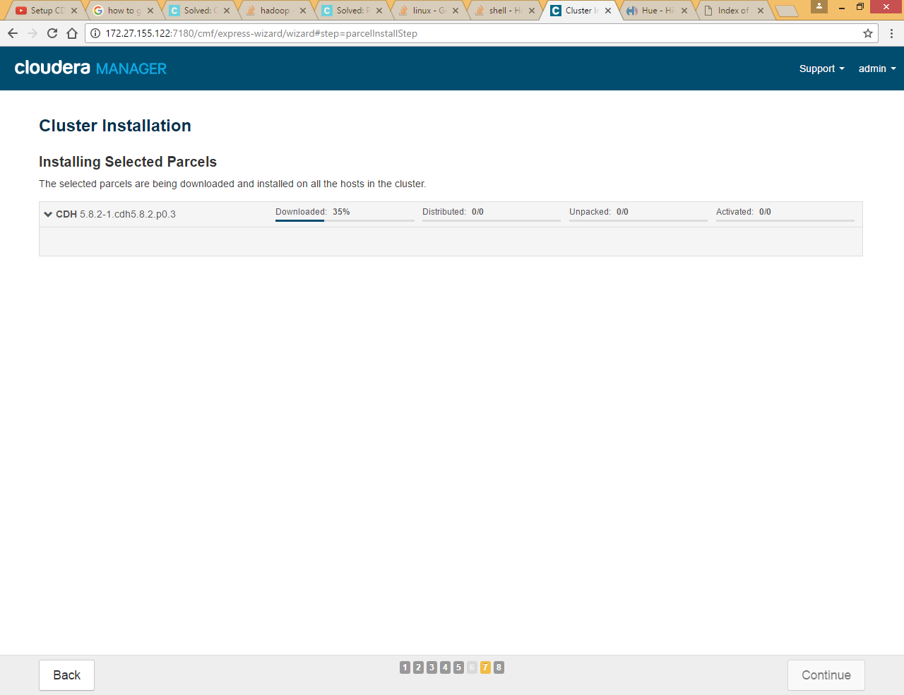

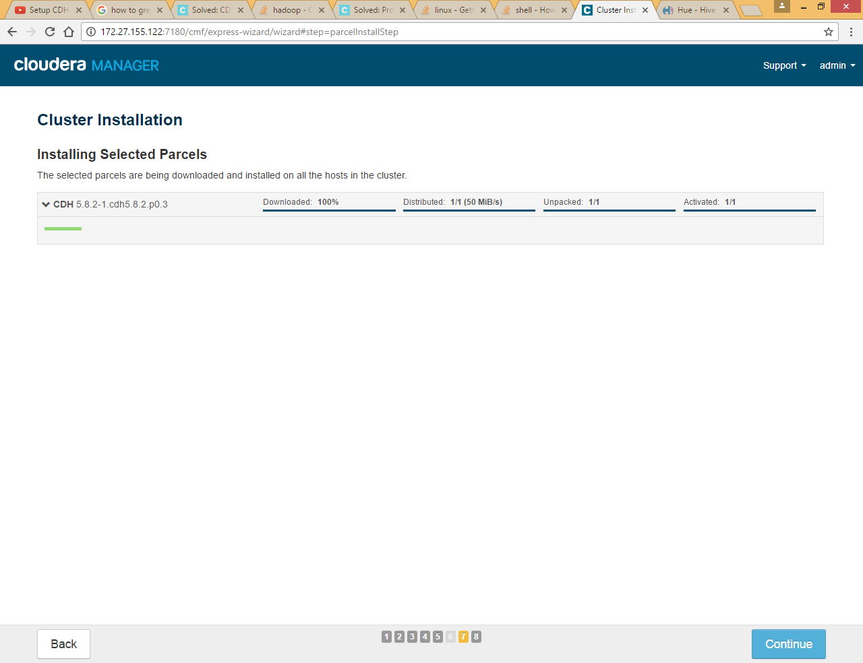

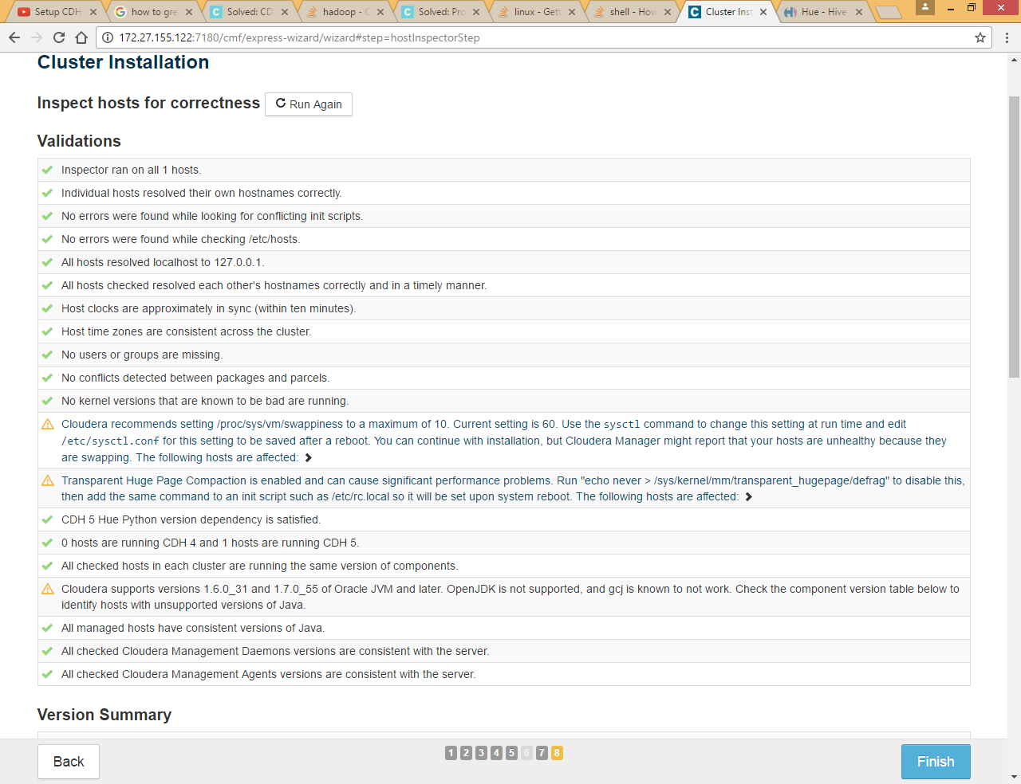

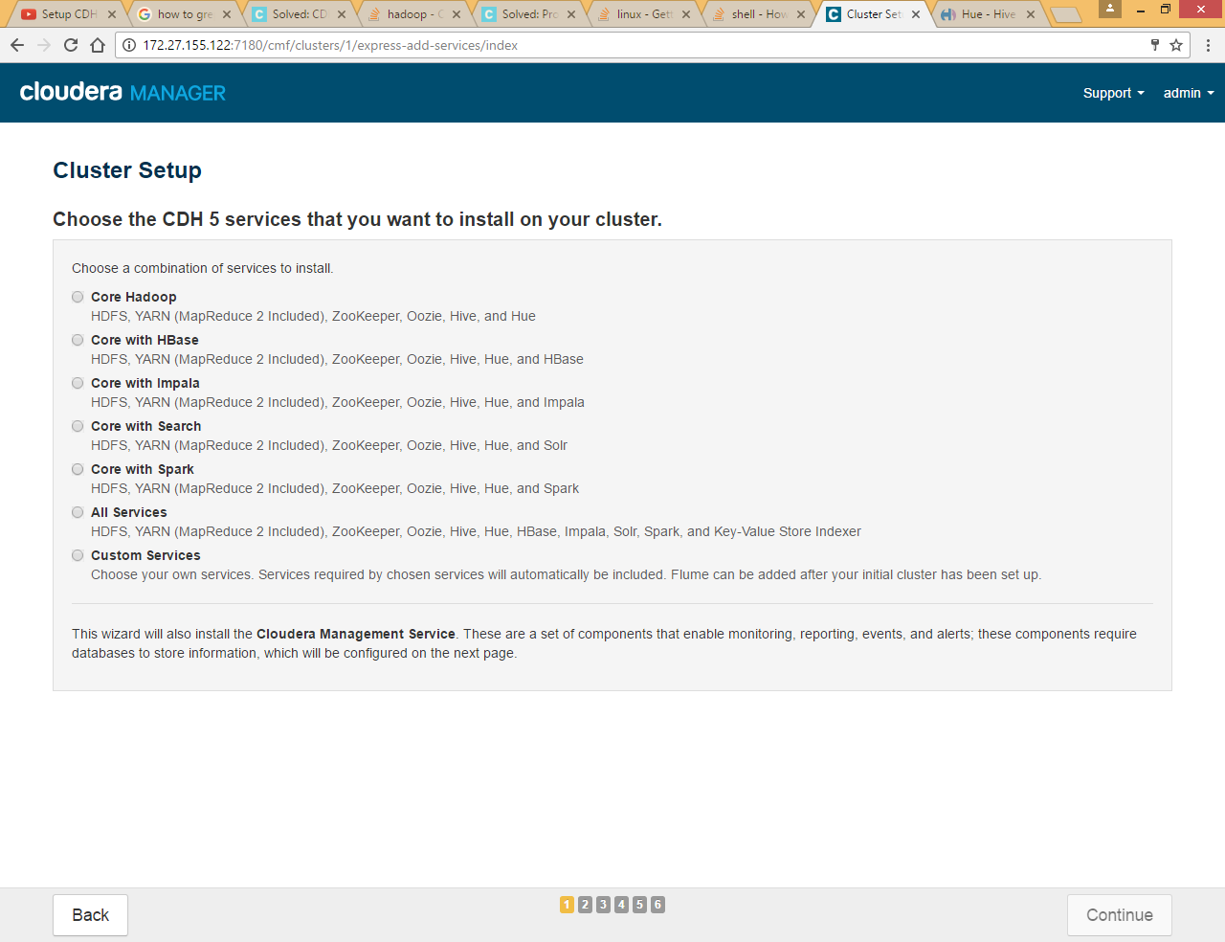

Select custom services and HDFS, we will add other services later

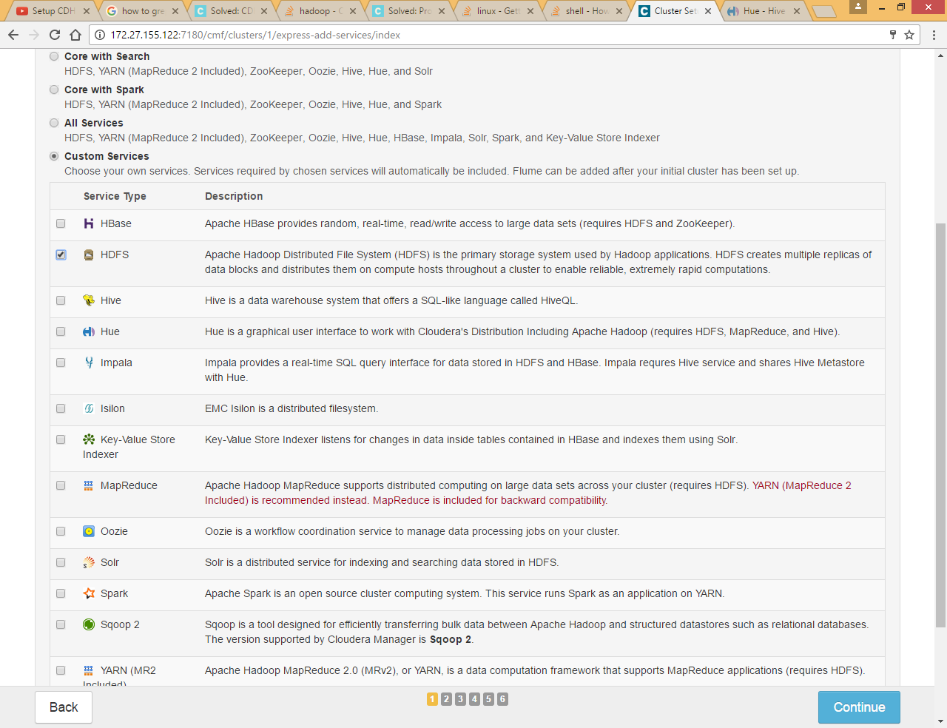

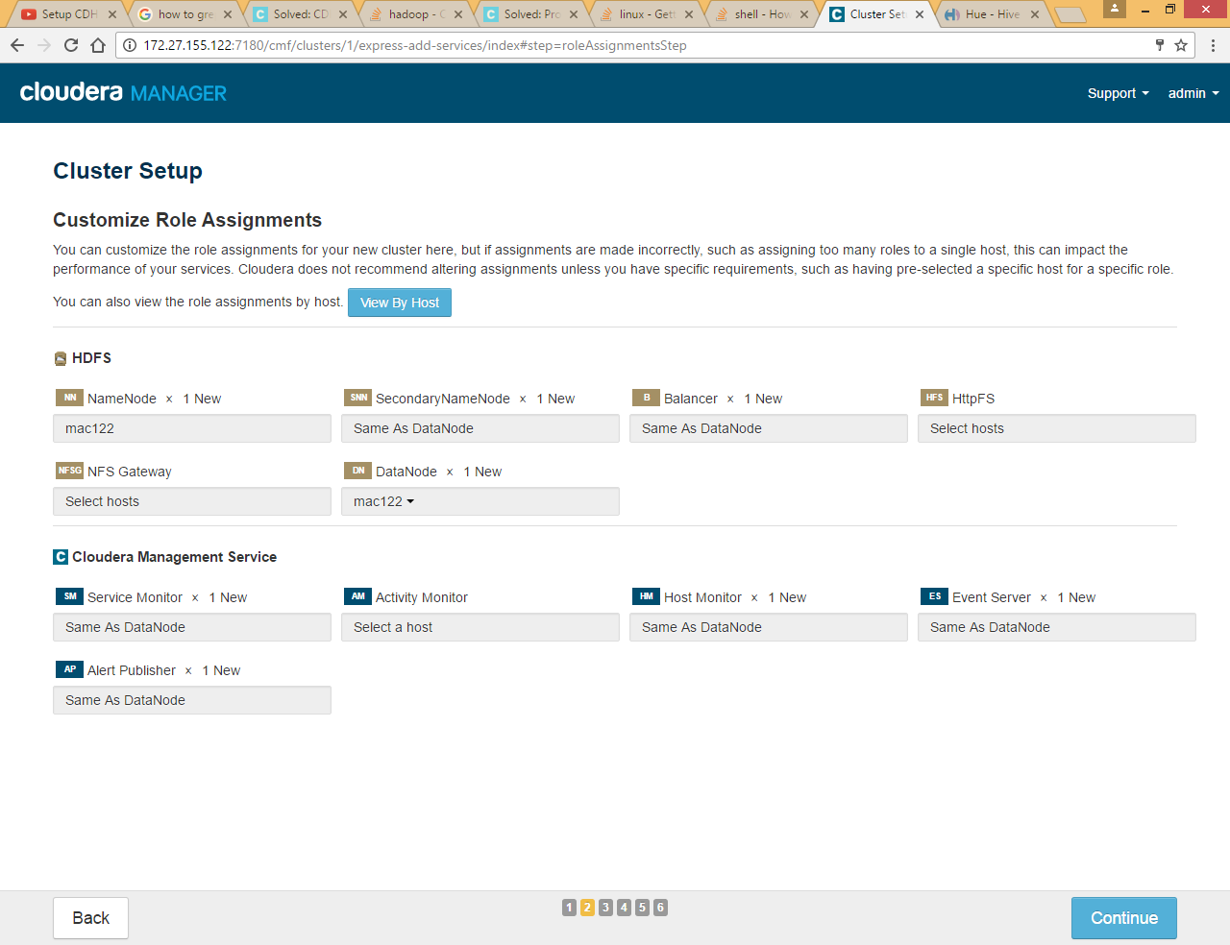

*Note: Instead of HDFS service we should install zookeeper first and later we should install HDFS so that we can choose different hosts for NameNode and Secondary Name Node so please choose zookeeper in place of HDFS service*

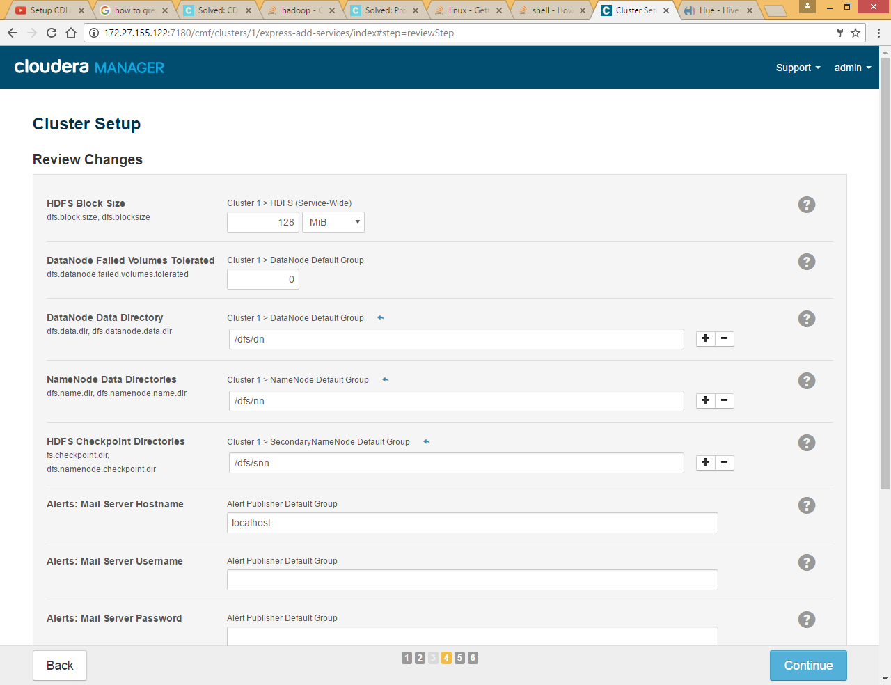

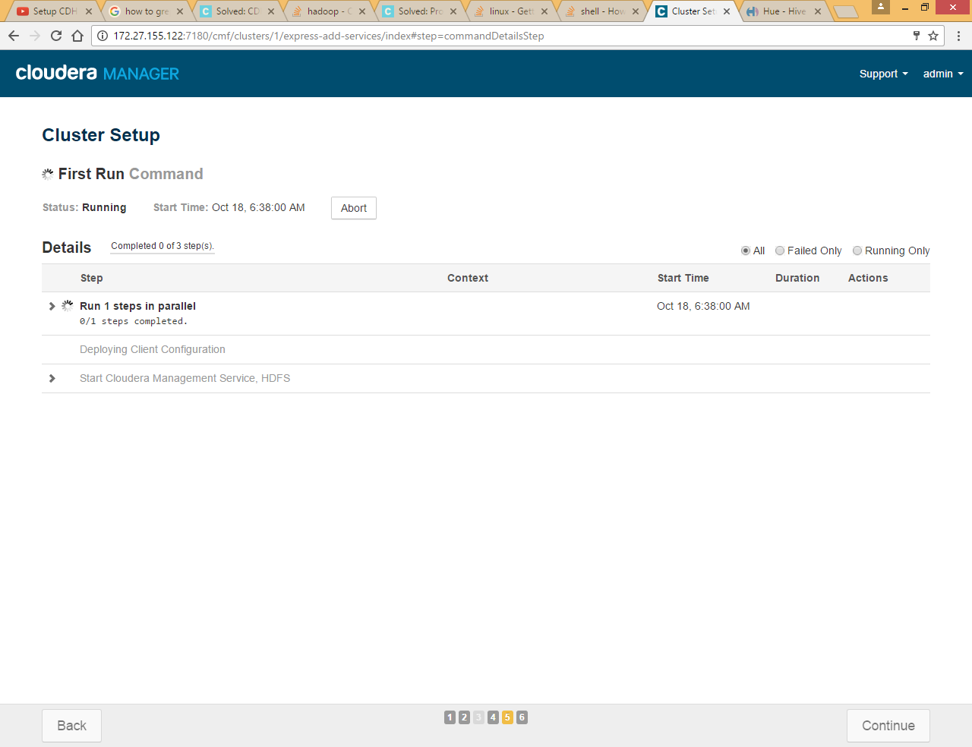

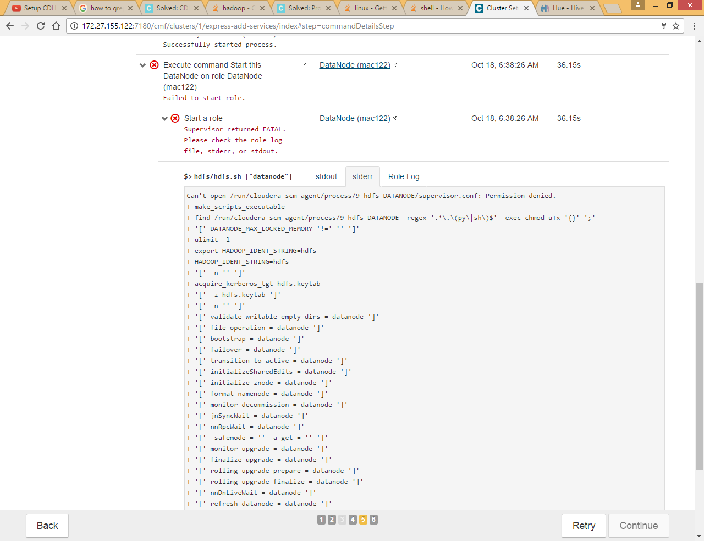

Chek Role Log tab

|  |
| --- |
| failed to add storage directory [DISK]file:/dfs/dn/  java.io.IOException: Incompatible clusterIDs in /dfs/dn: namenode clusterID = cluster4; datanode clusterID = cluster8  at org.apache.hadoop.hdfs.server.datanode.DataStorage.doTransition(DataStorage.java:779)  at org.apache.hadoop.hdfs.server.datanode.DataStorage.loadStorageDirectory(DataStorage.java:302)  at org.apache.hadoop.hdfs.server.datanode.DataStorage.loadDataStorage(DataStorage.java:418)  at org.apache.hadoop.hdfs.server.datanode.DataStorage.addStorageLocations(DataStorage.java:397) |

Go to dfs/dn and remove all files

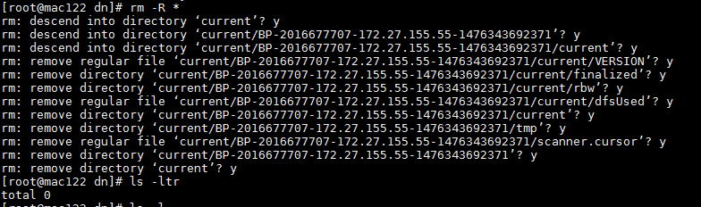

Retry again

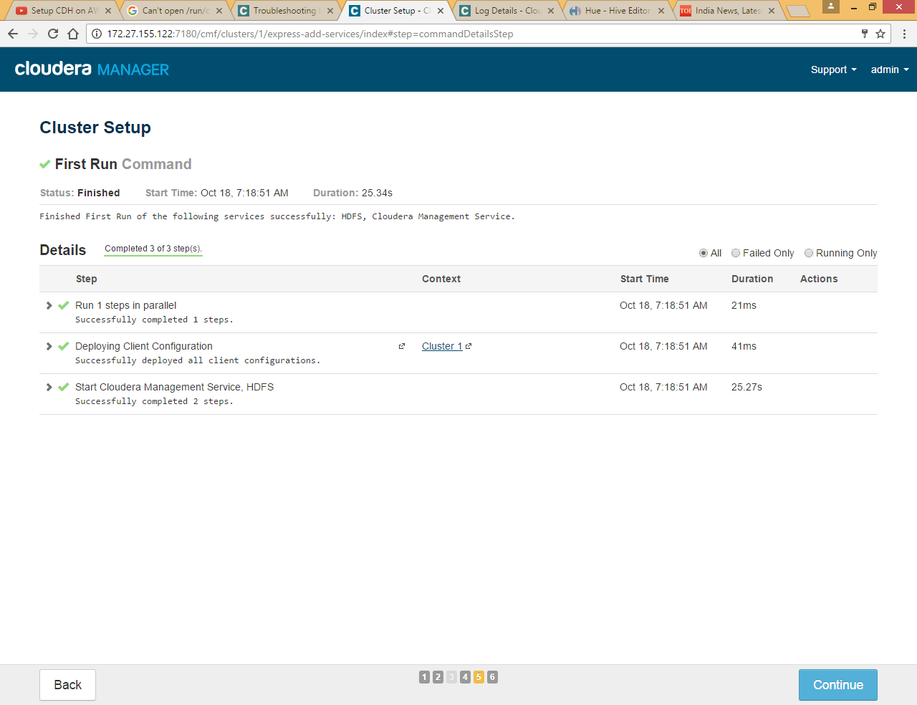

It worked ☺

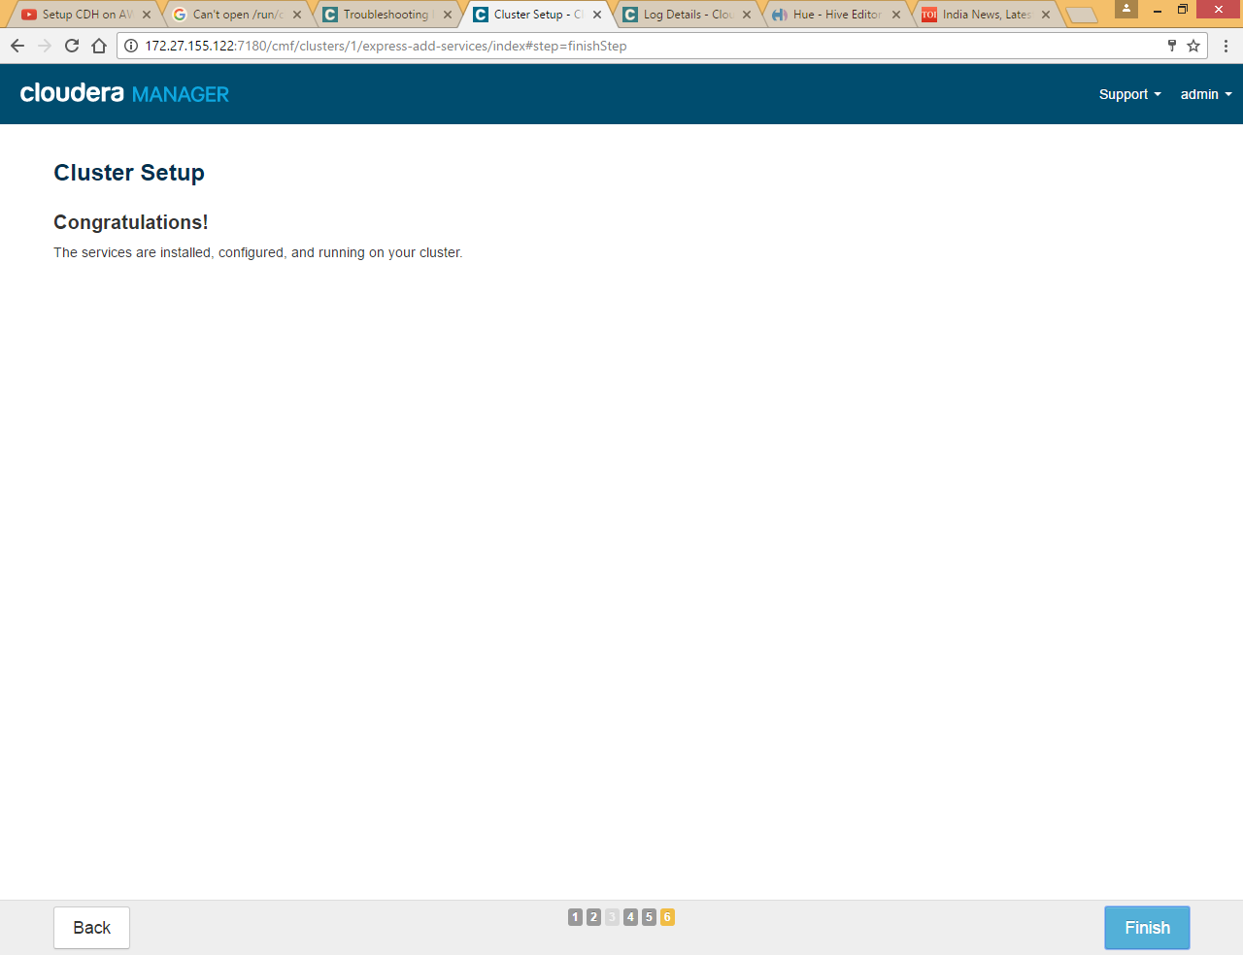

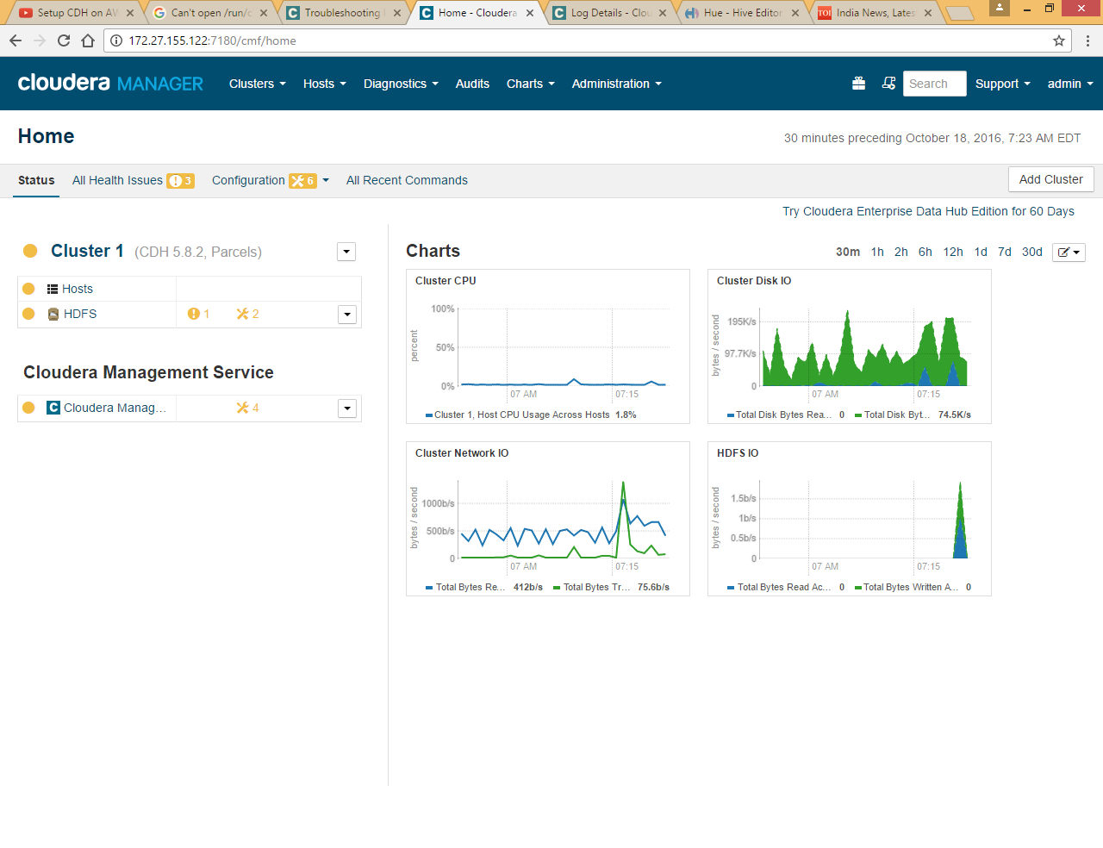

## Add hosts to cluster

First go to /etc/yum.repos.d and download cdh.repo file from our local repository

|  |
| --- |
| wget http://172.27.155.122/cdh5/redhat/7/x86_64/cdh/cloudera-cdh5.repo |

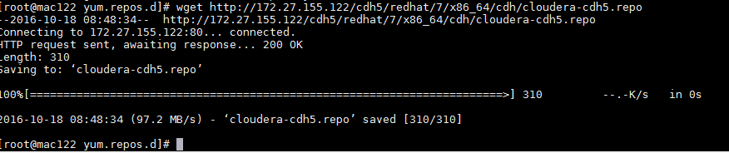

Click on Hosts>> All Hosts

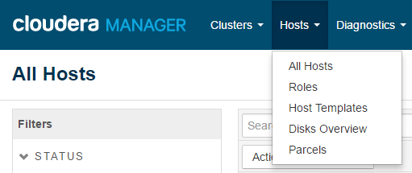

Click on Add New Hosts to Cluster



Again all steps will be almost same like we did for 172.27.155.122 machine installation

Again we are adding host one by one, you can do it at once by using comma separated machine IPs

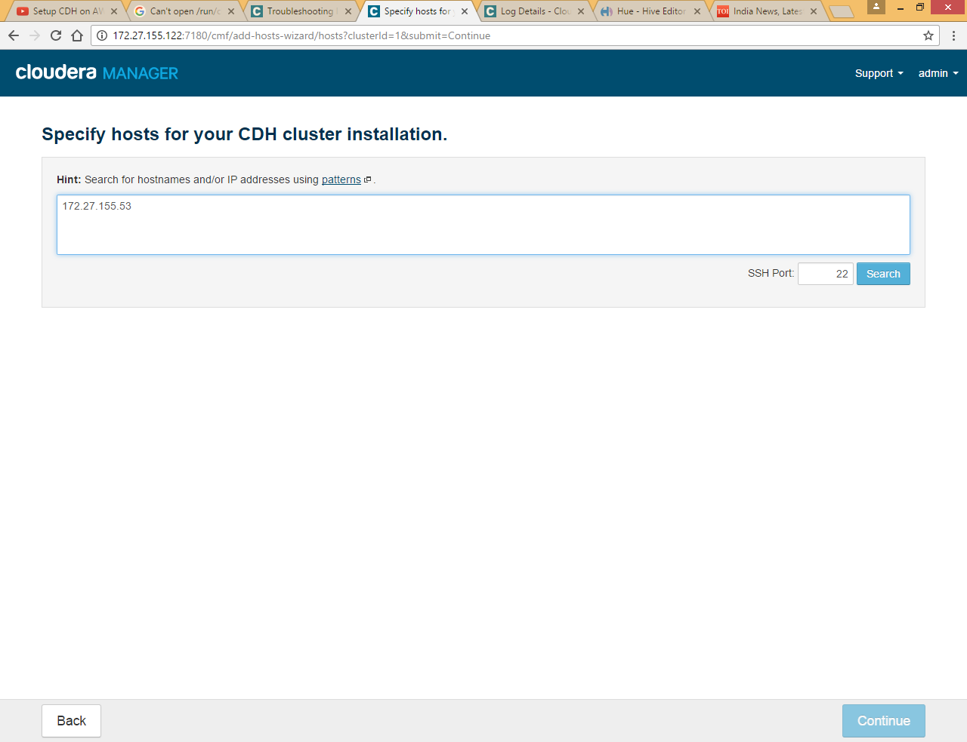

Enter IP and Click search

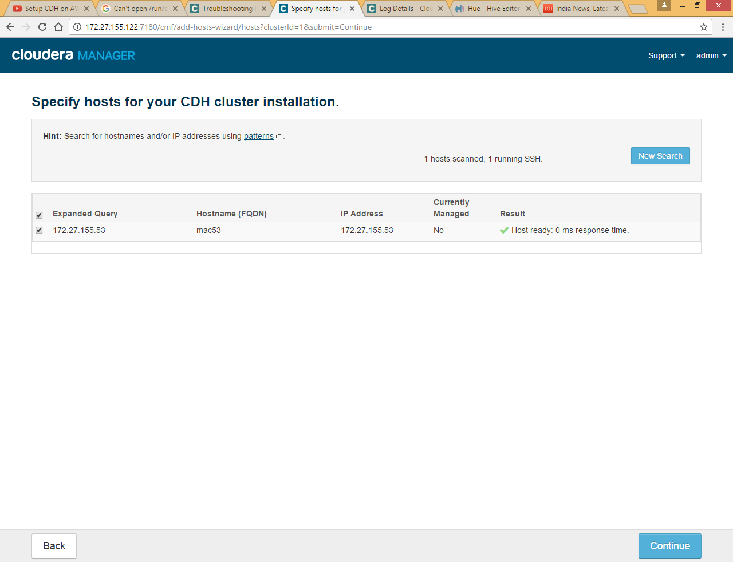

Click Continue

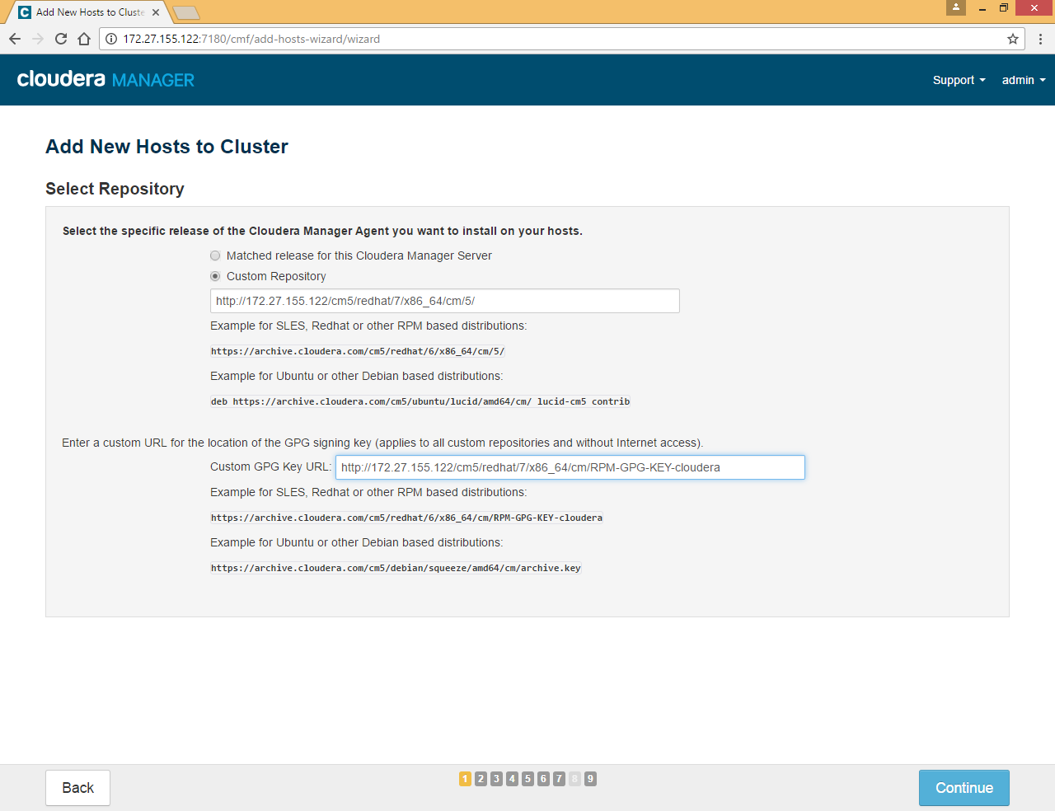

Here we need to choose custom Repository since we already created local yum repository for Cloudera

Enter <http://172.27.155.122/cm5/redhat/7/x86_64/cm/5/>for CM

<http://172.27.155.122/cm5/redhat/7/x86_64/cm/RPM-GPG-KEY-cloudera> for GPG key

Click Continue

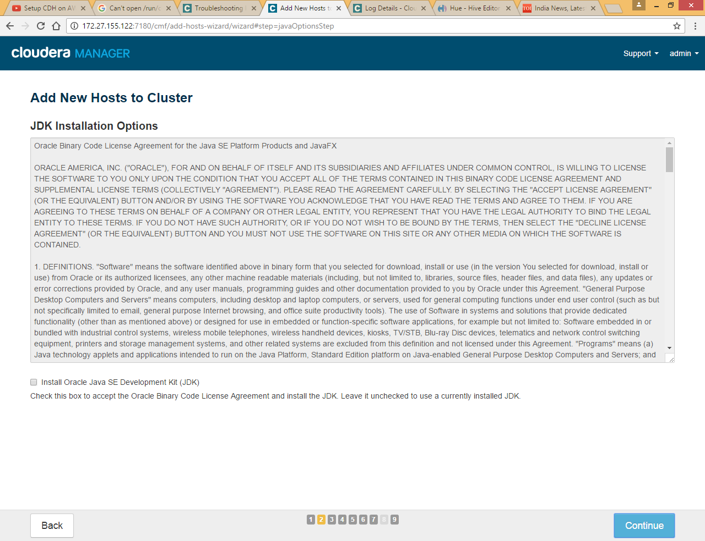

Leave Java installation since we already have java installed on machine

Click Continue



Provide machine password for root



Provide machine password for root

If you established SSH password less sudo Access , choose id_rsa file as private key



Click Continue

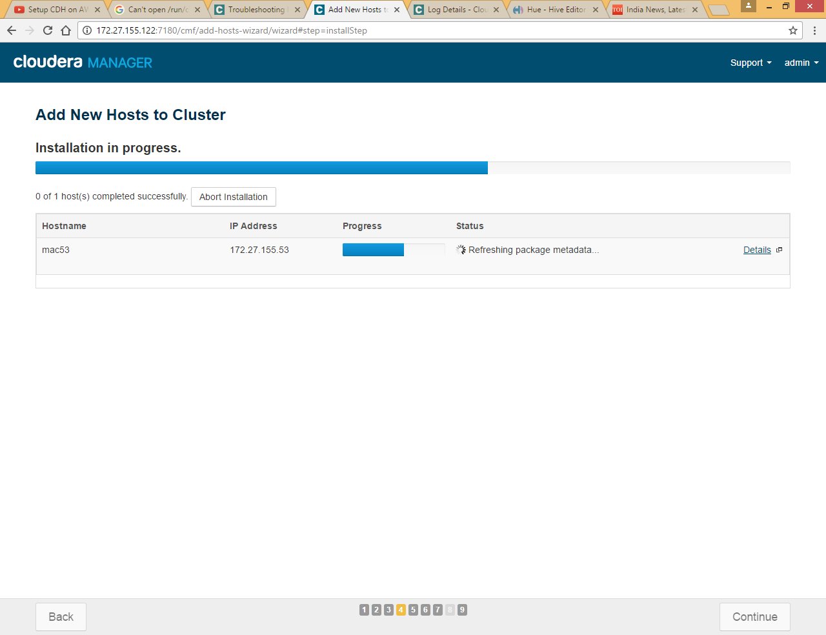

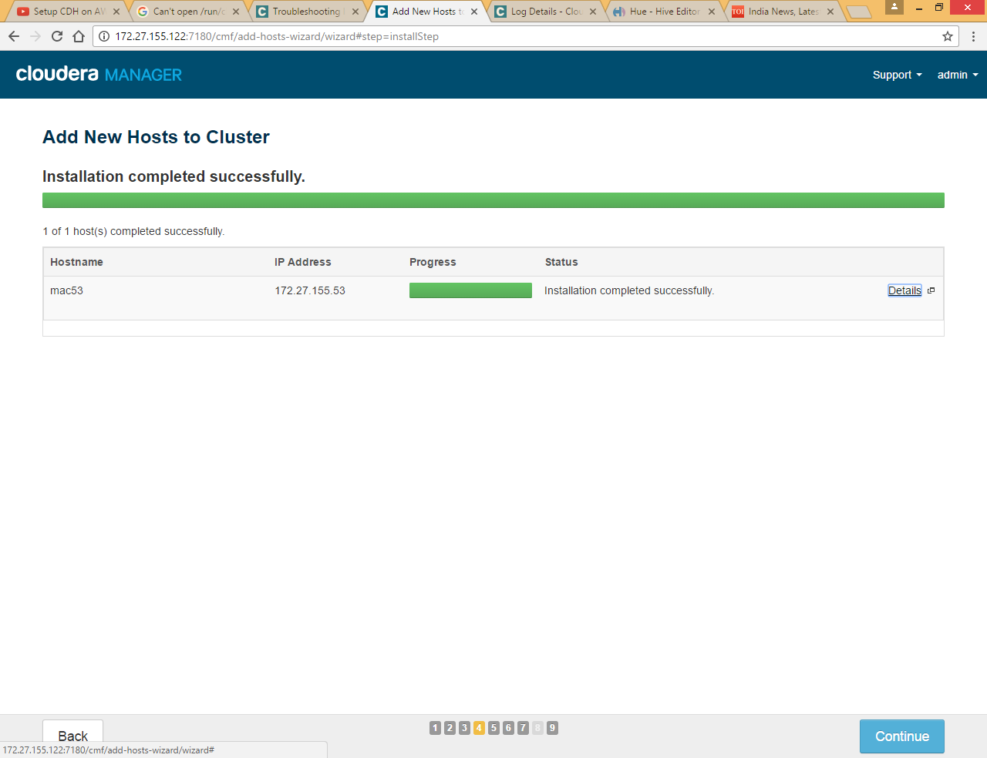

Click Continue

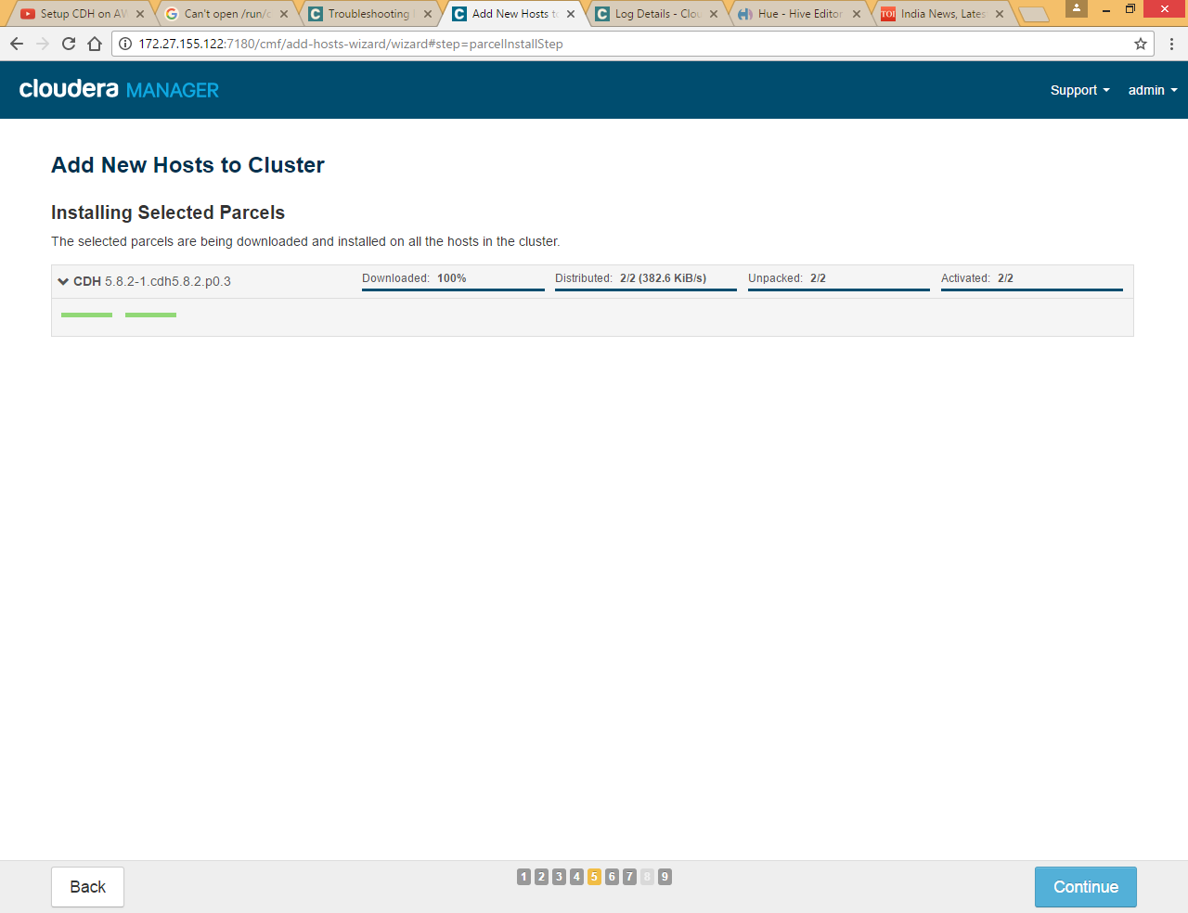

Click Continue

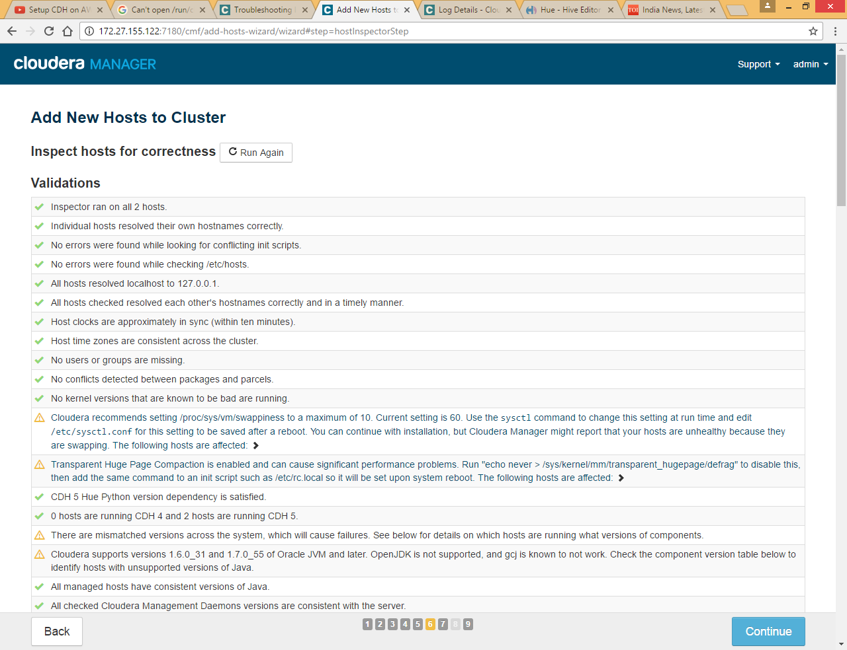

Click Continue

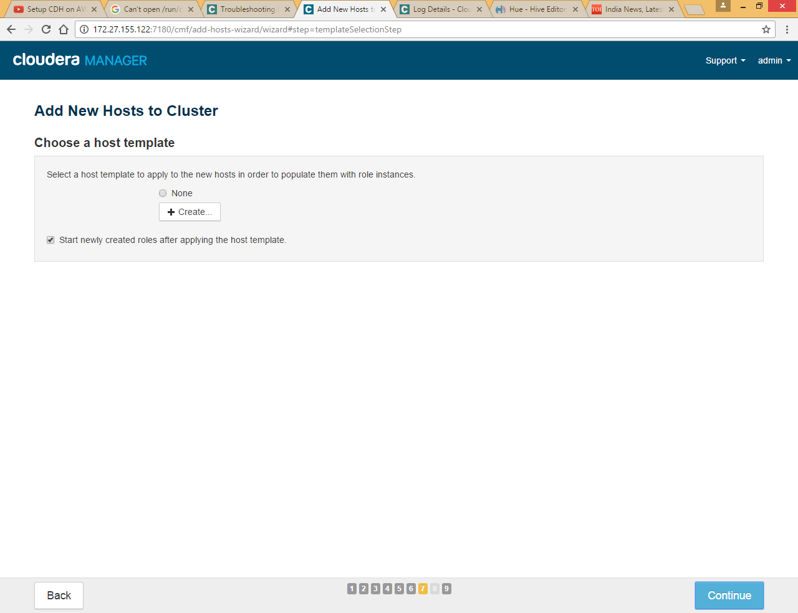

Click Continue

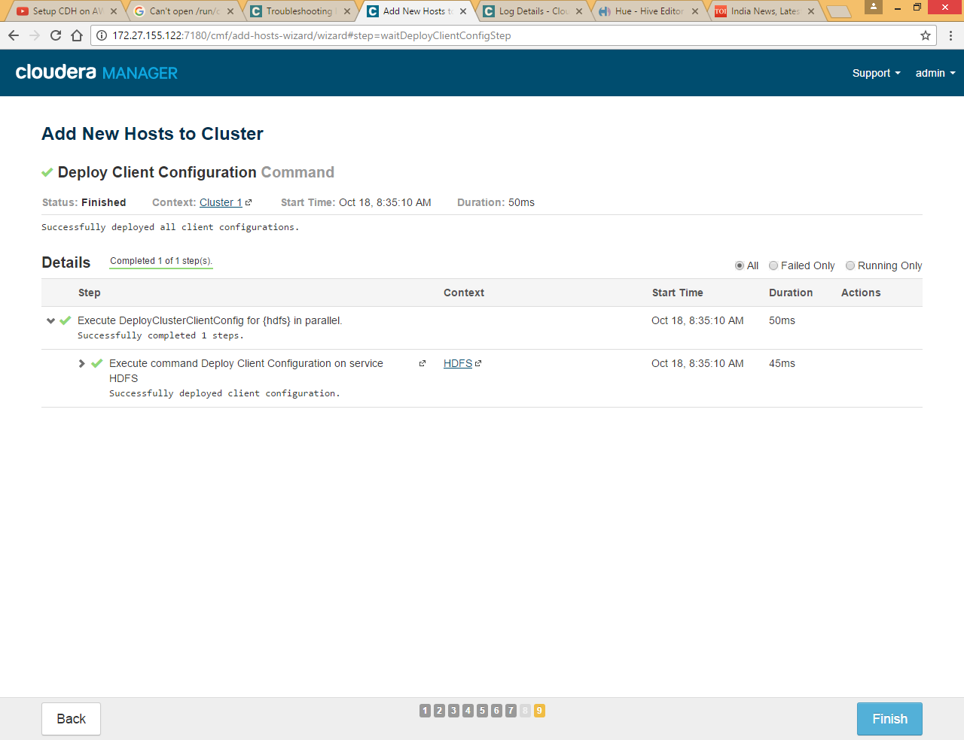

Click finish

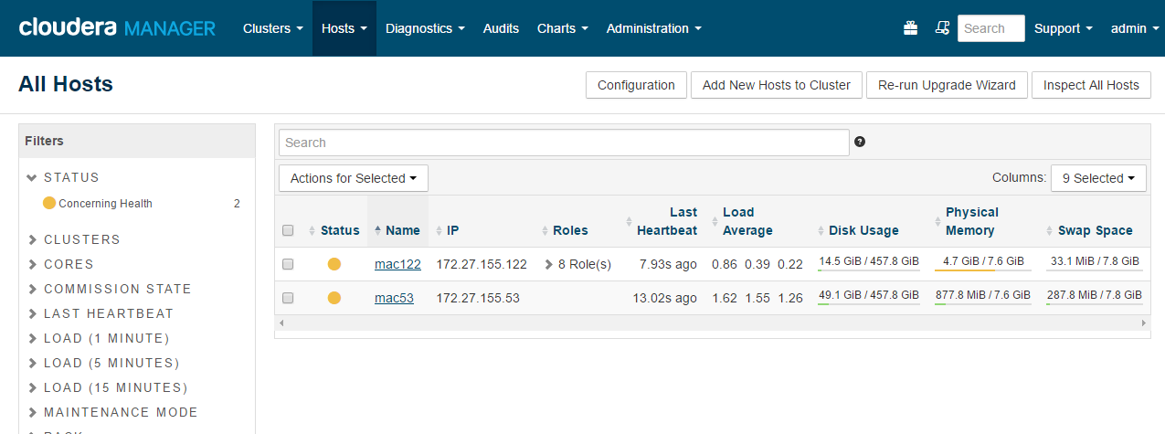

Same way we can add all nodes to cluster

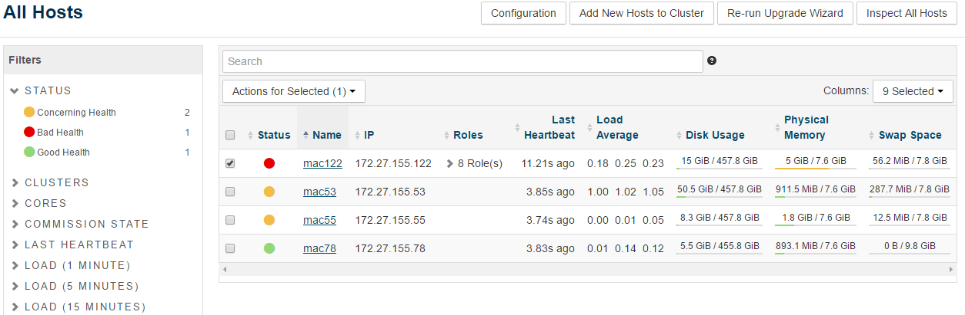

## Add Role Instance

### HDFS Service

As we already installed HDFS service we are going to delete this service here and will add it again for all 4 nodes so that we can allocate different hosts for Name Node and Secondary Name Node

First stop HDFS service and then delete it

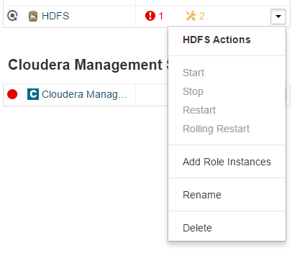

Now again add HDFS service

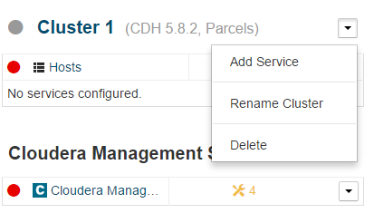

Click Add Service

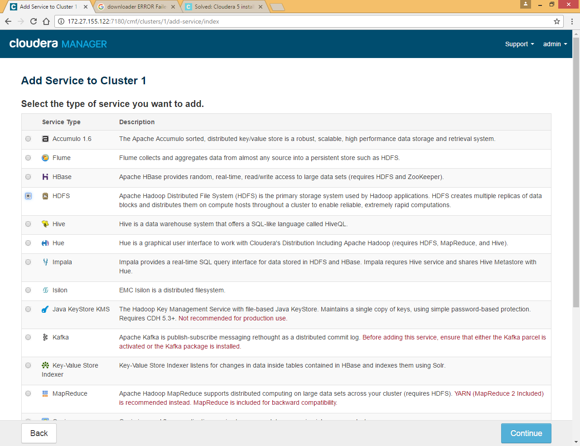

Select HDFS

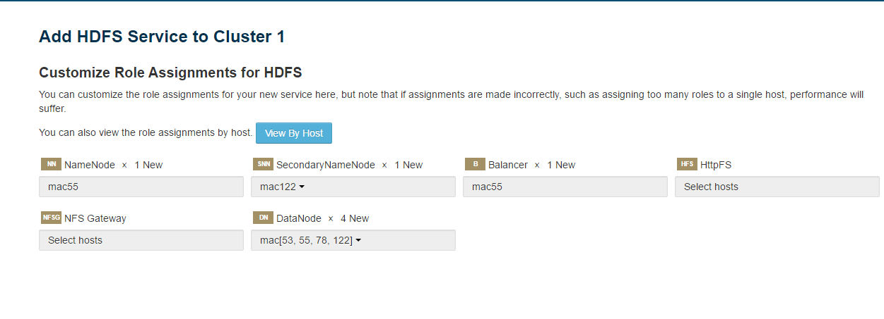

Here we are selecting as per below table

|  |  |
| --- | --- |
| **Service** | **Host** |
| Name Node | Mac55 |
| Secondary name node | Mac122 |
| Balancer | Mac55 |
| Data Node | All four hosts (mac53,mac55,mac78 and mac 122) |

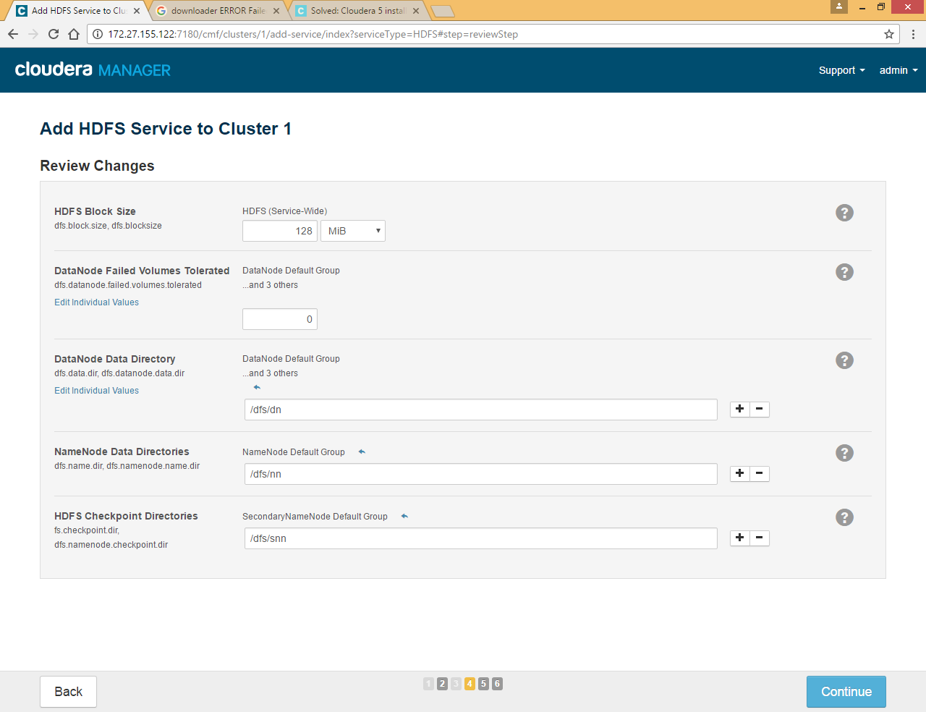

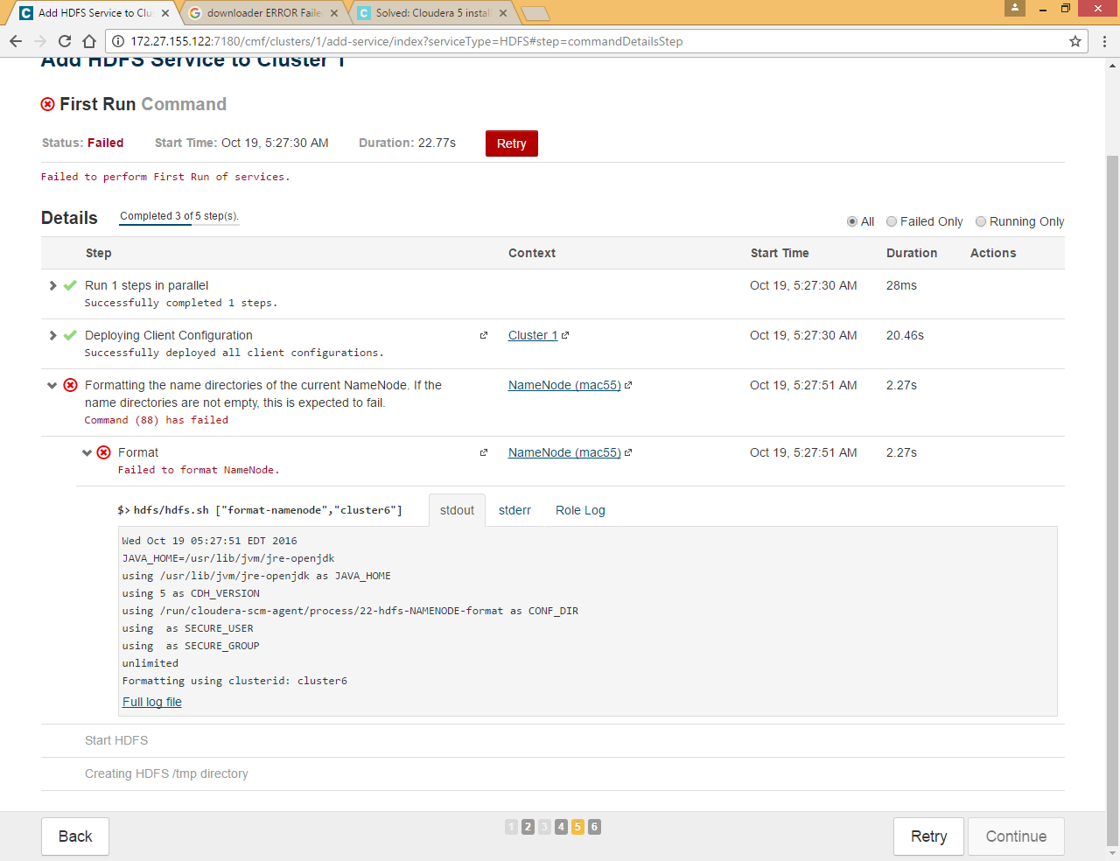

Make sure you delete all the files under **/dfs/dn** , **/dfs/nn** and **/dfs/snn** directory from all nodes

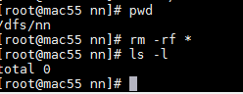

Retry again

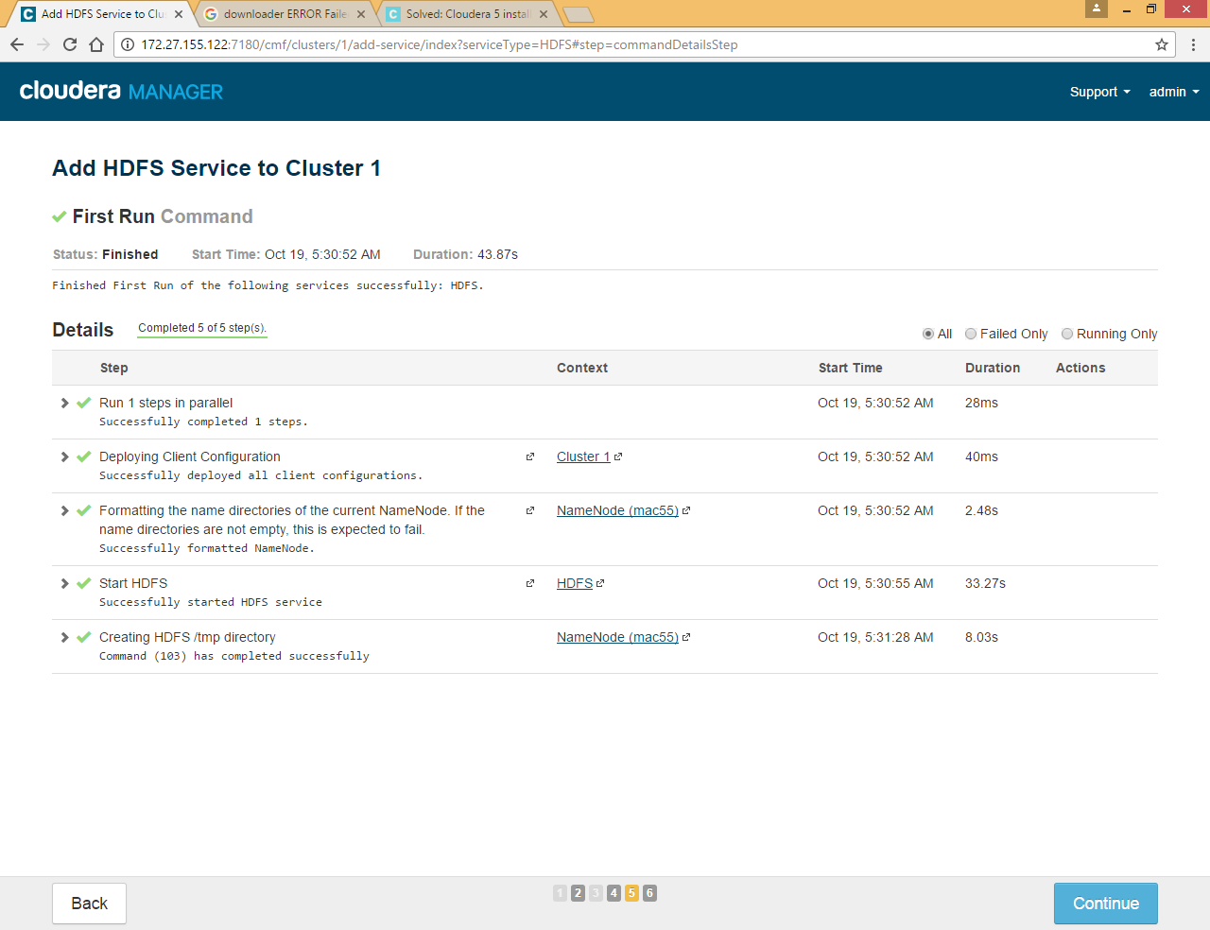

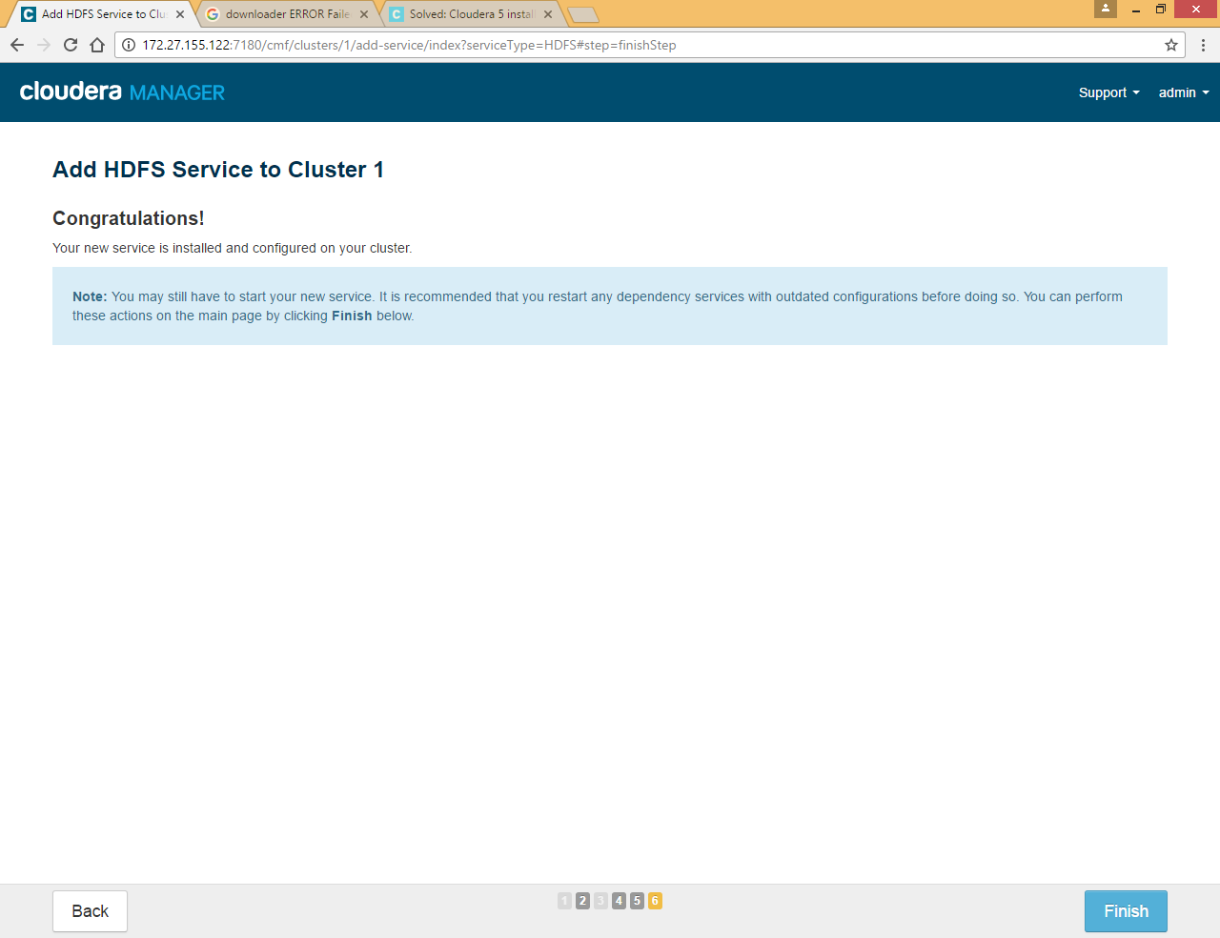

Click on HDFS >> Instances to check all Roles for HDFS

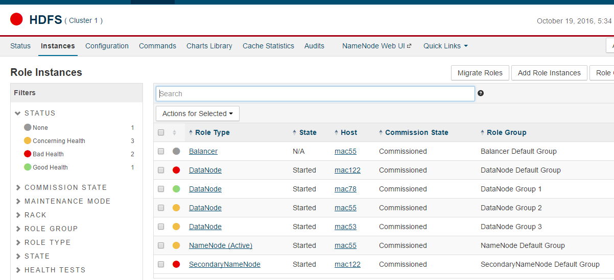

### Zookeeper Service

Click on Add Service



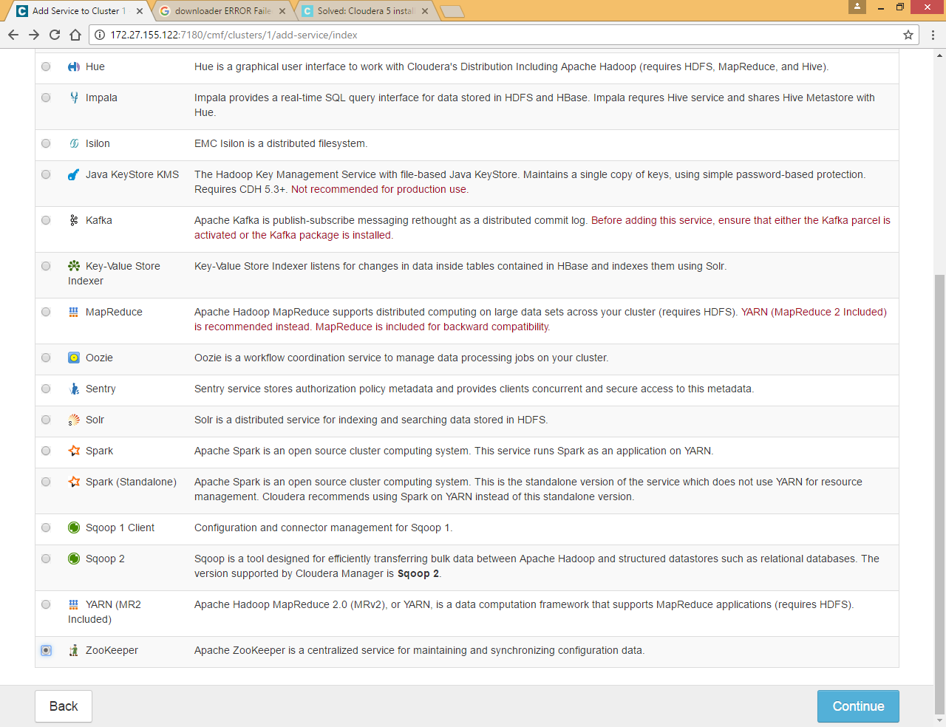

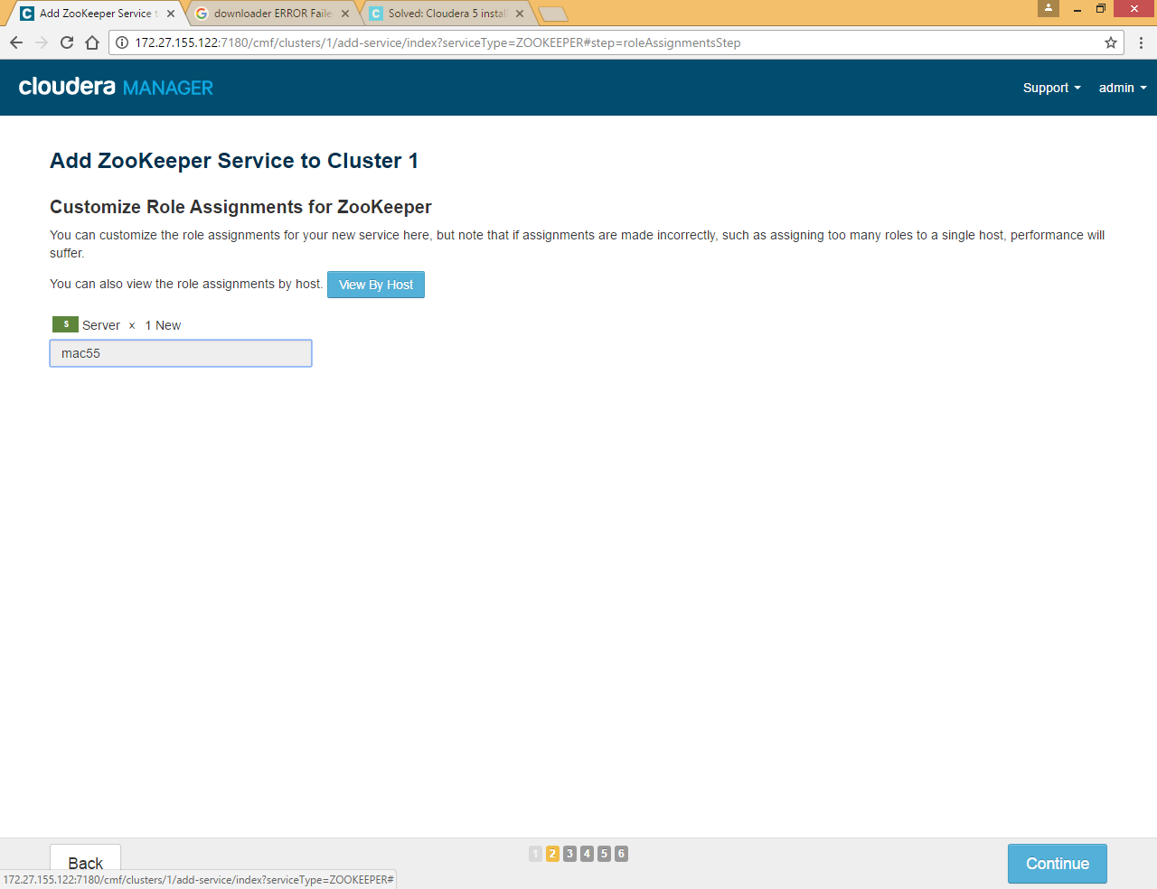

Click on mac55 and select any 3 hosts

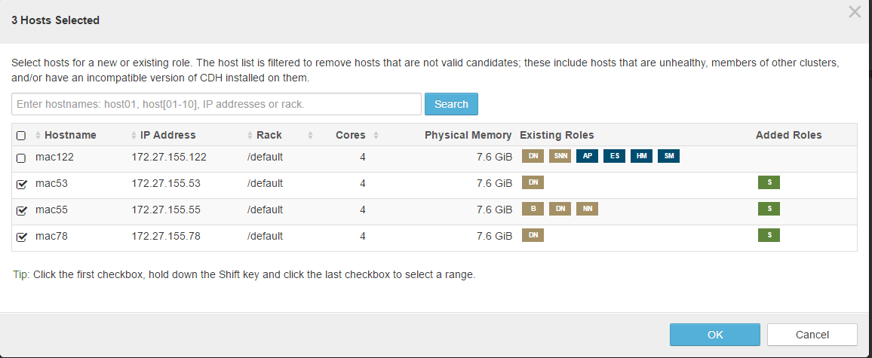

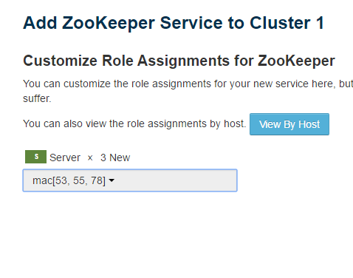

As per standard zookeeper should be installed on odd number of nodes

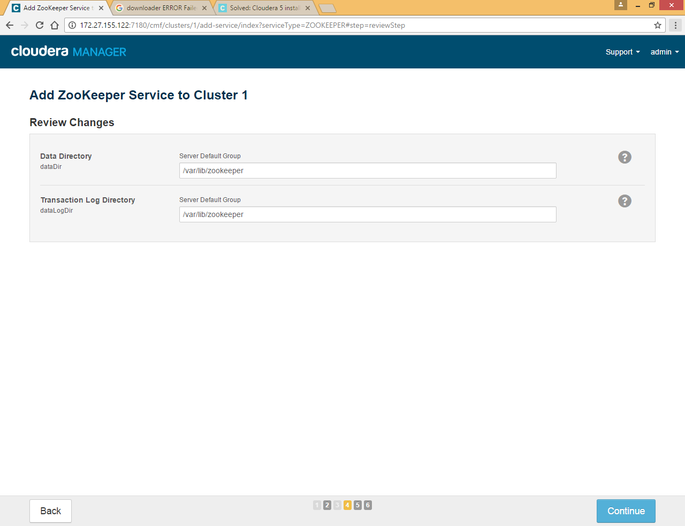

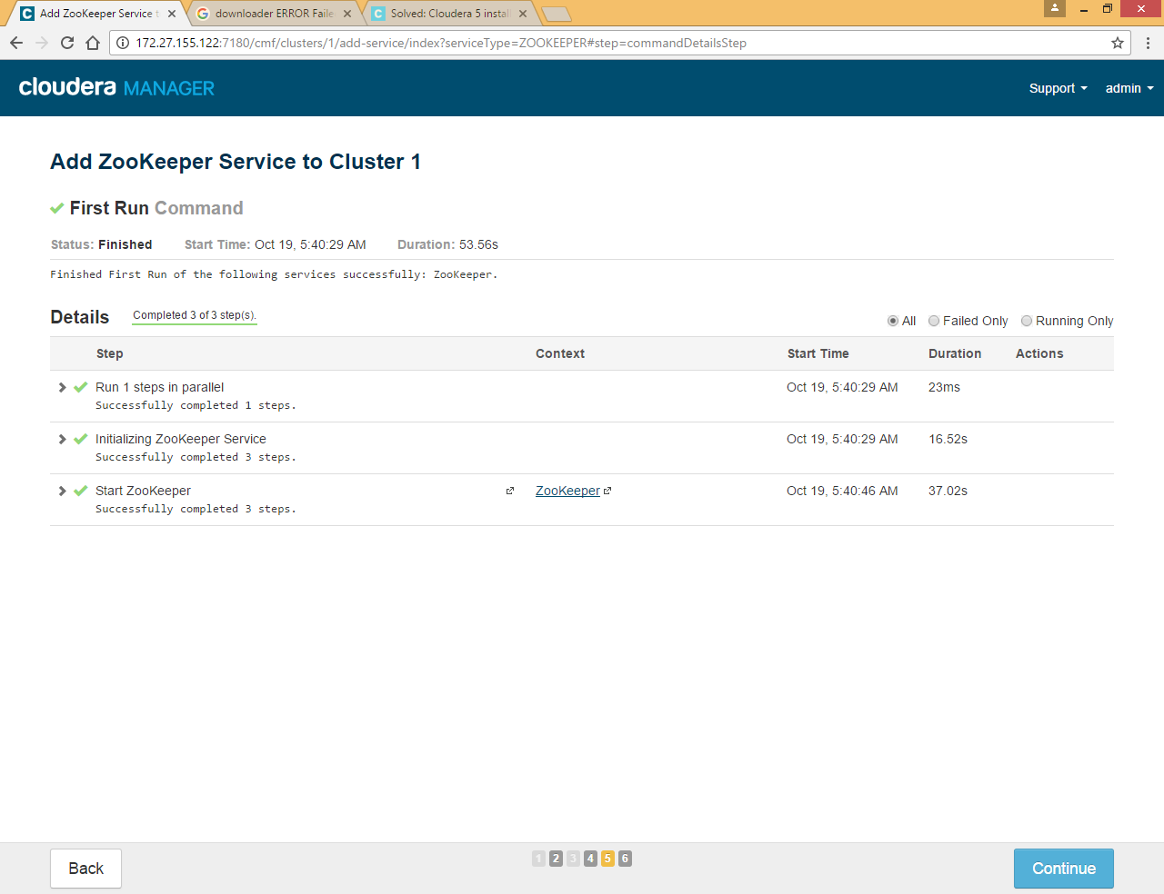

### Yarn Service

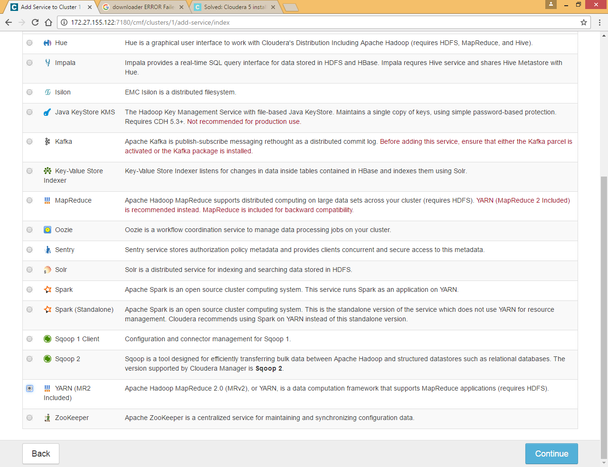

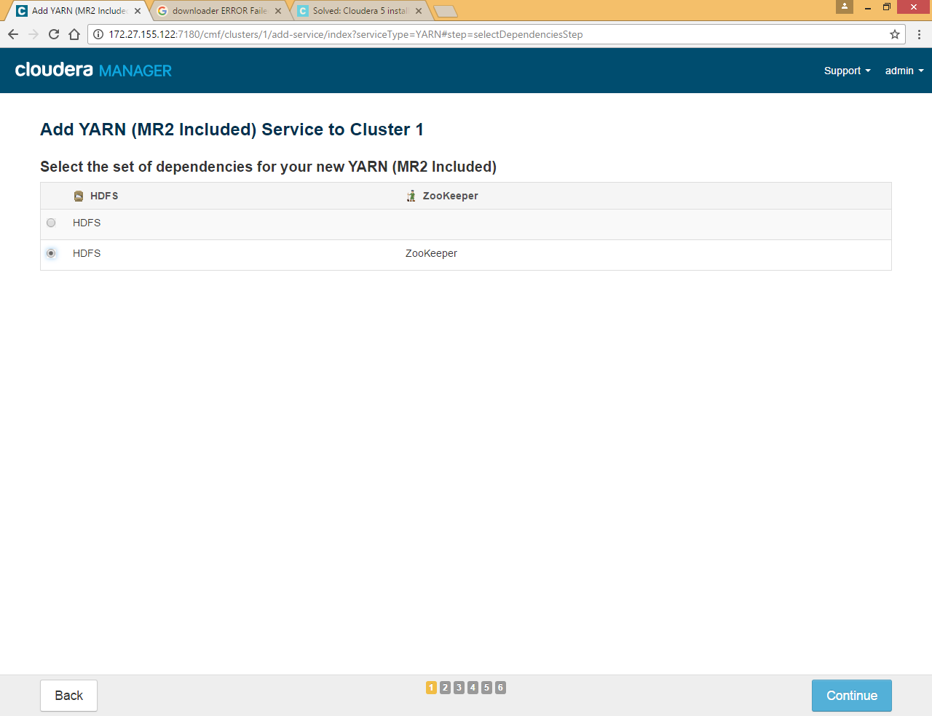

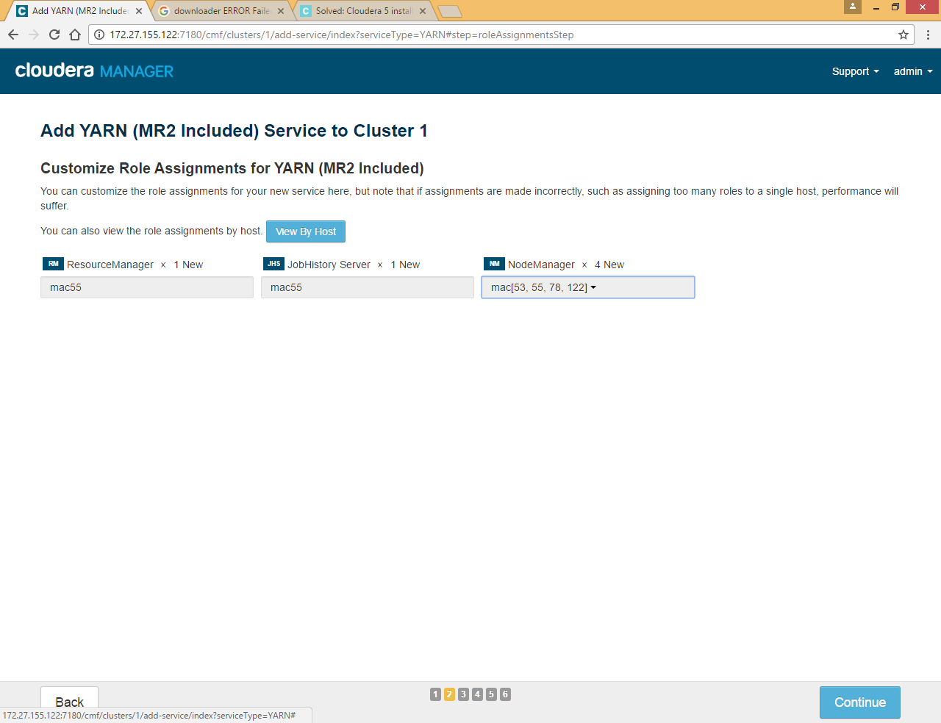

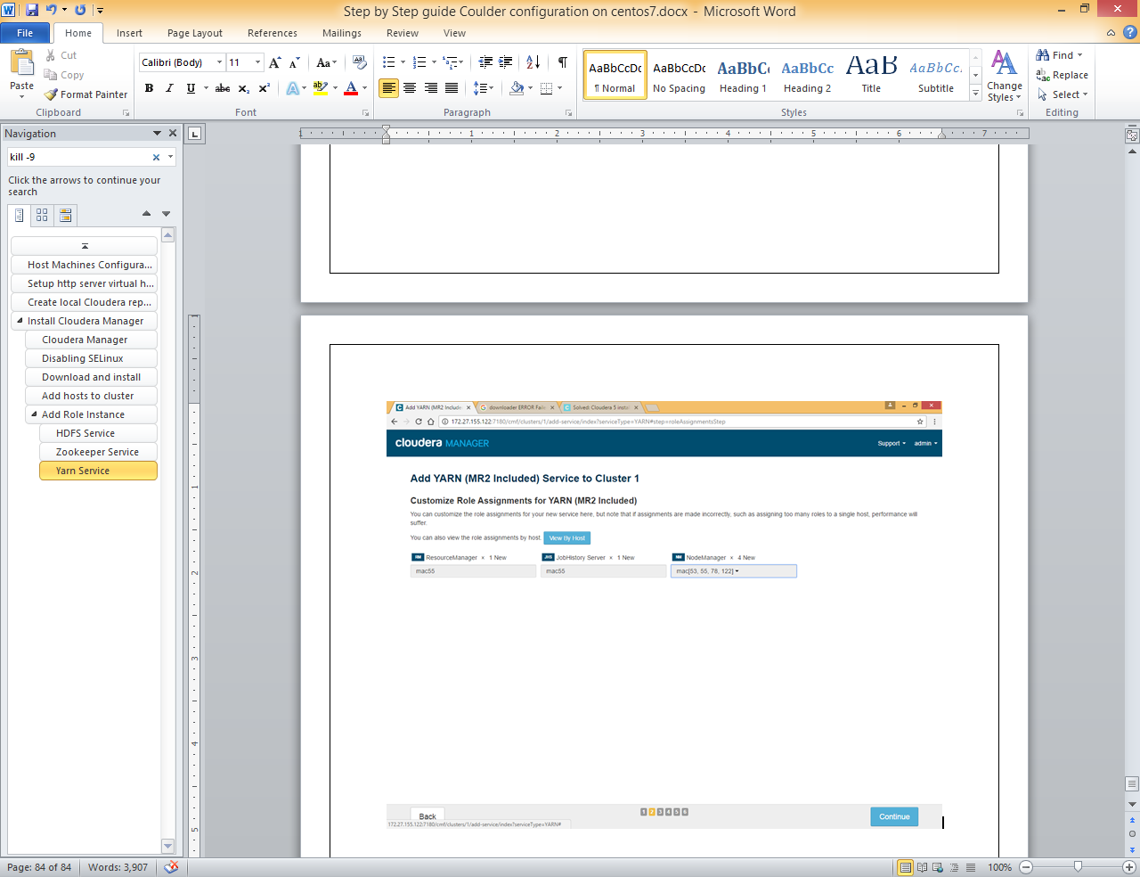

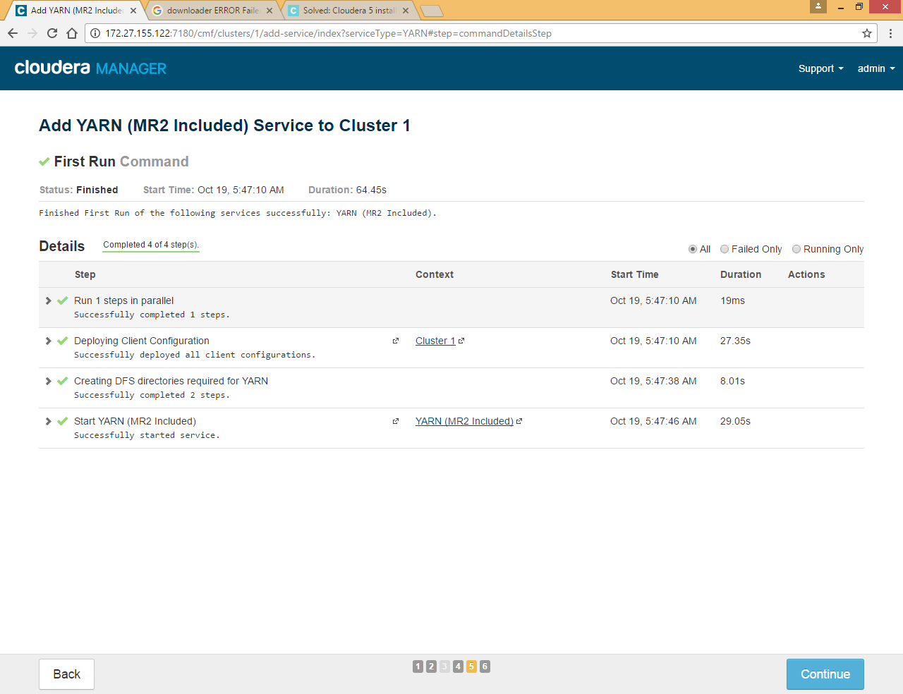

### Hive Service

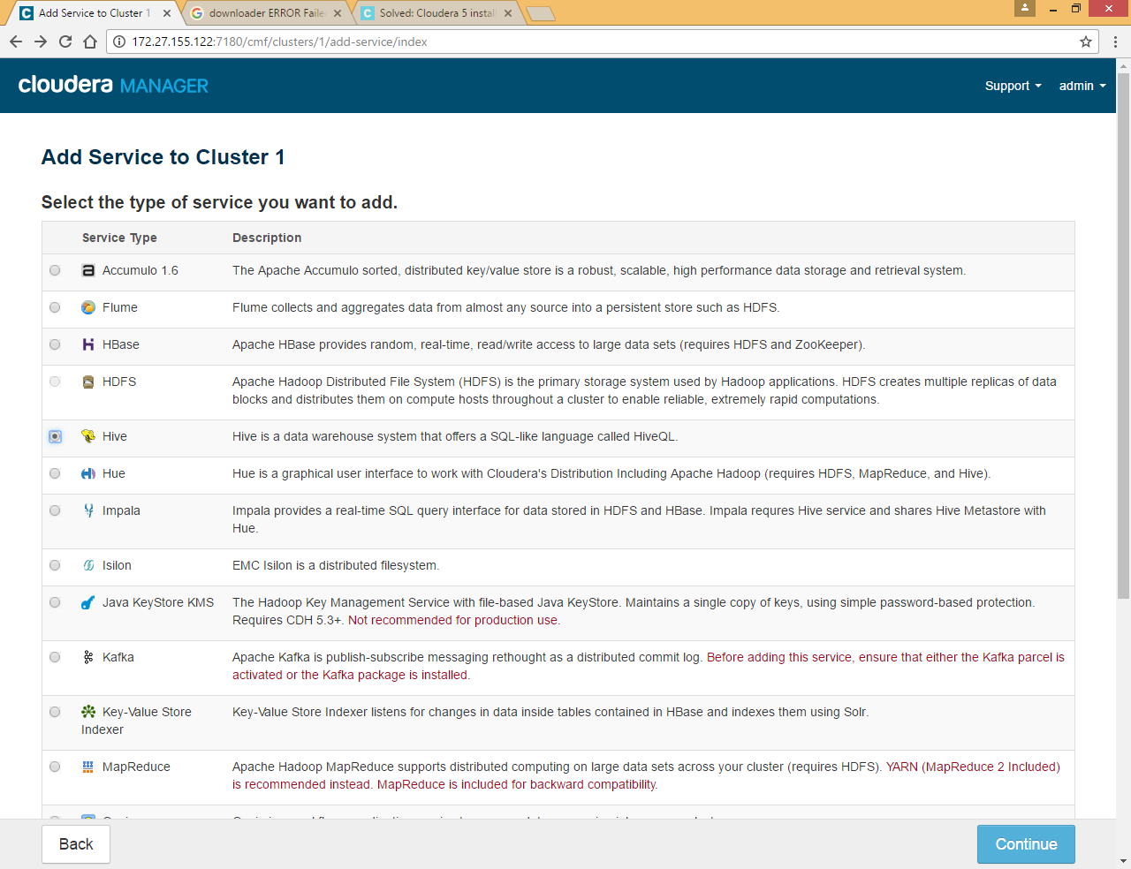

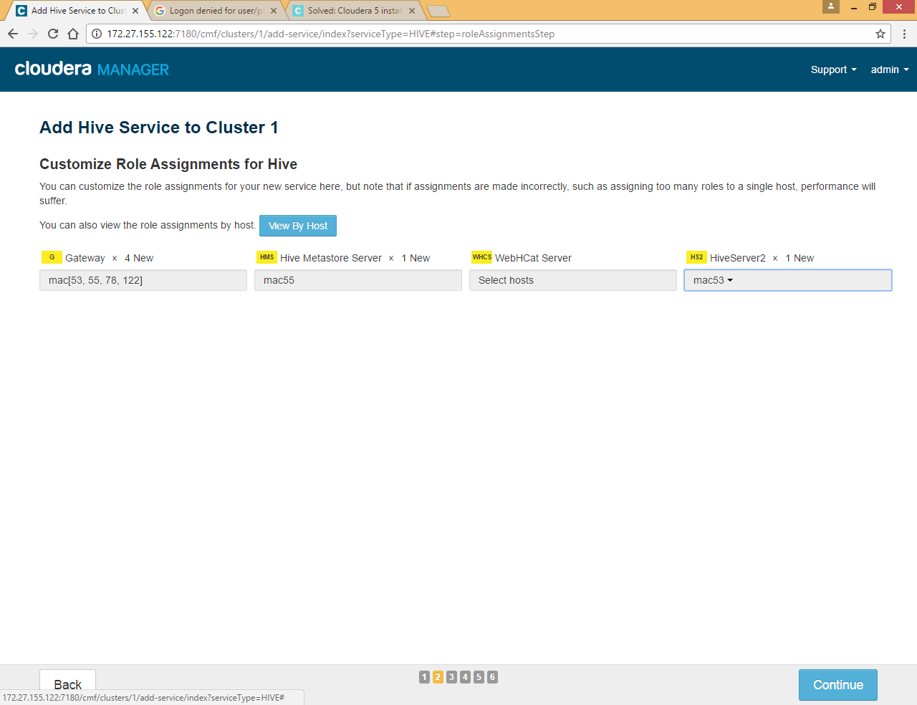

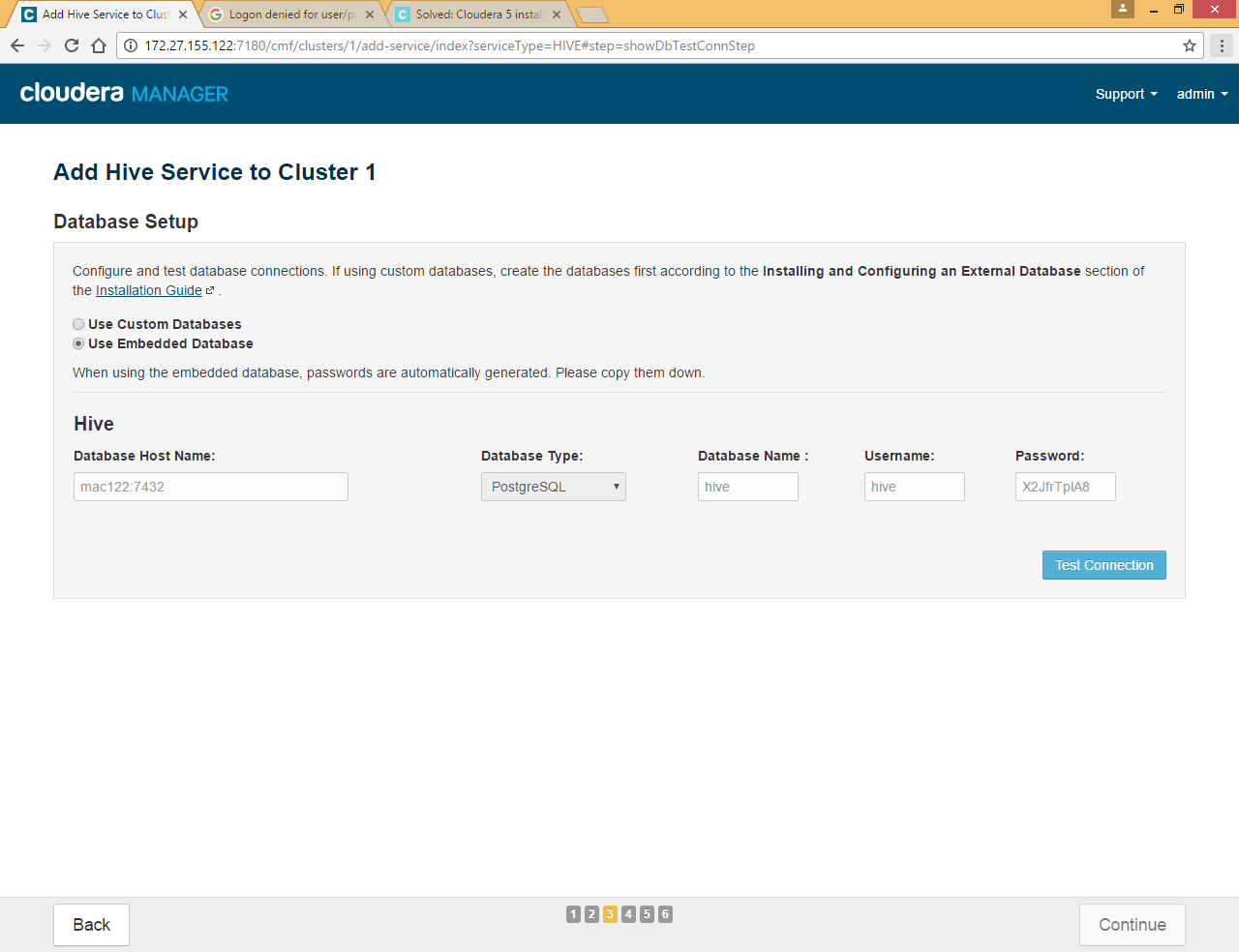

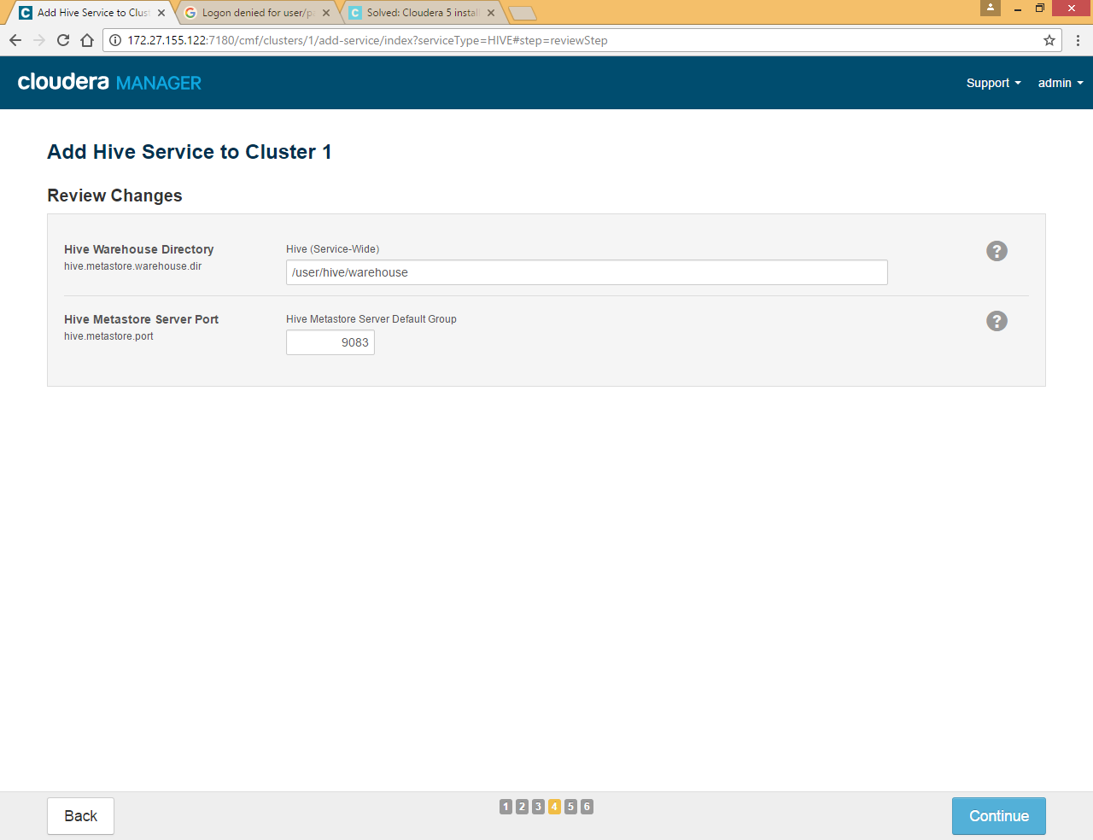

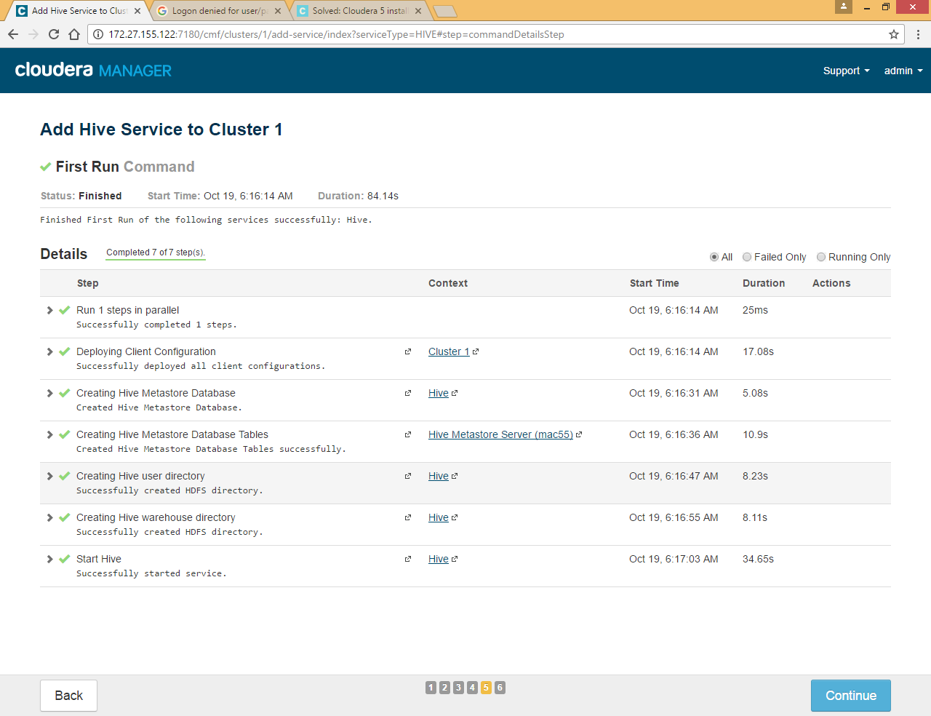

### Impala Service

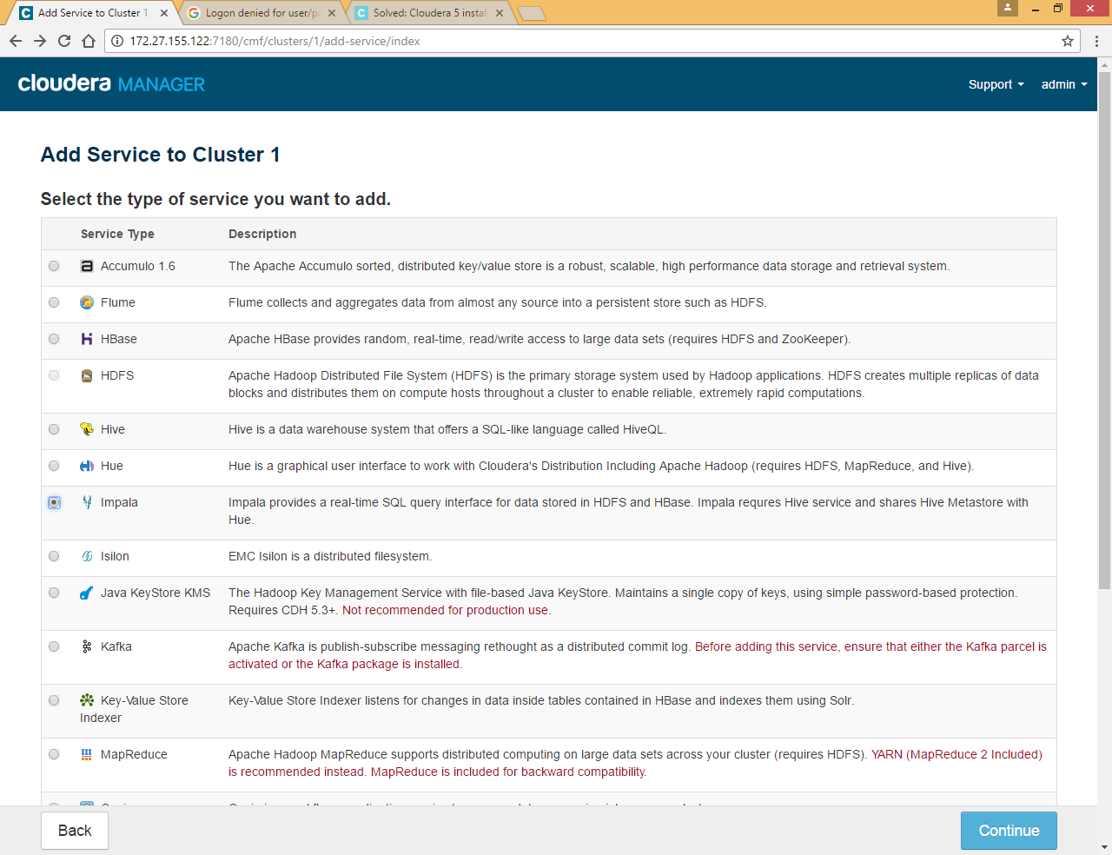

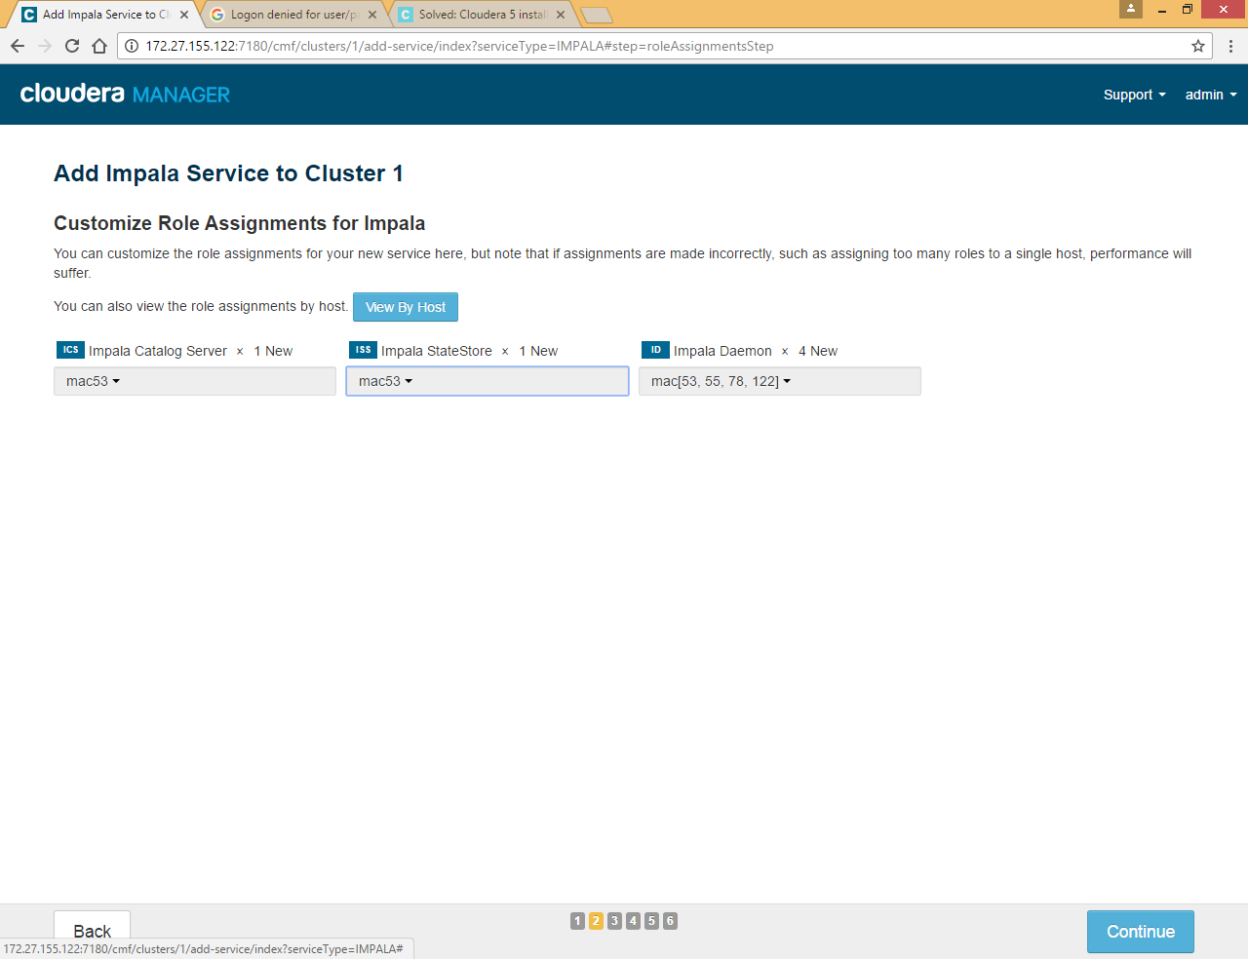

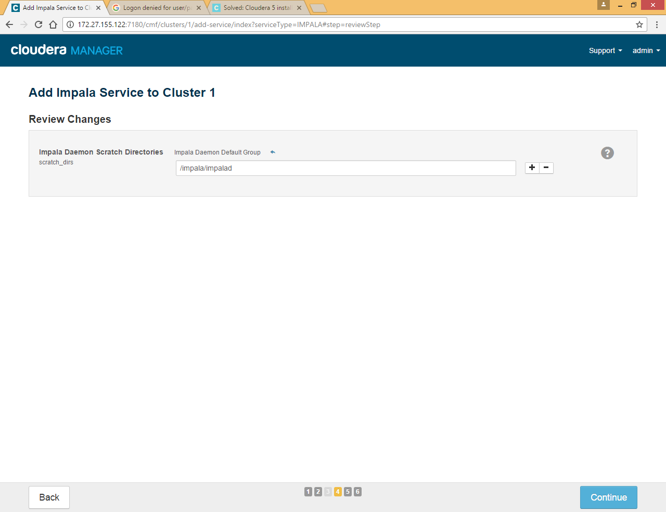

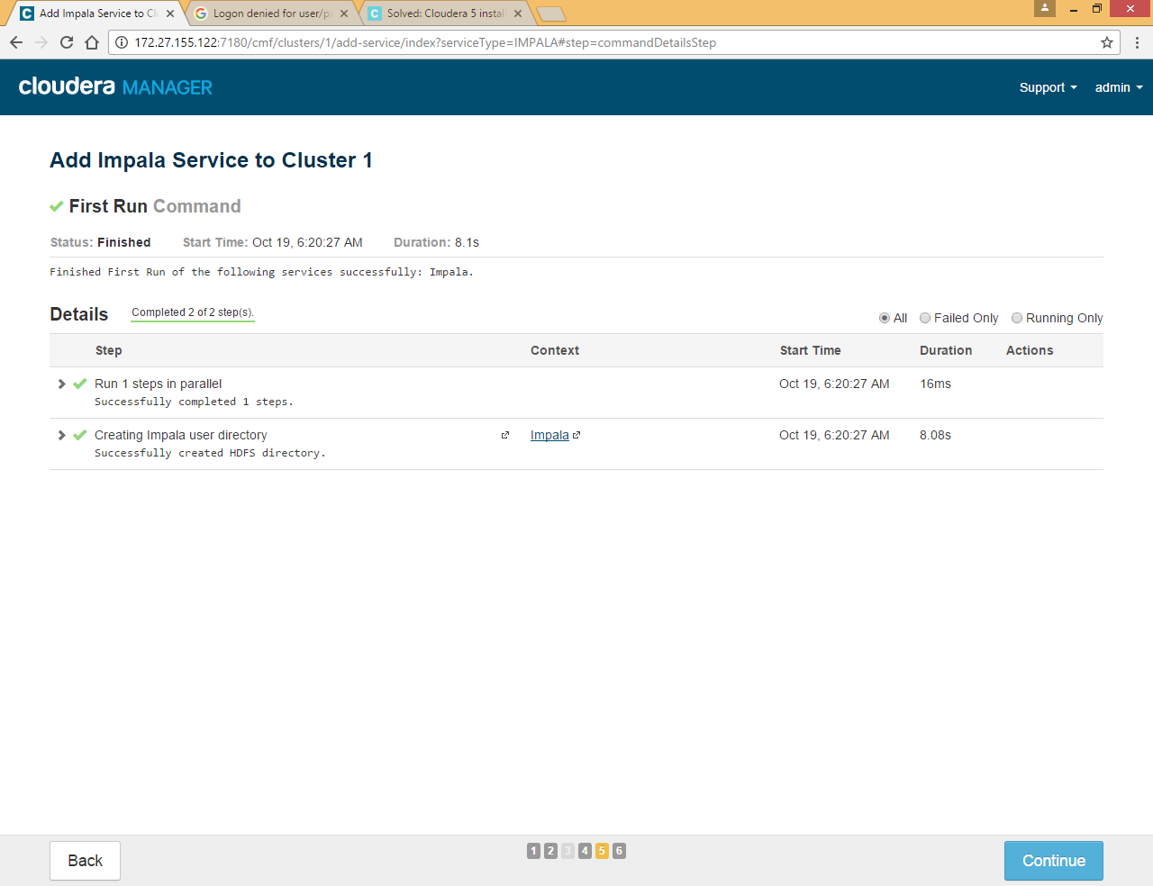

### Oozie Service

This service is required for hue

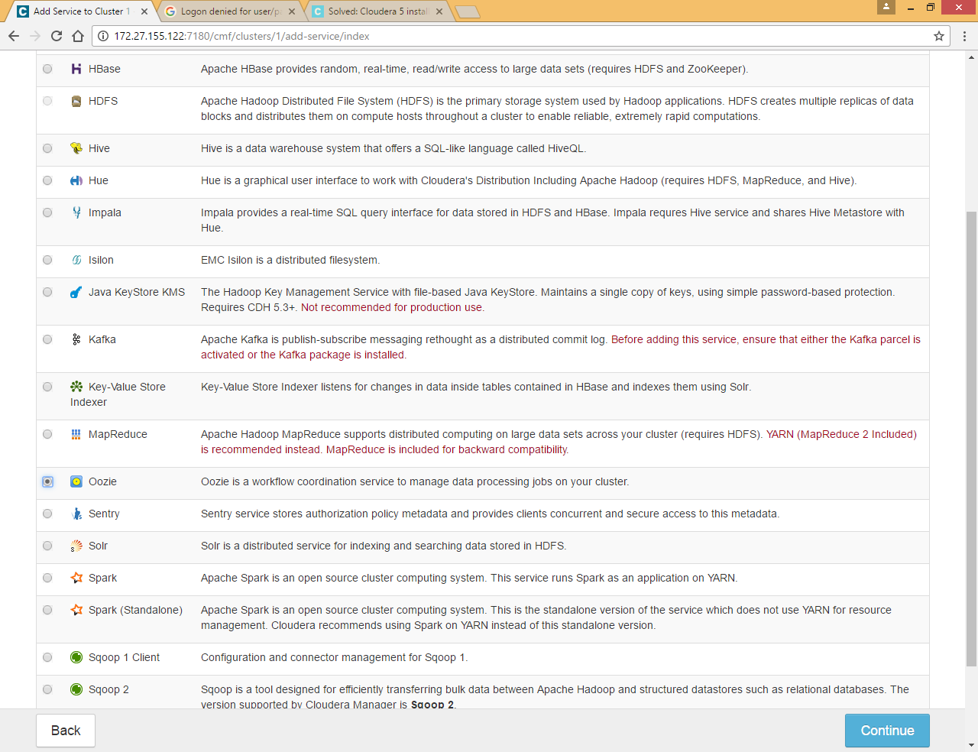

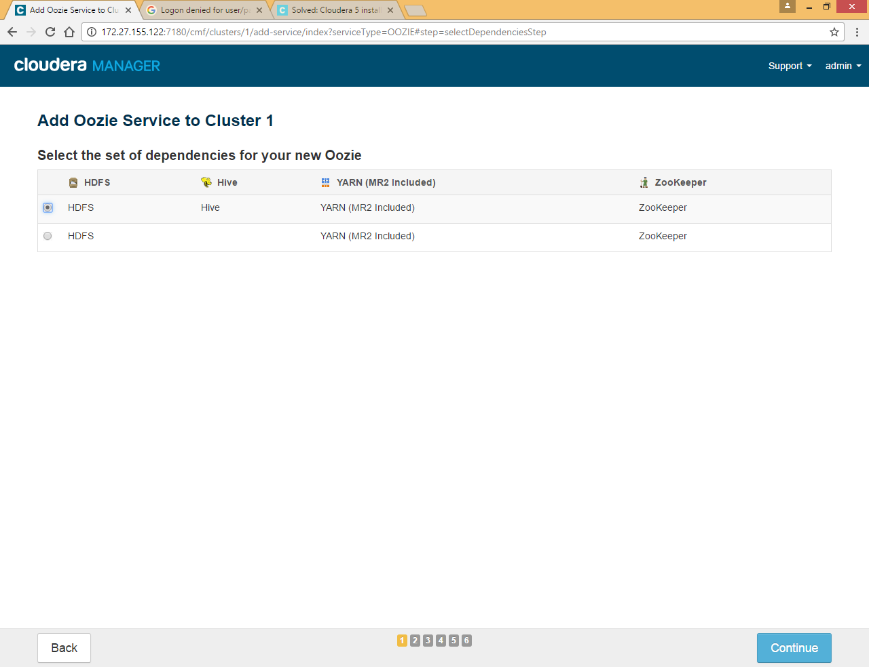

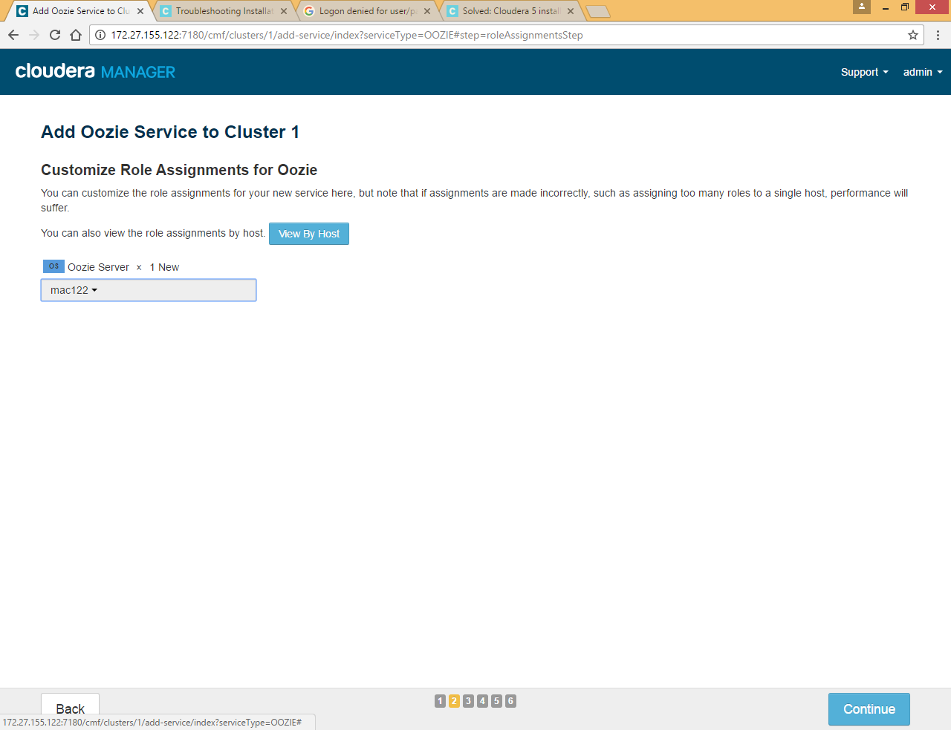

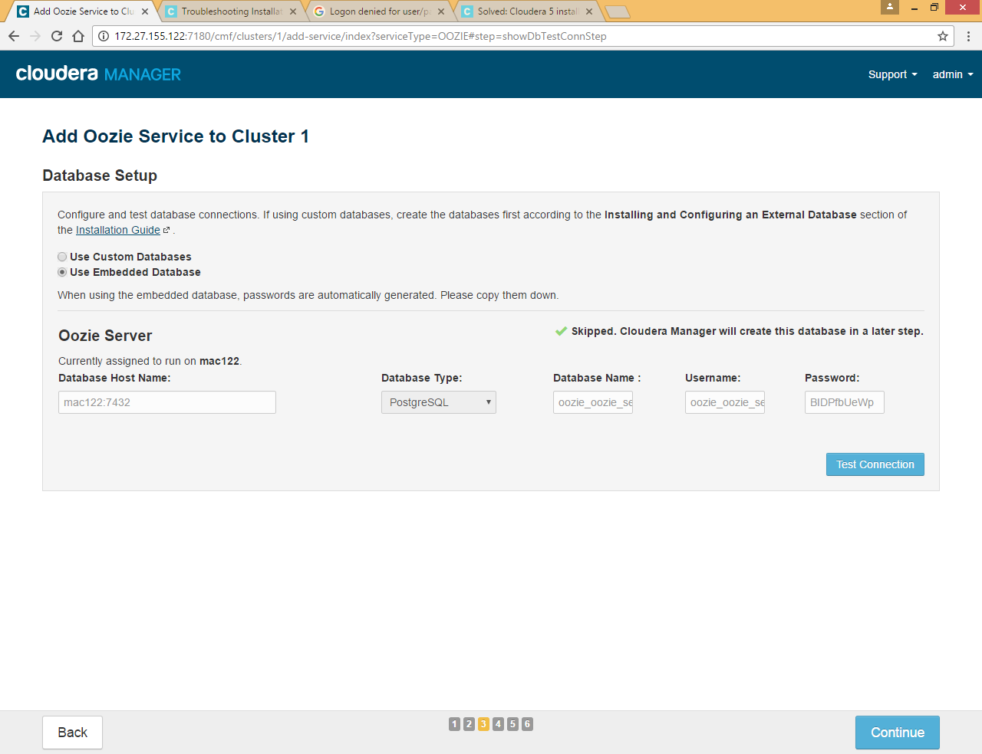

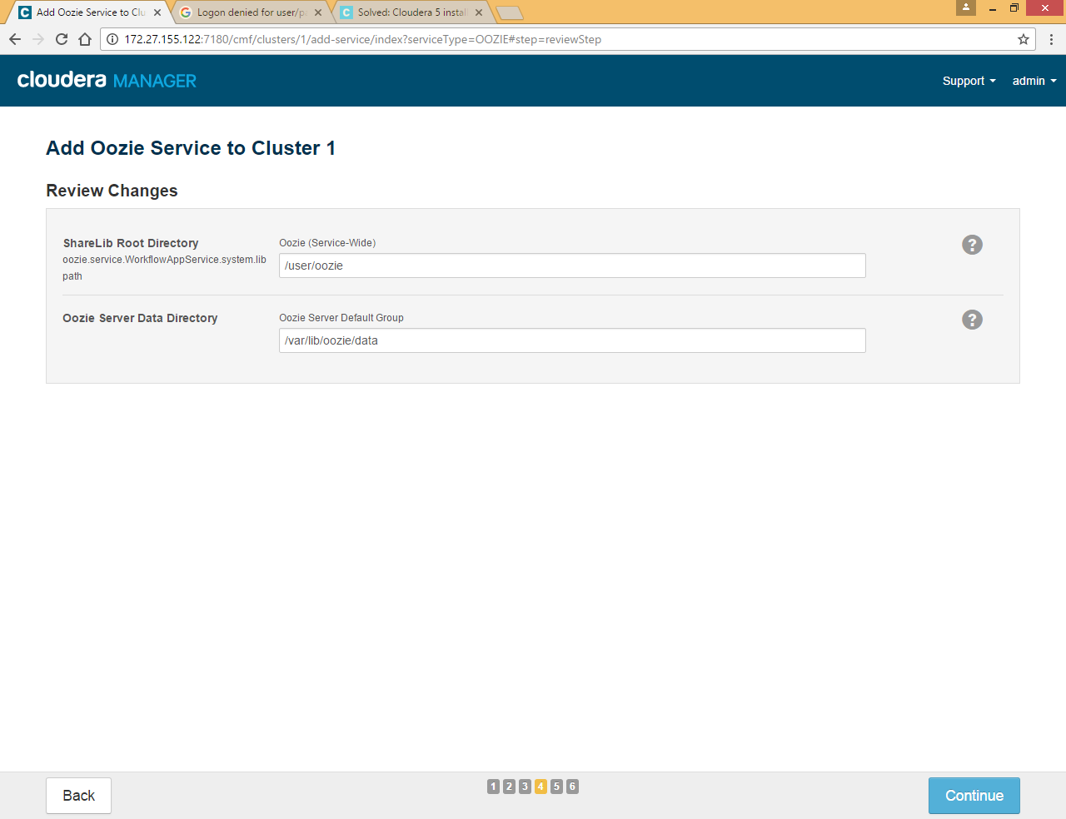

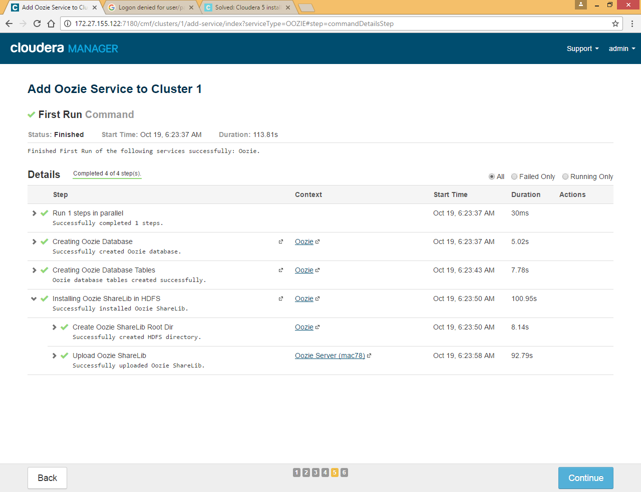

### Hue Service

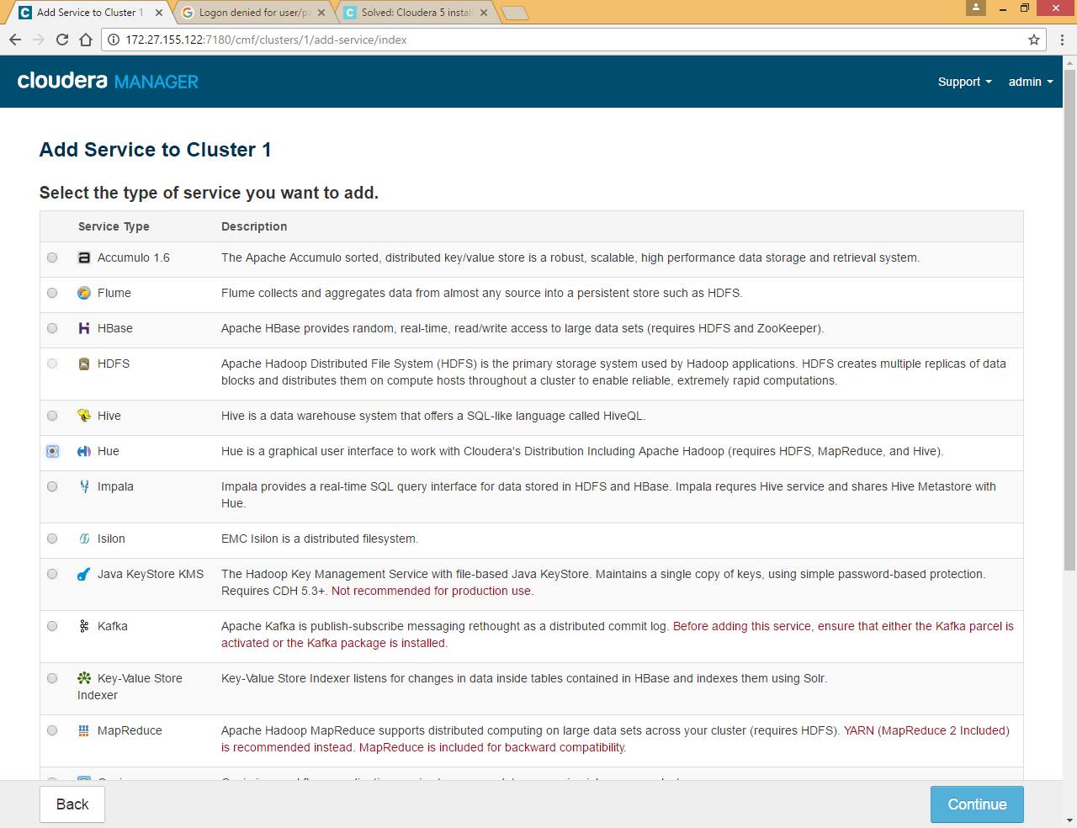

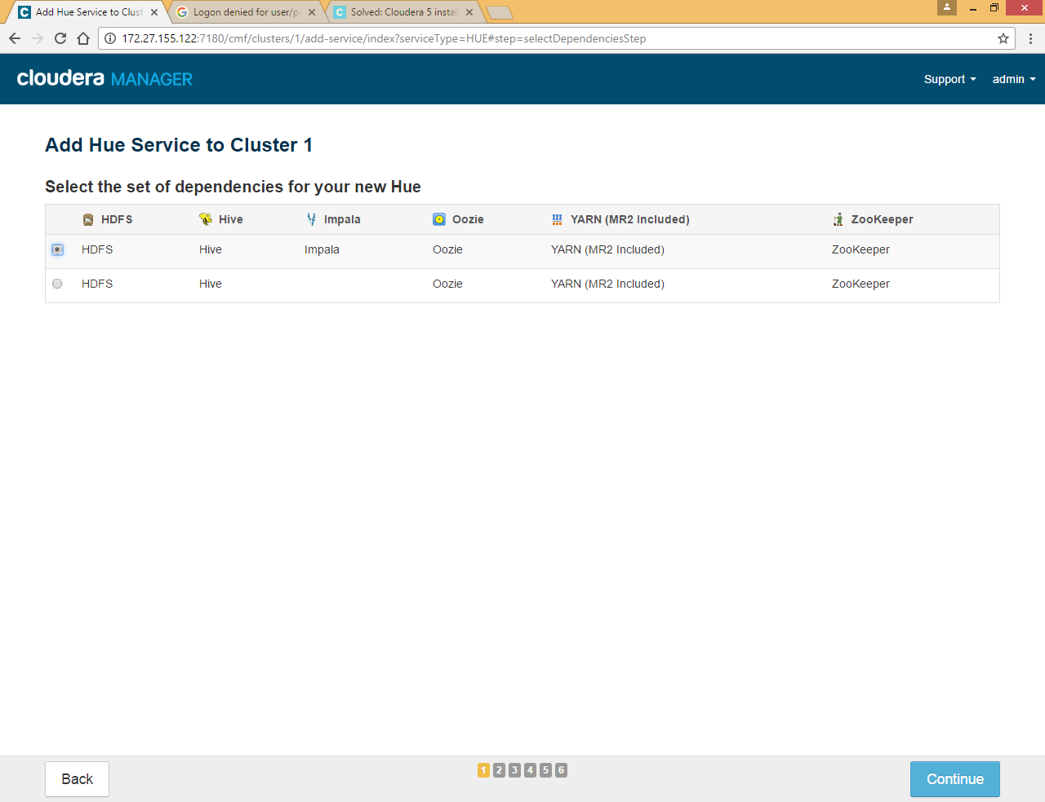

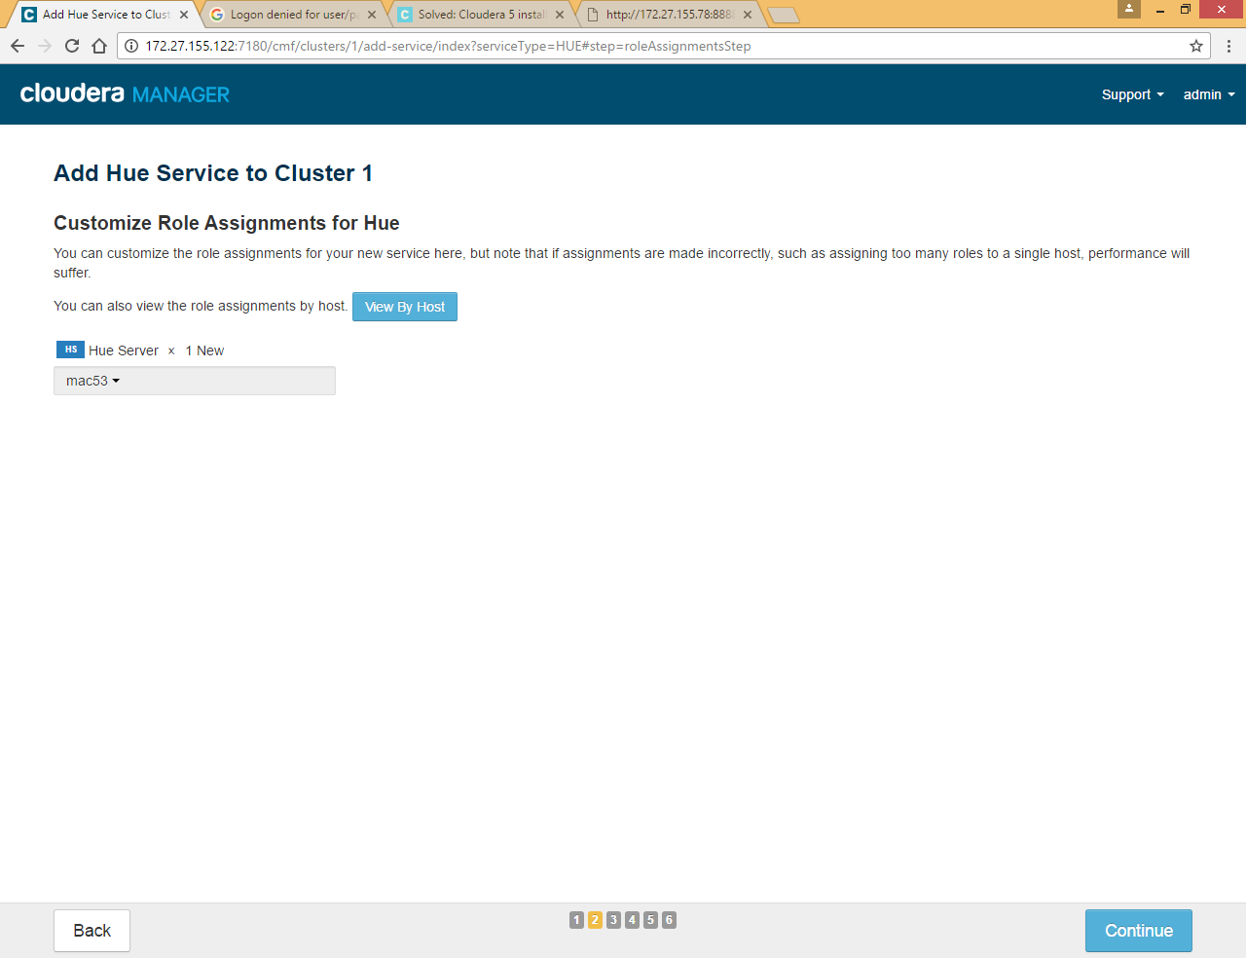

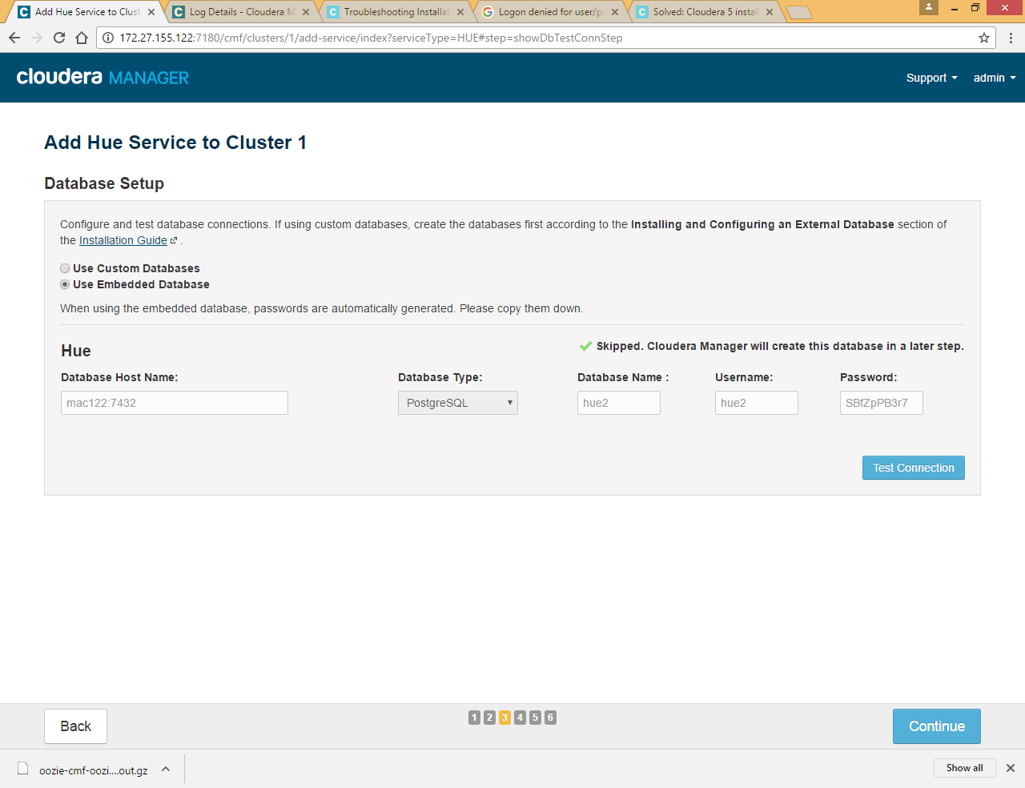

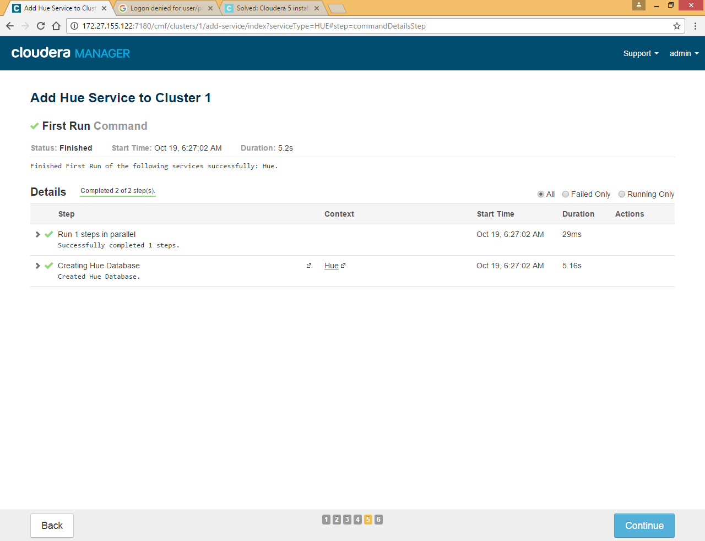

Start hue service

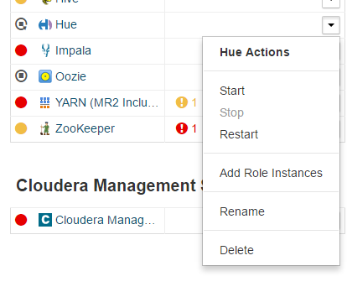

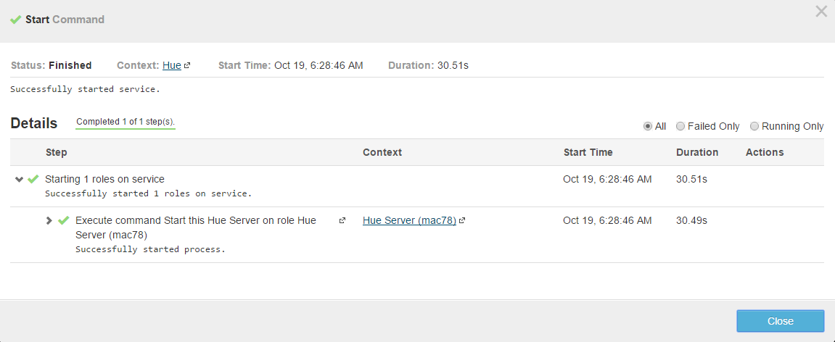

Go to <http://172.27.155.53:8888/> to access hue web UI

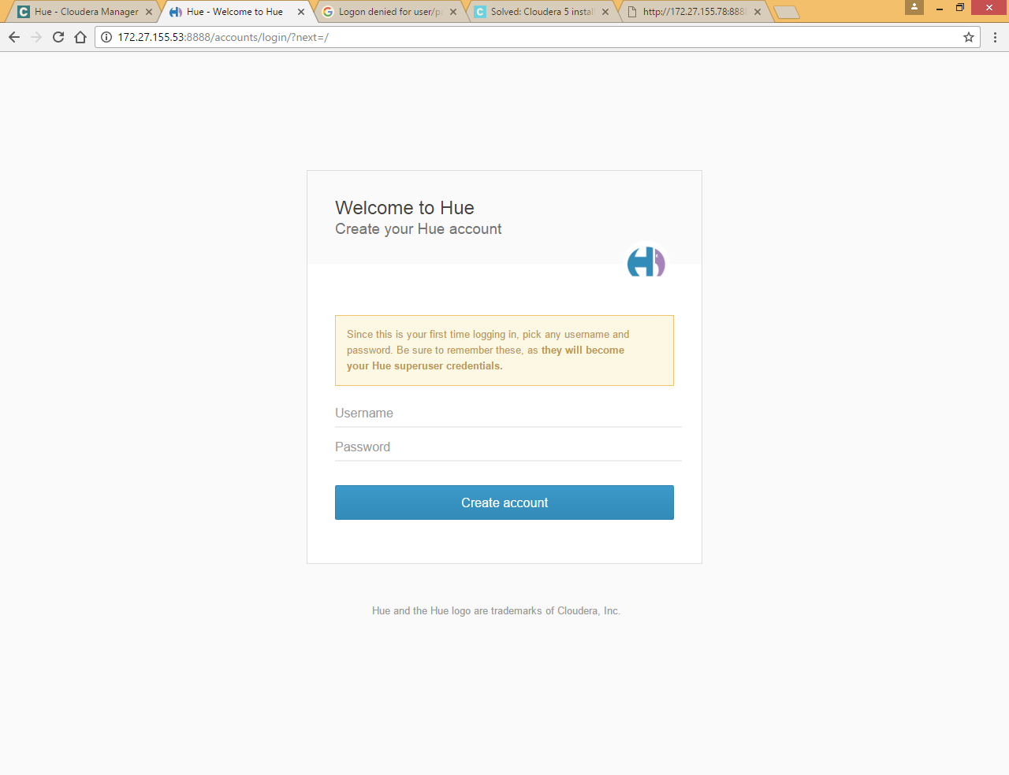

Set first time username and password admin/admin and click Create account

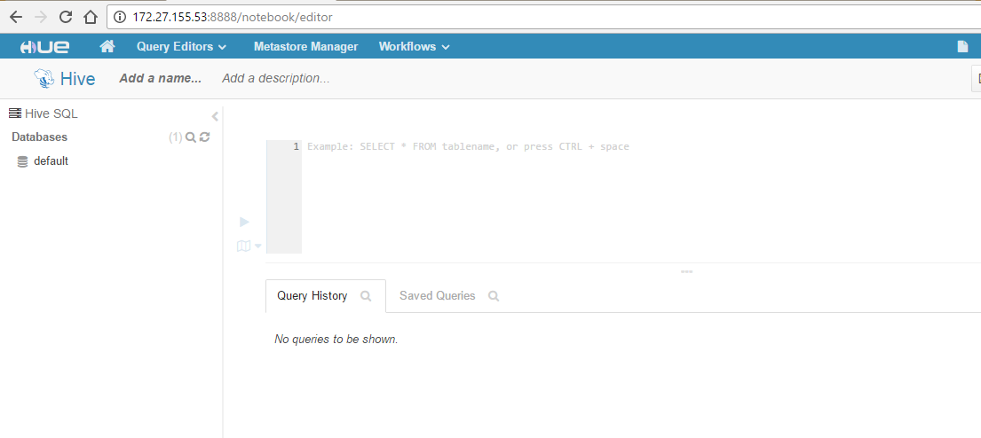

## Setup High Availability

### HDFS High Availability

Prior to Hadoop 2.0.0, the NameNode was a single point of failure (SPOF) in an HDFS cluster. Each cluster had a single NameNode, and if that machine or process became unavailable, the cluster as a whole would be unavailable until the NameNode was either restarted or brought up on a separate machine (Secondary Name Node)

This impacted the total availability of the HDFS cluster in two major ways:

* In the case of an unplanned event such as a machine crash, the cluster would be unavailable until an operator restarted the NameNode.
* Planned maintenance events such as software or hardware upgrades on the NameNode machine would result in windows of cluster downtime.

The HDFS High Availability feature addresses the above problems by providing the option of running two redundant NameNodes in the same cluster in an Active/Passive configuration with a hot standby. This allows a fast failover to a new NameNode in the case that a machine crashes, or a graceful administrator-initiated failover for the purpose of planned maintenance..

#### Architecture

In a typical HA cluster, two separate machines are configured as NameNodes. At any point in time, exactly one of the NameNodes is in an Active state, and the other is in a Standby state. The Active NameNode is responsible for all client operations in the cluster, while the Standby is simply acting as a slave, maintaining enough state to provide a fast failover if necessary.

In order for the Standby node to keep its state synchronized with the Active node, the current implementation requires that the two nodes both have access to a directory on a shared storage device (eg an NFS mount from a NAS). This restriction will likely be relaxed in future versions.

When any namespace modification is performed by the Active node, it durably logs a record of the modification to an edit log file stored in the shared directory. The Standby node is constantly watching this directory for edits, and as it sees the edits, it applies them to its own namespace. In the event of a failover, the Standby will ensure that it has read all of the edits from the shared storage before promoting itself to the Active state. This ensures that the namespace state is fully synchronized before a failover occurs.

In order to provide a fast failover, it is also necessary that the Standby node have up-to-date information regarding the location of blocks in the cluster. In order to achieve this, the DataNodes are configured with the location of both NameNodes, and send block location information and heartbeats to both.

It is vital for the correct operation of an HA cluster that only one of the NameNodes be Active at a time. Otherwise, the namespace state would quickly diverge between the two, risking data loss or other incorrect results. In order to ensure this property and prevent the so-called “split-brain scenario,” the administrator must configure at least one fencing method for the shared storage. During a failover, if it cannot be verified that the previous Active node has relinquished its Active state, the fencing process is responsible for cutting off the previous Active’s access to the shared edits storage. This prevents it from making any further edits to the namespace, allowing the new Active to safely proceed with failover.

#### Configuration

***Click on HDFS and Select Action***

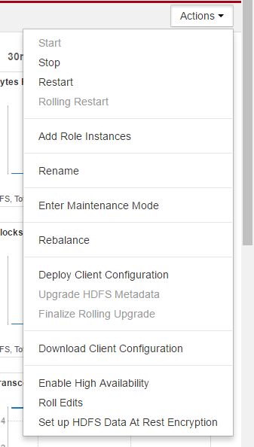

Click Enable High Availability

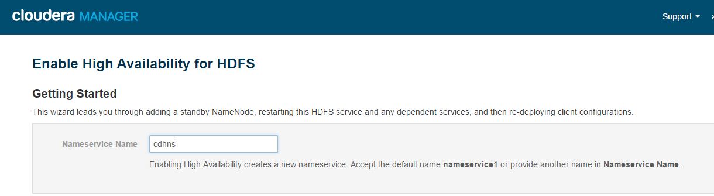

Provide some NameService Name (cdhns)

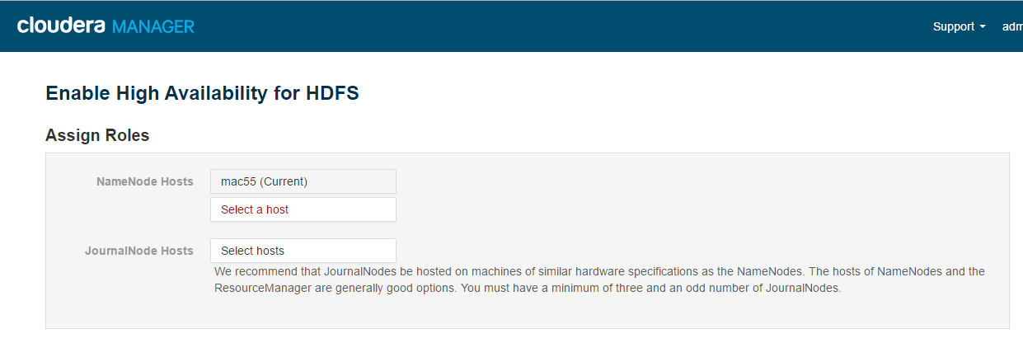

Select host for Standby Name Node (here we have selected mact78 as Standby name node), Once we use high availability and choose standby name node secondary name node instance goes away

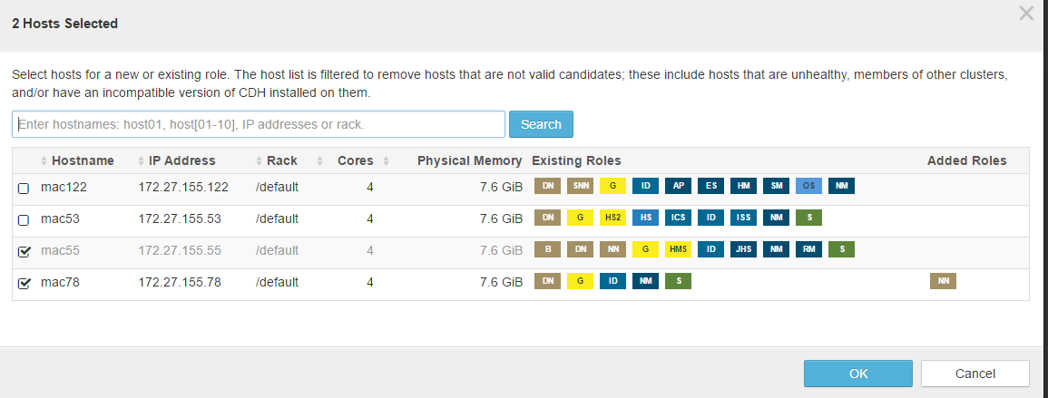

We need to select journal node, we should use odd number of journal node minimum 3, typically it is on Active name node, standby name node and Resource manager in production environment

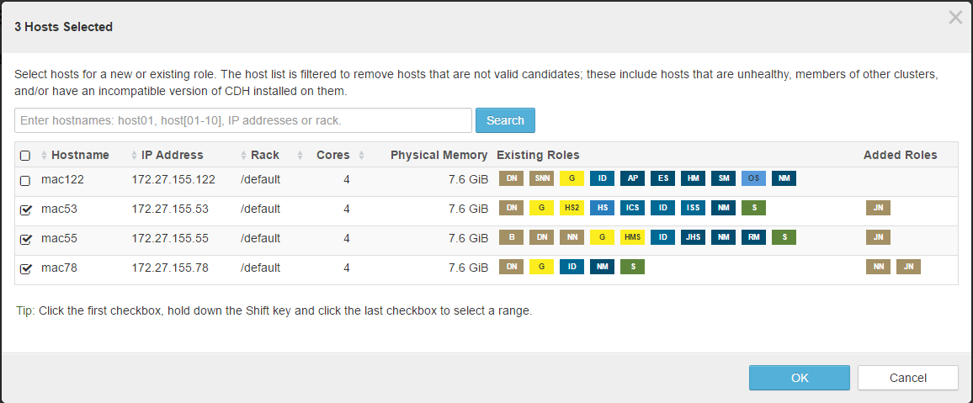

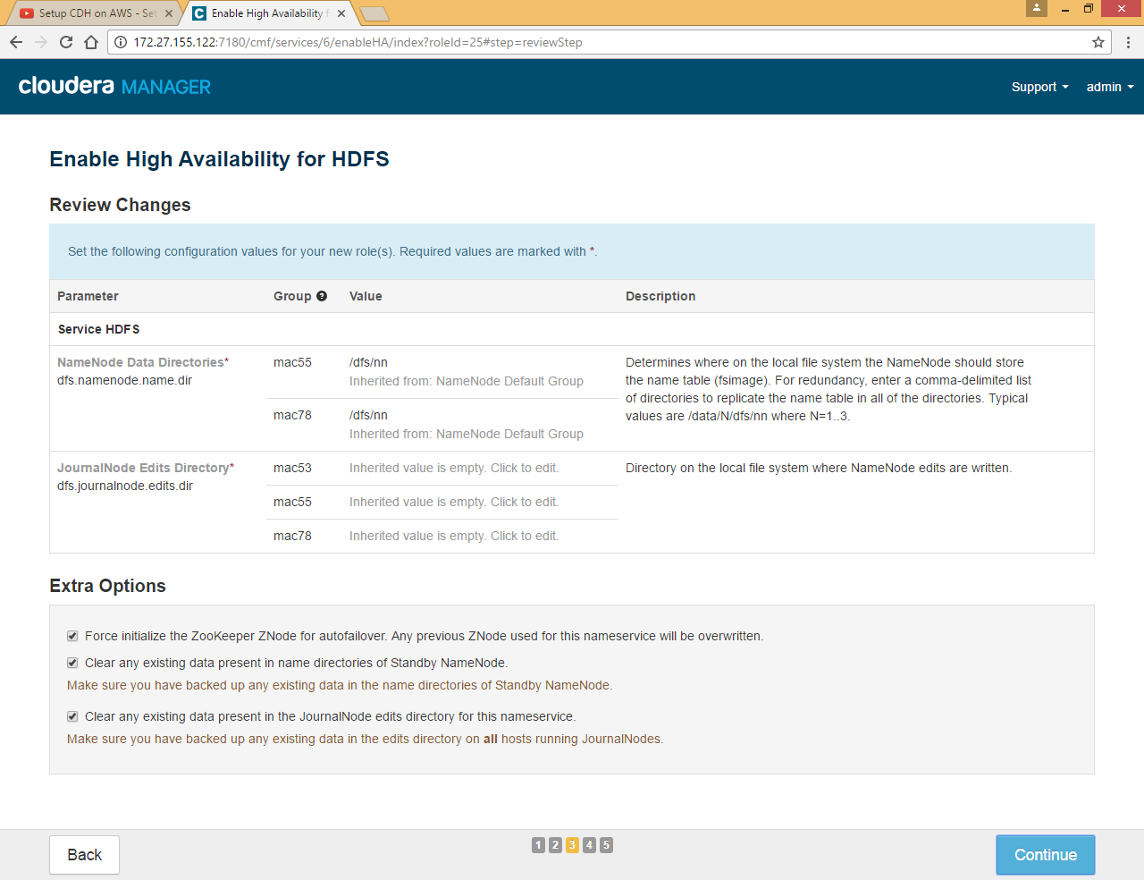

Need to configure journal node edits directory where active name node writes the edit logs in majority of journal nodes.

Apart from this Cloudera install failover controller service on Active and stand by name node

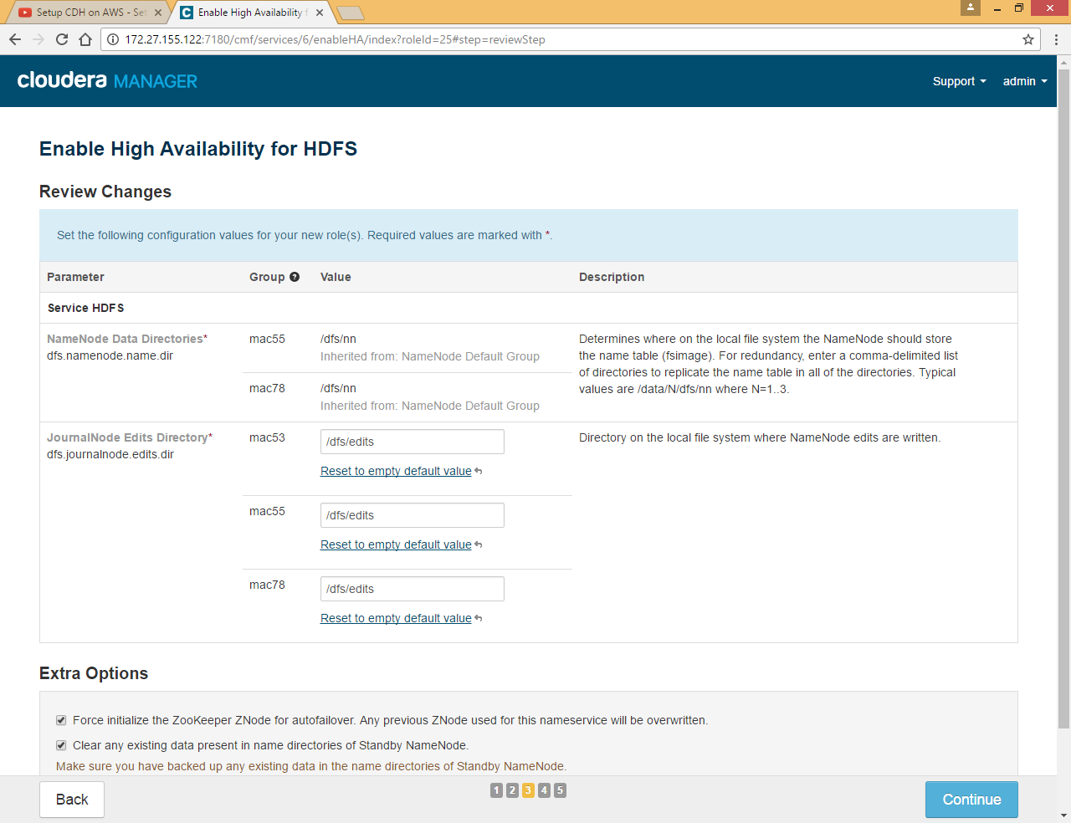

Here we defined **/dfs/edits** as Edits Directory for all journal nodes

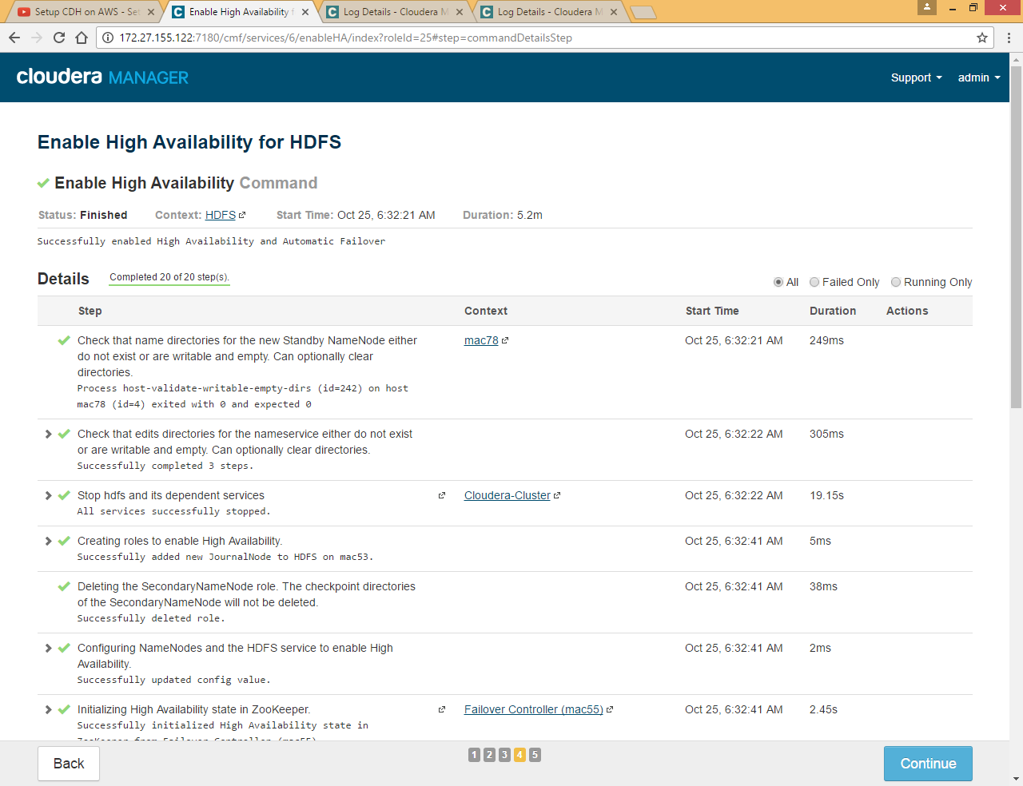

Click Continue

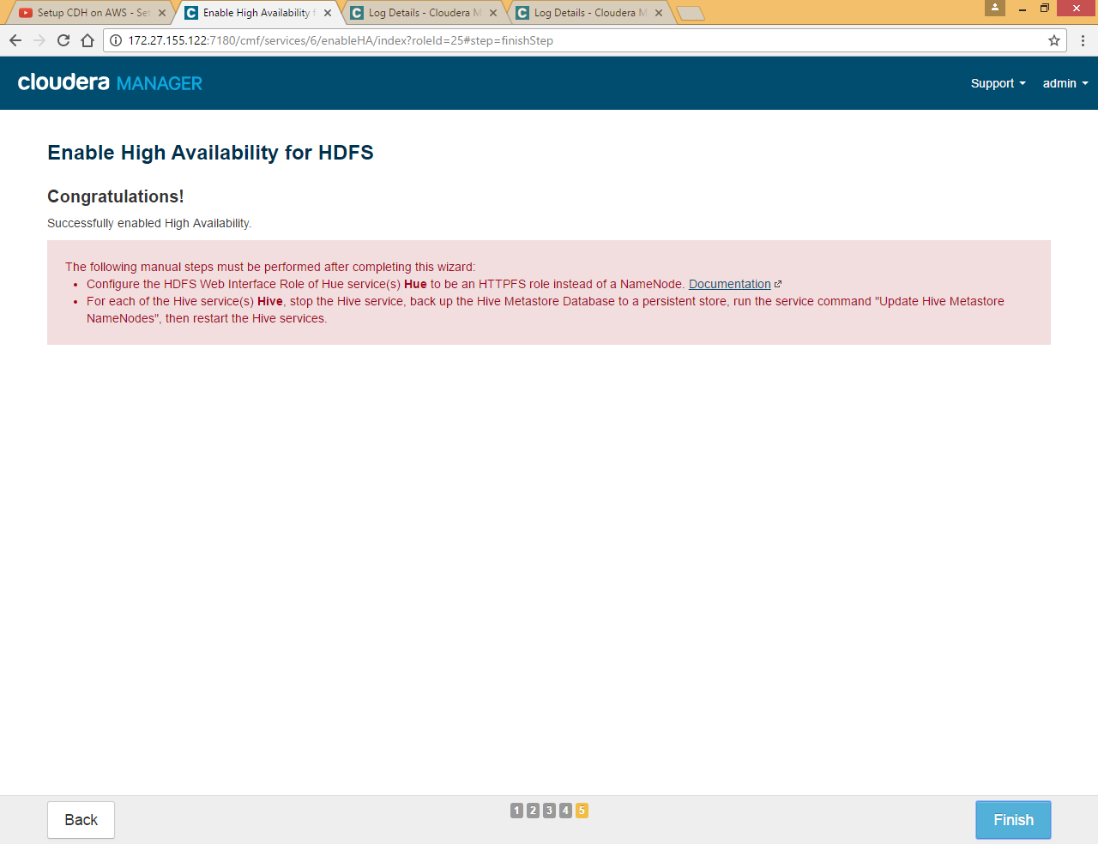

Click Finish

Now you can see edits directory on each journal node

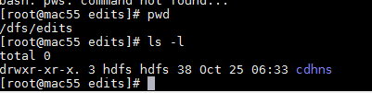

Now if you go to HDFS in Cloudera manager UI you can see there are two name nodes, 3 journal nodes and 2 failover controllers.

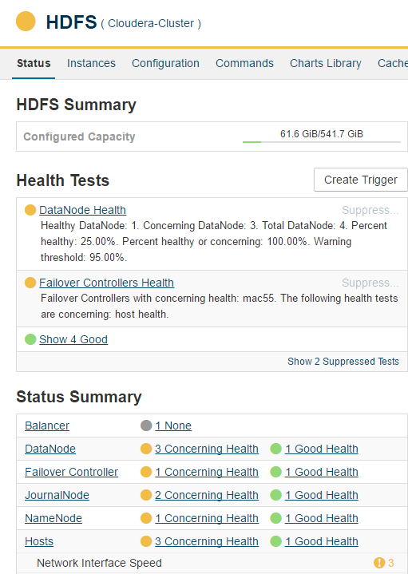

You can click on NameNode to check the Configuration, here you can see there are two name nodes are available one is Active and other is Standby

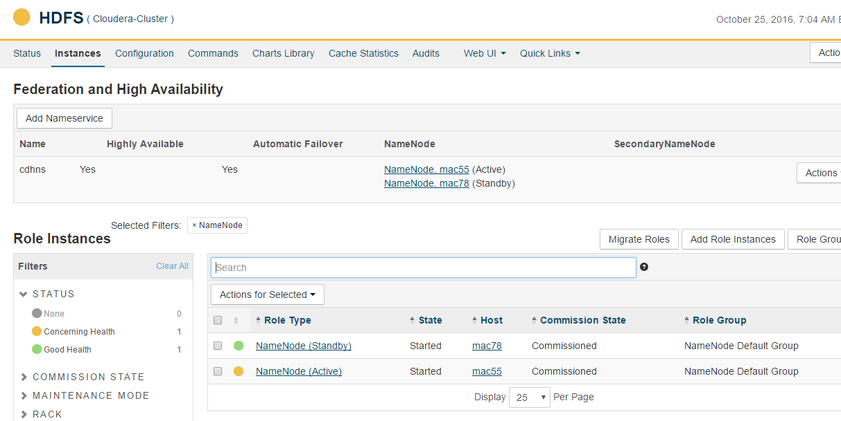

If you click on failover controller you can see this service is installed on Active and Standby name node

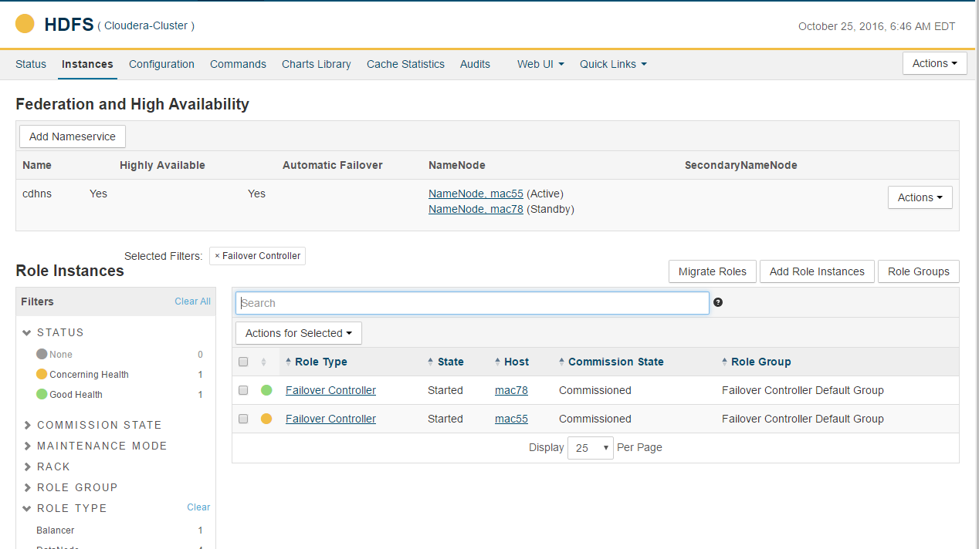

At any given point of point only one Active name node is available

Below are some components related to HDFS high availability

|  |
| --- |
| * HDFS HA – Quorum cluster components   + Active and Standby Namenodes     - HA is different than Secondary namenode or Federation     - Only one node will be active     - Standby node will get edit logs at regular intervals from journal nodes (journal nodes get edit logs from active nodes)   + Shared edits     - Shared Storage       * Uses NFS to store edit logs in shared location by both Namenodes (Active and standby)       * Active Namenode writes to shared edit logs       * Statndby Namenode reads from shared edit logs and apply     - Journal Nodes (Journal directories)       * Typically 3 (when greater than 3 it needs to be odd number)       * Active namenode will write edit logs to majority of the configured journal nodes       * Standby namenode will read edit logs from any of the surviving journal node   + Zookeeper (quorum)     - It will be running on typically 3 or 5 nodes (proc_zkfc)     - As proc_zkfc is lightweight it can be deployed on both Namenodes and ResourceManager |

When an entry is made into Active name node (new file, update or delete file.. etc.) it will try to write to majority of Journal node, so if we have three journal node only if it writes to two of them then the write is successful, stand by name node will read edit logs from one of the journal node which is active and save it to namenode dir (typically /dfs/nn)

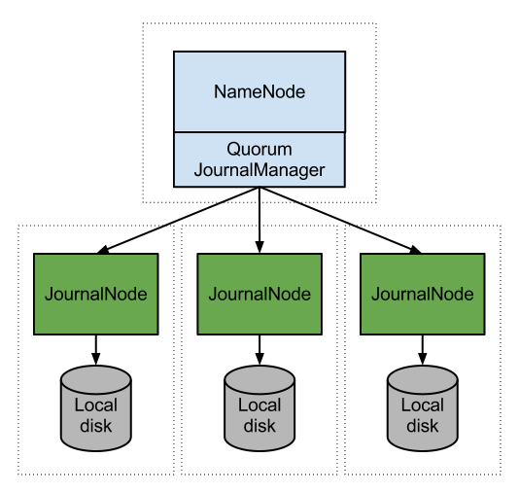

#### Check High Availability Feature

Click on HDFS >> NameNode

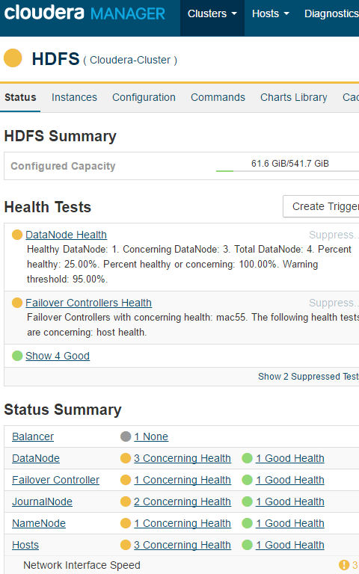

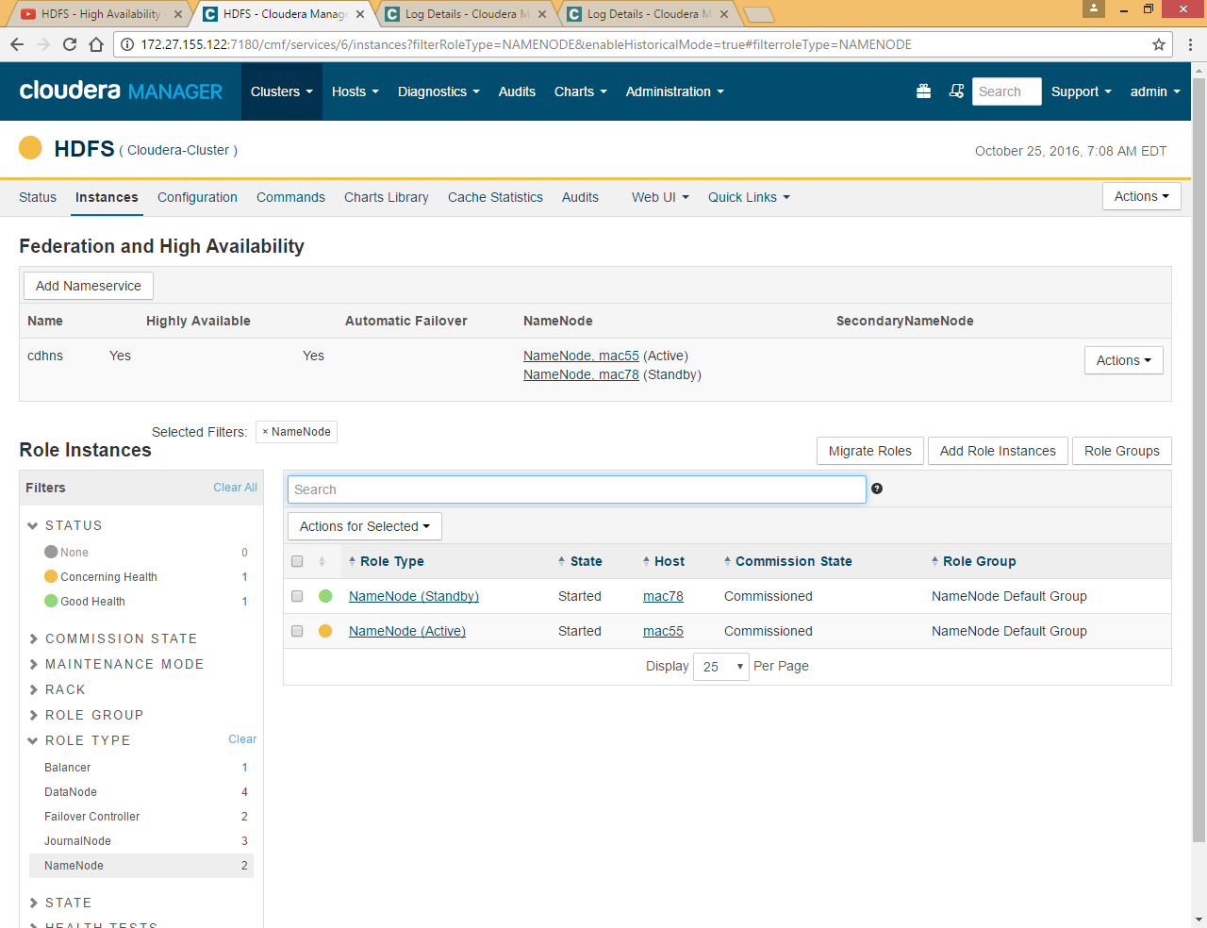

Stop Active name node which is installed on mac55, just click Active name node and click on Stop

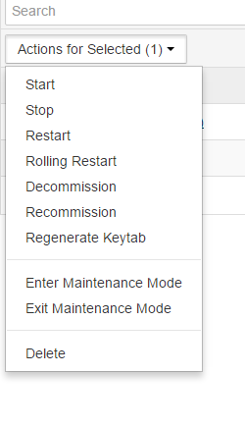

Now Again click on HDFS >>NameNode

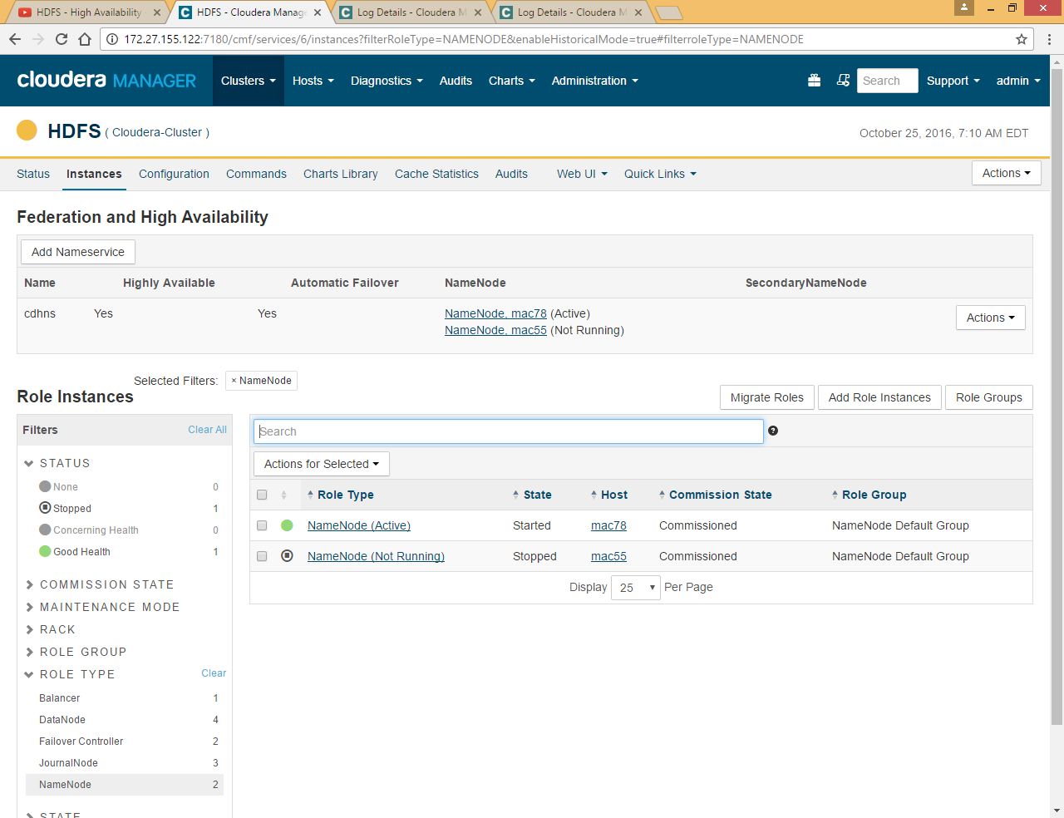

You can see mac78 is now became Active

Now start mac55 again but as already mac78 is Active name node so mac55 will started as standby as at any given point of time there could be only one name node

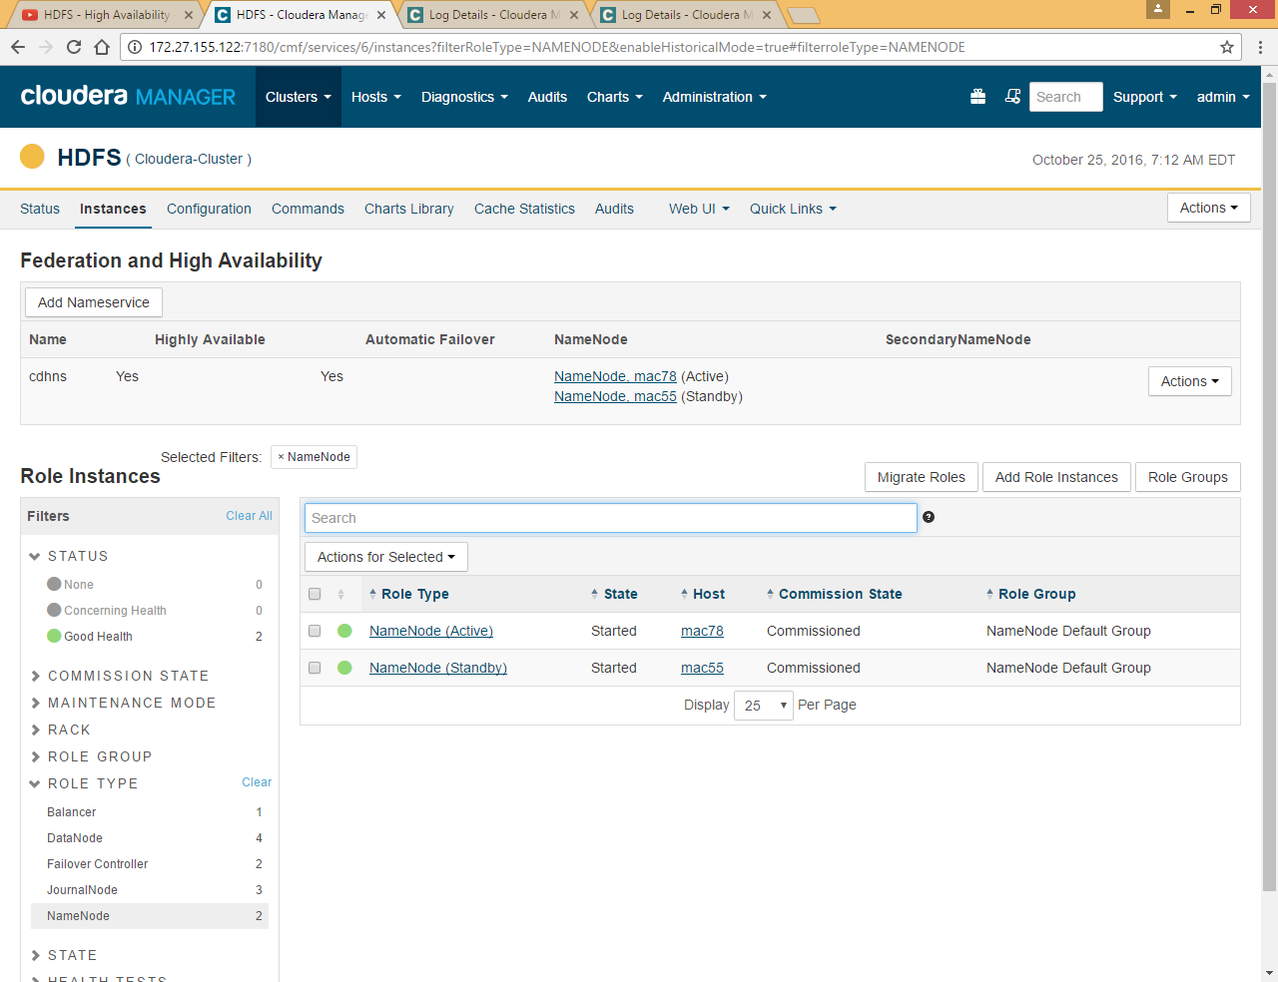

Now mac55 became standby.

#### Journal Node

As we have configured three journal nodes on mac78,55 and 53

Just check in Cloudera Manager UI by clicking on HDFS >> JournalNode

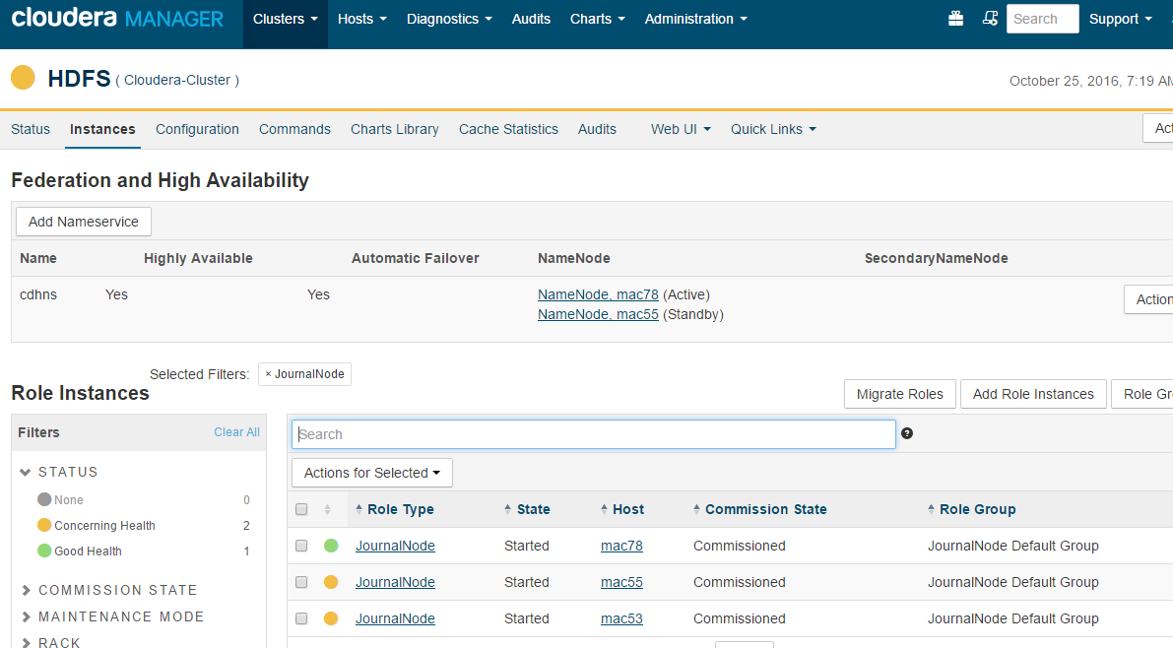

If you want to check the edit logs under journal node go to one of the journal node machine.

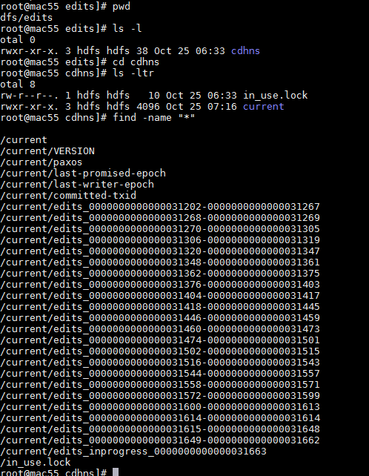

You can see all the edits log generated as a copy here, stand by name node get the information from any survival journal node and apply it on standby name node on regular interval so when Active Name Node goes down Standby NameNode has all the information available.

#### Configuration difference between HA and Non HA Version

If you want to see the configuration file in HA Scenario

Go to HDFS Click on Action and click on Download Client Configuration

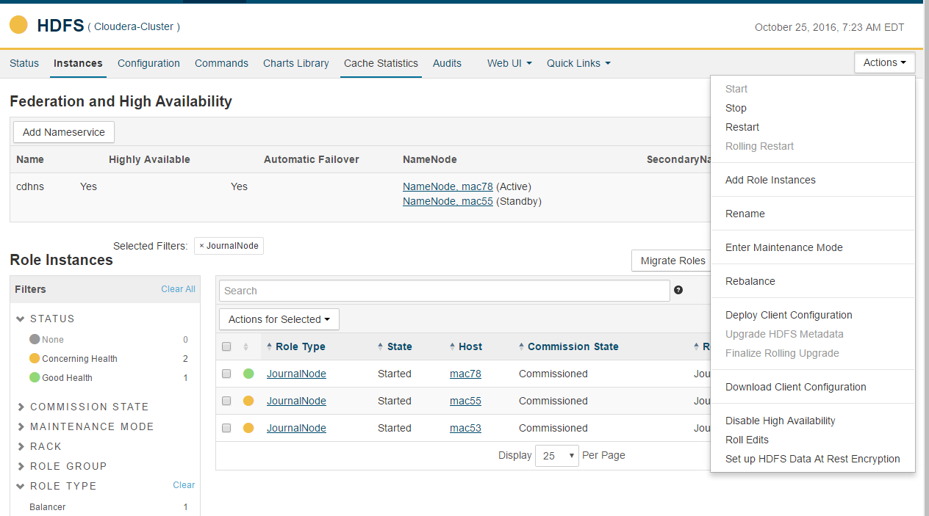

Now if you want to see the old configuration without HA

Just go to **/var/run/cloudera-scm-agent/process**

You will find there lots of hdfs directory begin with some number so check the older version of hdfs-NAMENODE and check the core-site.xml file

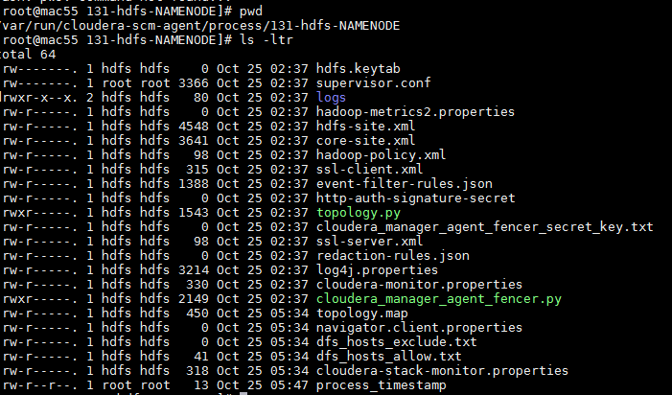

|  |  |
| --- | --- |
| **Latest Version (With HA) core-site.xml** | **Old version (Without HA) core-site.xml** |
|  |  |

You can see in latest version hostname and port is not hardcoded and in old version it is hardcoded. Because during HA there are two namenodes so we cannot hard code hostname and port instead we are using name space.

If you open hdfs-site.xml file for new configuration you can see that namespace is used to determine rest of the values

|  |  |
| --- | --- |
| **Latest Version (With HA) hdfs-site.xml** | **Old version (Without HA) hdfs-site.xml** |
| <configuration>  <property>  <name>dfs.nameservices</name>  <value>cdhns</value>  </property>  <property>  <name>dfs.ha.namenodes.cdhns</name>  <value>namenode25,namenode155</value>  </property>  <property>  <name>dfs.namenode.rpc-address.cdhns.namenode25</name>  <value>mac55:8020</value>  </property>  <property>  <name>dfs.namenode.servicerpc-address.cdhns.namenode25</name>  <value>mac55:8022</value>  </property>  <property>  <name>dfs.namenode.http-address.cdhns.namenode25</name>  <value>mac55:50070</value>  </property>  <property>  <name>dfs.namenode.https-address.cdhns.namenode25</name>  <value>mac55:50470</value>  </property>  <property>  <name>dfs.namenode.rpc-address.cdhns.namenode155</name>  <value>mac78:8020</value>  </property>  ..  ..  ..  ..  ..  </configuration> | <configuration>  <property>  <name>dfs.hosts</name>  <value>/run/cloudera-scm-agent/process/131-hdfs-NAMENODE/dfs_hosts_allow.txt</value>  </property>  <property>  <name>dfs.hosts.exclude</name>  <value>/run/cloudera-scm-agent/process/131-hdfs-NAMENODE/dfs_hosts_exclude.txt</value>  </property>  <property>  <name>dfs.namenode.name.dir</name>  <value>file:///dfs/nn</value>  </property>  <property>  <name>dfs.namenode.servicerpc-address</name>  <value>mac55:8022</value>  </property>  <property>  <name>dfs.namenode.rpc-address</name>  <value>mac55:8020</value>  </property>  ..  ..  ..  ..  ..  </configuration> |

So you can see in the HA version of hdfs-stite.xml that namenode are configured here with **namenode25,namenode155** and for rest of the properties namenode25 and namenode155 used as a suffix while in old hdfs-site.xnl properties are set without suffix

### YARN (MR2) Resource Manager High Availability

The YARN ResourceManager is responsible for tracking the resources in a cluster and scheduling applications (for example, MapReduce jobs). Before CDH 5, the ResourceManager was a single point of failure in a YARN cluster. The ResourceManager high availability (HA) feature adds redundancy in the form of an active-standby ResourceManager pair to remove this single point of failure. Furthermore, upon failover from the active ResourceManager to the standby, the applications can resume from the last state saved to the state store; for example, map tasks in a MapReduce job are not executed again if a failover to a new active ResourceManager occurs after the completion of the map phase. This allows events such the following to be handled without any significant performance effect on running applications:

* Unplanned events such as machine crashes
* Planned maintenance events such as software or hardware upgrades on the machine running the ResourceManager

ResourceManager HA requires ZooKeeper and HDFS services to be running.

|  |
| --- |
| * YARN – Yet Another Resource Negotiator * A generic job management tool which can share resources between "map reduce" based distributed processing tools as well as "non map reduce" based distributed processing tools. * Daemon Processes   + Master -> Resource Manager   + Slave(s) -> Node Managers   + Apptimeline server (application history)   + History server (Map Reduce history)   + Per job Application Master * Parameter Files   + yarn-site.xml   + mapred-site.xml * Apache Web Interfaces   + Resource Manager WUI   + Application Master WUI   + Job History Server * Log files |

#### Automatic Failover

By default, ResourceManager HA uses ZKFC (ZooKeeper-based failover controller) for automatic failover in case the active ResourceManager is unreachable or goes down. Internally, the **StandbyElector** is used to elect the active ResourceManager. The failover controller runs as part of the ResourceManager (not as a separate process as in HDFS and MapReduce v1) and requires no further setup after the appropriate properties are [configured](https://www.cloudera.com/documentation/enterprise/5-6-x/topics/cdh_hag_rm_ha_config.html#concept_skx_n1z_vl__table_lbx_g21_wl) in yarn-site.xml.

#### Configuration

High availability can be configured in YARN which means there will be multiple RM running in the cluster. There is no high availability in MRv1 **(only one job tracker)**

Click on Yarn

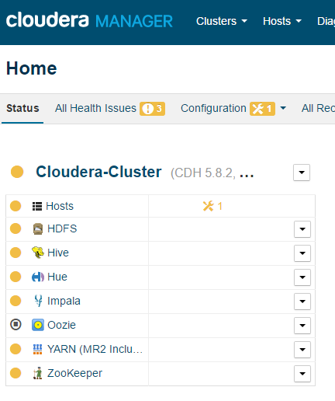

Click on Action >> Enable High Availability

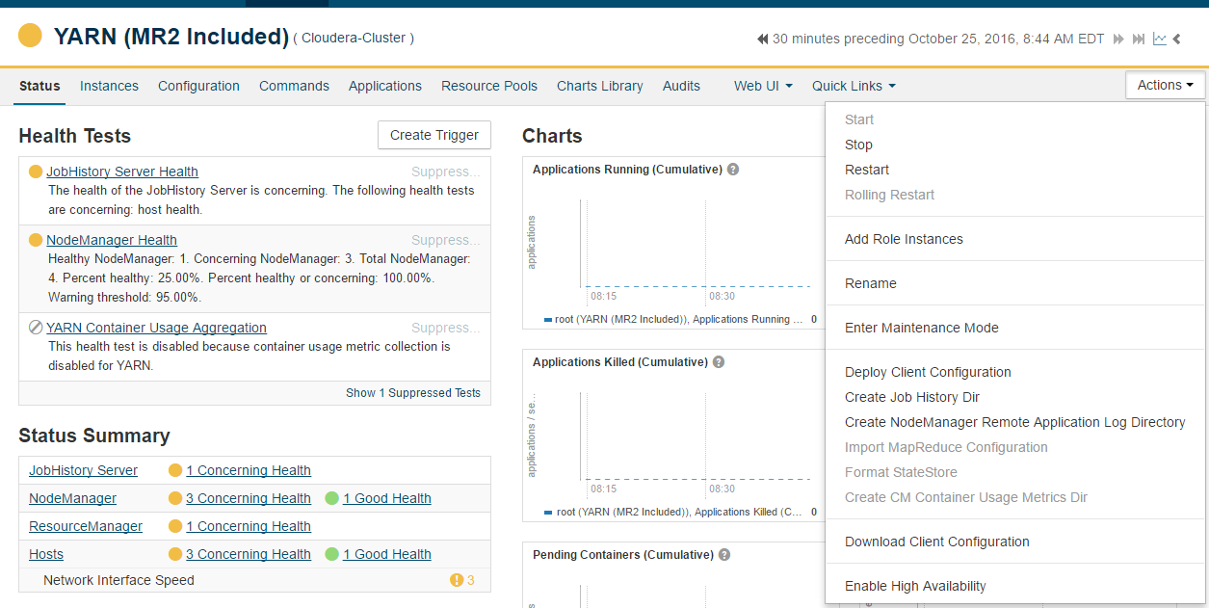

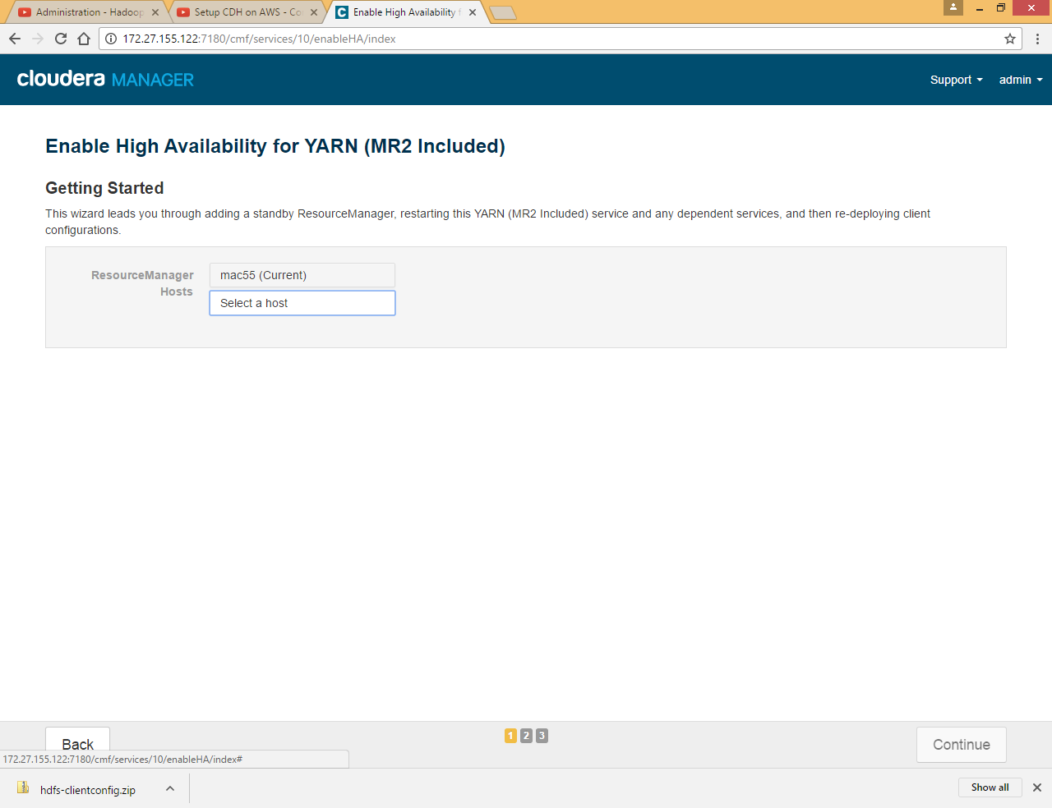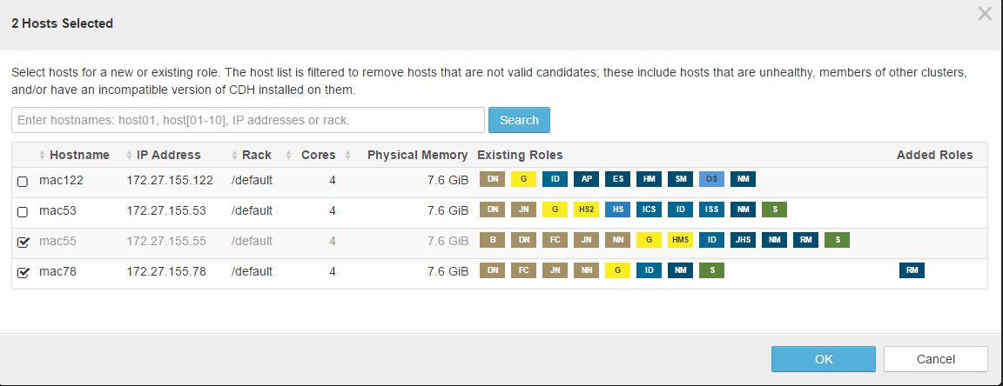 Here we are selecting mac78 as Resource Manager Standby

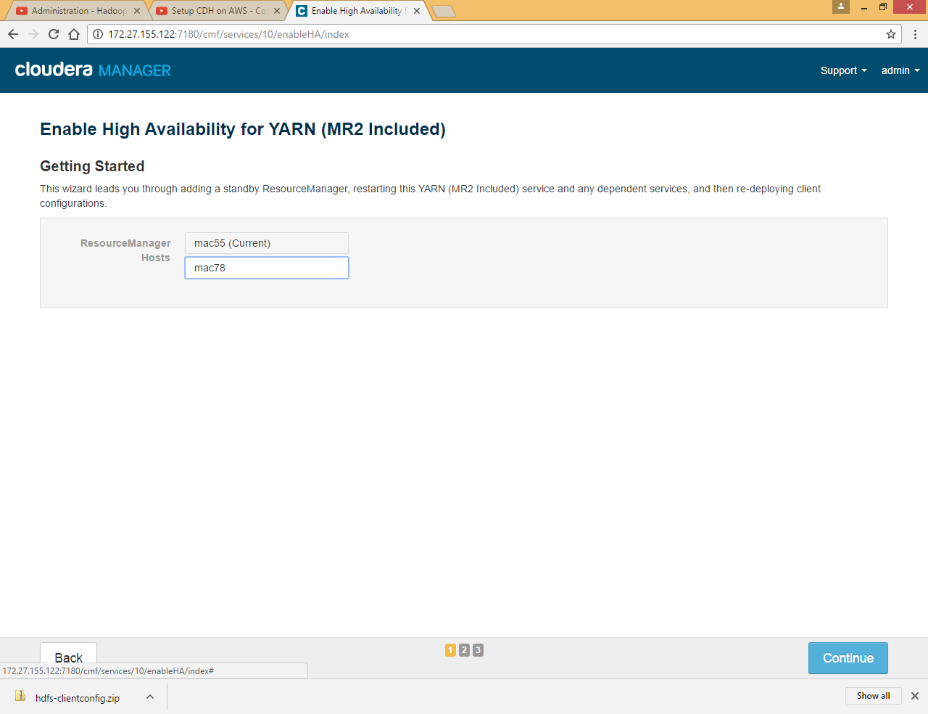

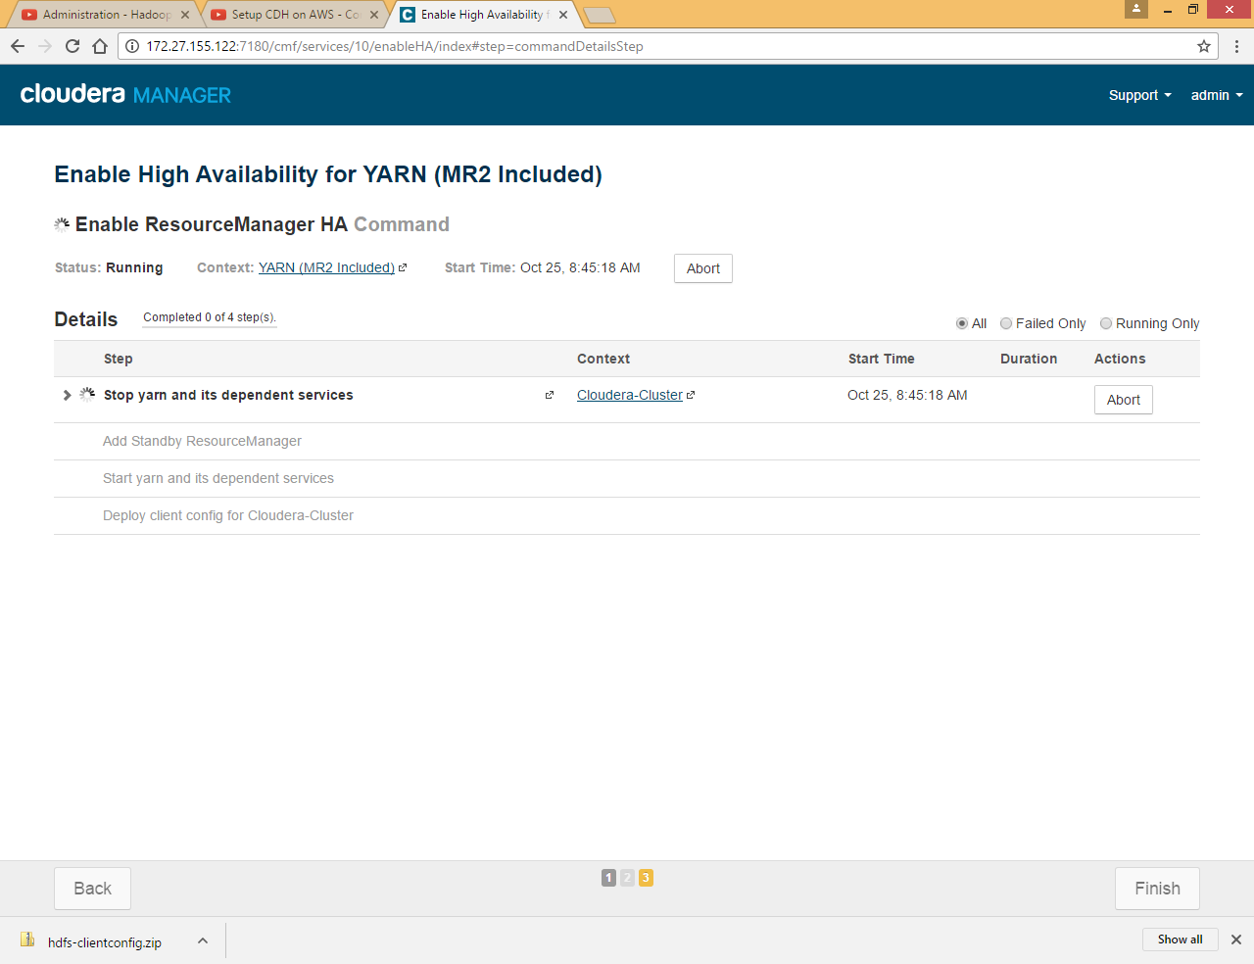

It will deploy yarn-site.xml and mapred-site.xml with new configuration

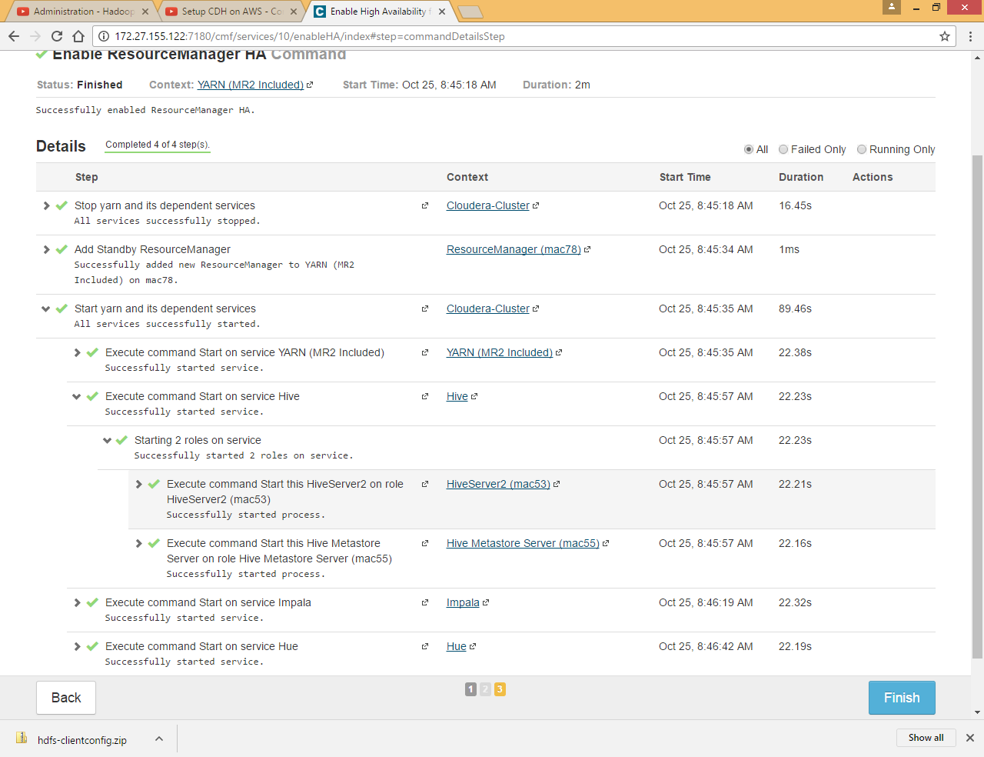

Click Finish

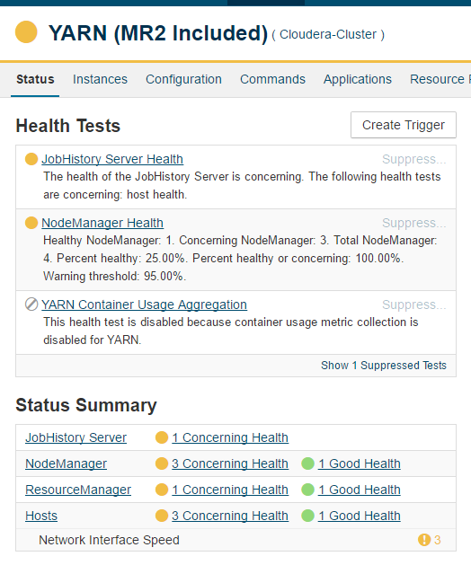

Click on ResourceManager

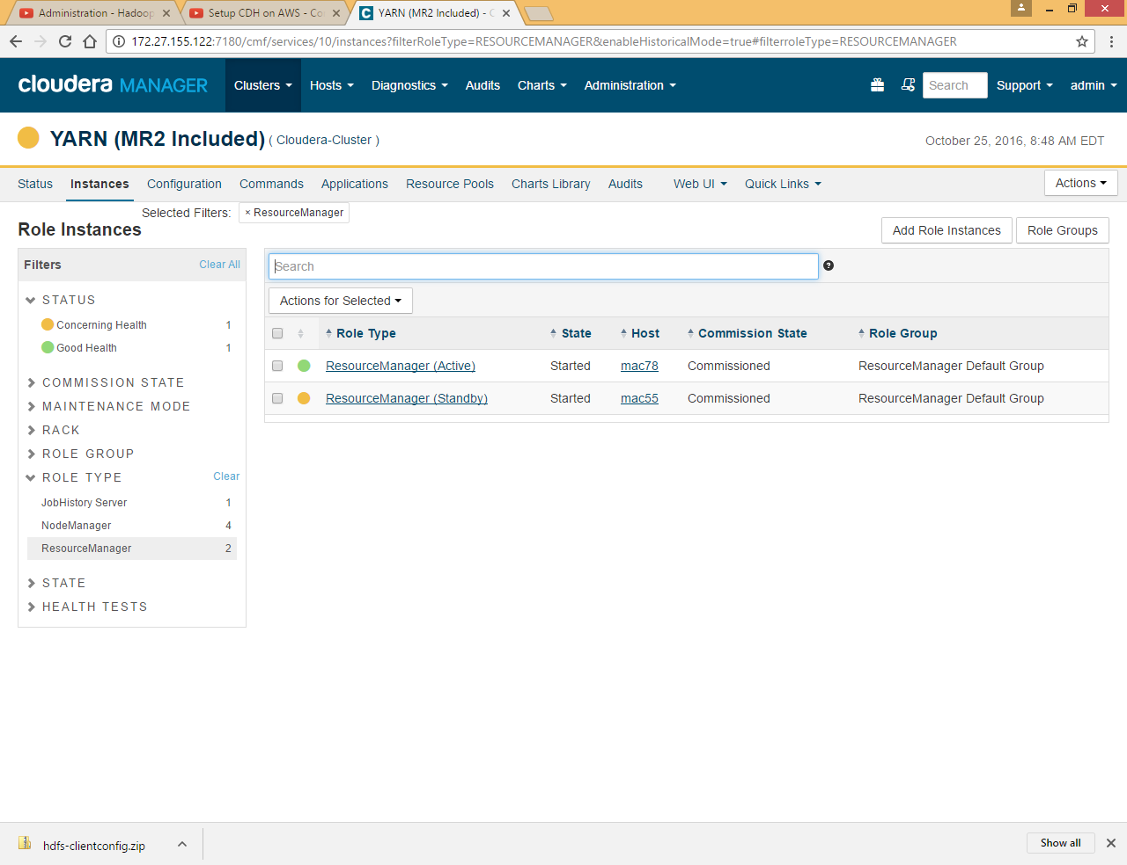

You can see now there are two ResourceManager mac55 as Active and mac78 as standby, at single point of time only one Active ResourceManager is available.

## Install Custom-database (MySQL)

In case you want custom database for hue,hive and oozie , you can install oracle and mysql and select them at the time of configuration

Refer attached doc for installation and configuration of my SQL.



## Uninstall Cloudera Manager and Managed Software

Refer attached doc for steps

